UNITED STATES
SECURITIES AND EXCHANGE COMMISSION
Washington, D.C. 20549

FORM 6-K

REPORT OF FOREIGN PRIVATE ISSUER
PURSUANT TO RULE 13a-16 OR 15d-16 UNDER
THE SECURITIES EXCHANGE ACT OF 1934

For the month of September 2026

Commission File Number: 001-42101

SUPER HI INTERNATIONAL HOLDING LTD.

1 Paya Lebar Link, #09-04
PLQ 1 Paya Lebar Quarter
Singapore 408533
+65 6378 1921
(Address of principal executive offices)

Indicate by check mark whether the registrant files or will file annual reports under cover of Form 20-F or Form 40-F.

Form 20-F ☒ Form 40-F ☐

Exhibit Index

Exhibit No. |  | Description
Exhibit 99.1 |  | SUPER HI INTERNATIONAL HOLDING LTD. 2026 Interim Report

SIGNATURE

Pursuant to the requirements of the Securities Exchange Act of 1934, the registrant has duly caused this report to be signed on its behalf by the undersigned, thereunto duly authorized.

 | SUPER HI INTERNATIONAL HOLDING LTD.
 | By: | /s/ Ping Shu
 | Name: | Ping Shu
 | Title: | Director and Chairperson

Date: September 22, 2026

Exhibit 99.1
 | 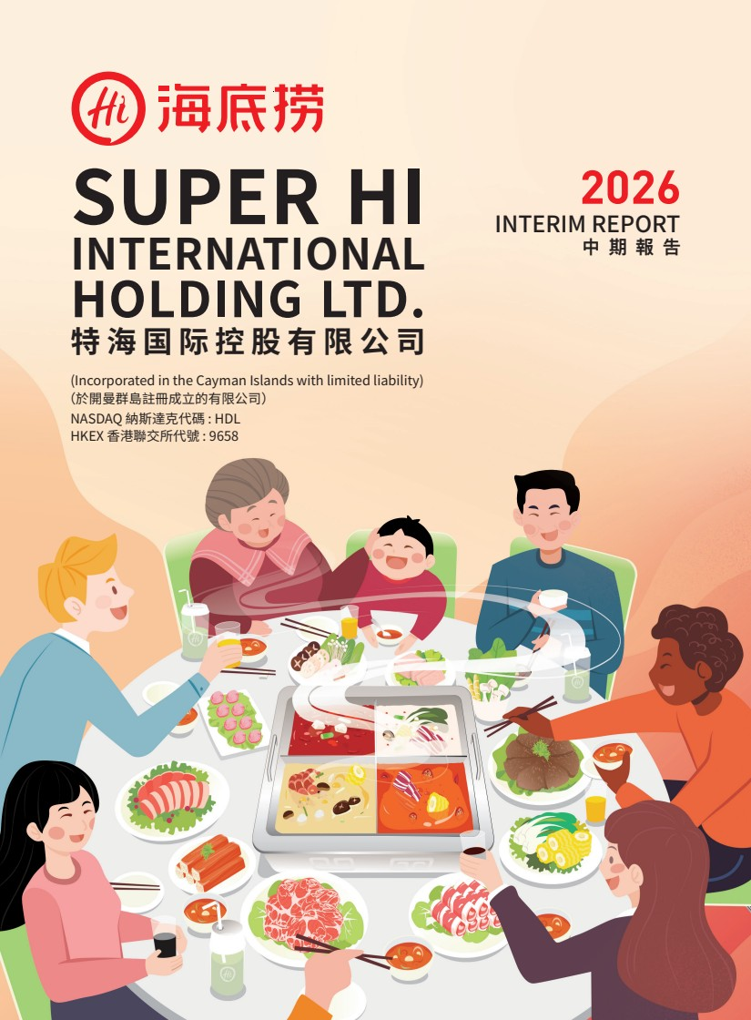 | SUPER HI INTERNATIONAL HOLDING LTD. 特海国际控股有限公司 特海国际控股有限公司 SUPER HI INTERNATIONAL HOLDING LTD. NASDAQ 納斯達克代碼 : HDL HKEX 香港聯交所代號 : 9658 (Incorporated in the Cayman Islands with limited liability) INTERIM REPORT 中期報告 2026 （於開曼群島註冊成立的有限公司）
 | 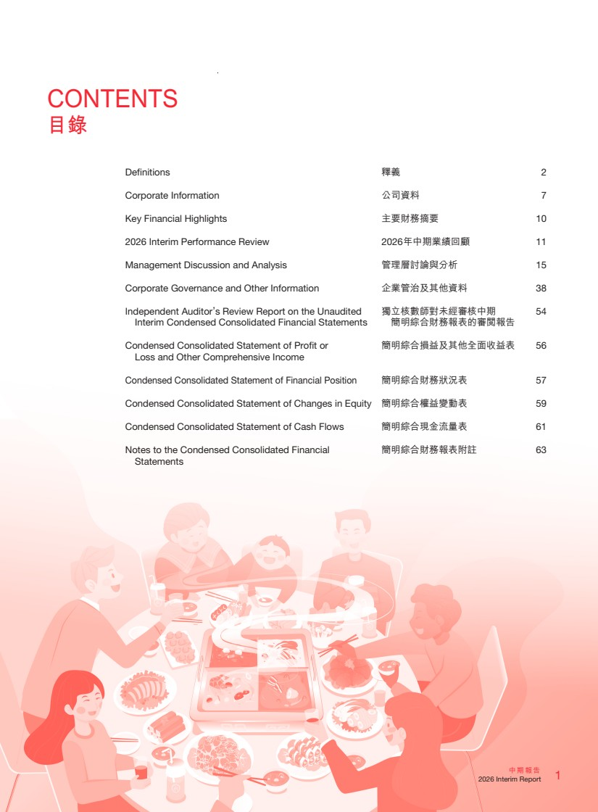 | CONTENTS 目錄 Definitions 釋義 2 Corporate Information 公司資料 7 Key Financial Highlights 主要財務摘要 10 2026 Interim Performance Review 2026年中期業績回顧 11 Management Discussion and Analysis 管理層討論與分析 15 Corporate Governance and Other Information 企業管治及其他資料 38 Independent Auditor’s Review Report on the Unaudited Interim Condensed Consolidated Financial Statements 獨立核數師對未經審核中期 簡明綜合財務報表的審閱報告 54 Condensed Consolidated Statement of Profit or Loss and Other Comprehensive Income 簡明綜合損益及其他全面收益表 56 Condensed Consolidated Statement of Financial Position 簡明綜合財務狀況表 57 Condensed Consolidated Statement of Changes in Equity 簡明綜合權益變動表 59 Condensed Consolidated Statement of Cash Flows 簡明綜合現金流量表 61 Notes to the Condensed Consolidated Financial Statements 簡明綜合財務報表附註 63 1 中期報告 2026 Interim Report
 | 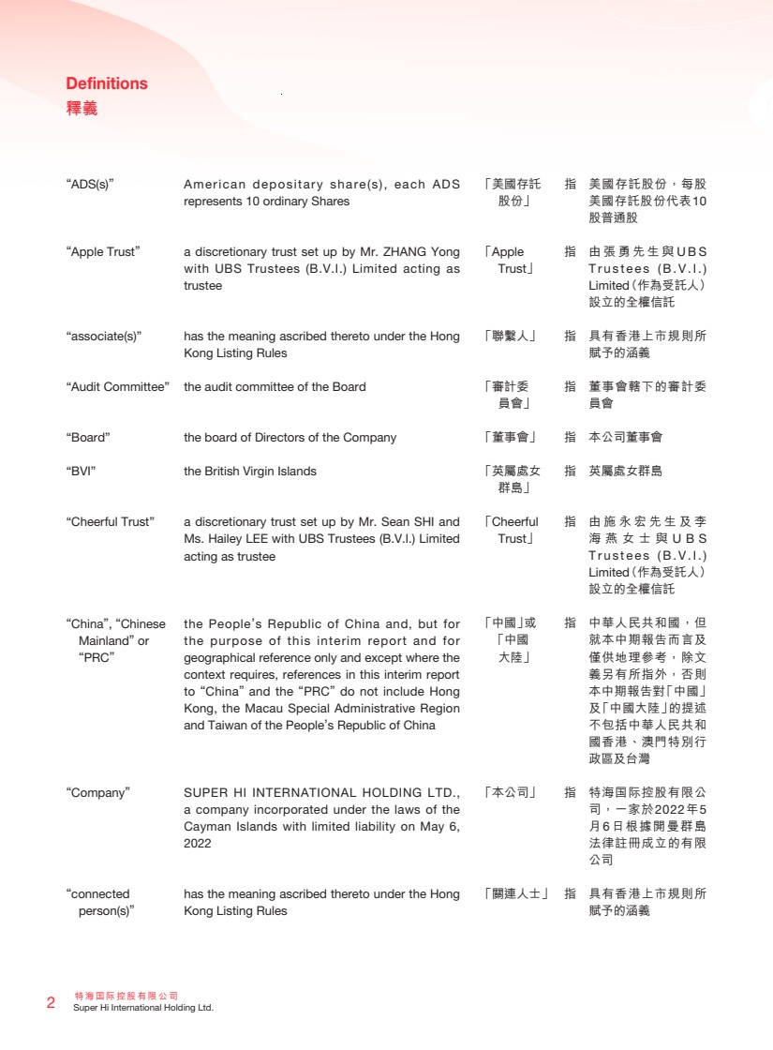 | 特海國際控股有限公司 2 Super Hi International Holding Ltd. Definitions 釋義 “ADS(s)” American depositary share(s), each ADS represents 10 ordinary Shares “Apple Trust” a discretionary trust set up by Mr. ZHANG Yong with UBS Trustees (B.V.I.) Limited acting as trustee “associate(s)” has the meaning ascribed thereto under the Hong Kong Listing Rules “Audit Committee” the audit committee of the Board “Board” the board of Directors of the Company “BVI” the British Virgin Islands “Cheerful Trust” a discretionary trust set up by Mr. Sean SHI and Ms. Hailey LEE with UBS Trustees (B.V.I.) Limited acting as trustee “China”, “Chinese Mainland” or “PRC” the People’s Republic of China and, but for the purpose of this interim report and for geographical reference only and except where the context requires, references in this interim report to “China” and the “PRC” do not include Hong Kong, the Macau Special Administrative Region and Taiwan of the People’s Republic of China “Company” SUPER HI INTERNATIONAL HOLDING LTD., a company incorporated under the laws of the Cayman Islands with limited liability on May 6, 2022 “connected person(s)” has the meaning ascribed thereto under the Hong Kong Listing Rules 「美國存託 股份」 指 美國存託股份，每股 美國存託股份代表10 股普通股 「Apple Trust」 指 由張勇先生與 U B S T r u s t e e s ( B . V . I . ) Limited（作為受託人） 設立的全權信託 「聯繫人」 指 具有香港上市規則所 賦予的涵義 「審計委 員會」 指 董事會轄下的審計委 員會 「董事會」 指 本公司董事會 「英屬處女 群島」 指 英屬處女群島 「Cheerful Trust」 指 由施永宏先生及李 海燕女士與 U B S T r u s t e e s ( B . V . I . ) Limited（作為受託人） 設立的全權信託 「中國」或 「中國 大陸」 指 中華人民共和國，但 就本中期報告而言及 僅供地理參考，除文 義另有所指外，否則 本中期報告對「中國」 及「中國大陸」的提述 不包括中華人民共和 國香港、澳門特別行 政區及台灣 「本公司」 指 特海国际控股有限公 司，一家於2022年5 月6日根據開曼群島 法律註冊成立的有限 公司 「關連人士」 指 具有香港上市規則所 賦予的涵義
 | 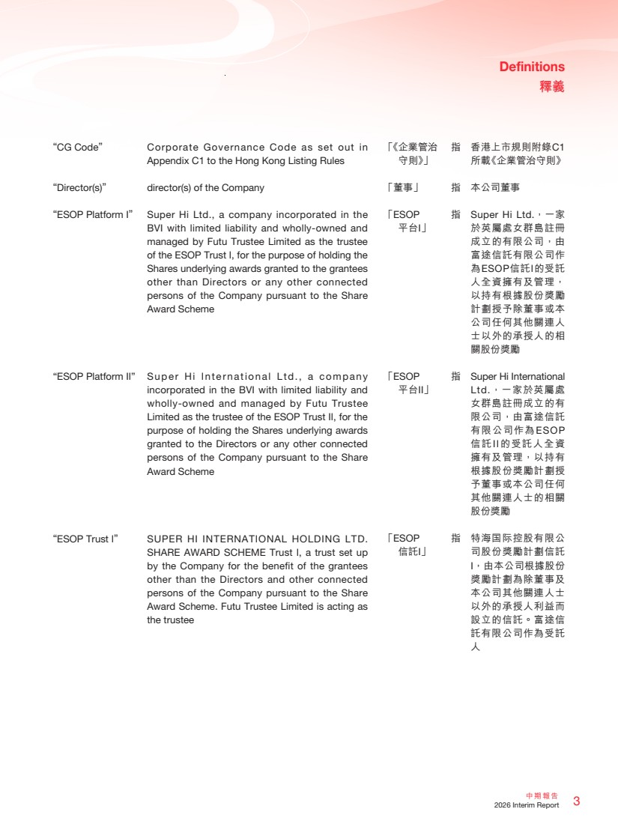 | 3 中期報告 2026 Interim Report Definitions 釋義 “CG Code” Corporate Governance Code as set out in Appendix C1 to the Hong Kong Listing Rules “Director(s)” director(s) of the Company “ESOP Platform I” Super Hi Ltd., a company incorporated in the BVI with limited liability and wholly-owned and managed by Futu Trustee Limited as the trustee of the ESOP Trust I, for the purpose of holding the Shares underlying awards granted to the grantees other than Directors or any other connected persons of the Company pursuant to the Share Award Scheme “ESOP Platform II” Super Hi International Ltd., a company incorporated in the BVI with limited liability and wholly-owned and managed by Futu Trustee Limited as the trustee of the ESOP Trust II, for the purpose of holding the Shares underlying awards granted to the Directors or any other connected persons of the Company pursuant to the Share Award Scheme “ESOP Trust I” SUPER HI INTERNATIONAL HOLDING LTD. SHARE AWARD SCHEME Trust I, a trust set up by the Company for the benefit of the grantees other than the Directors and other connected persons of the Company pursuant to the Share Award Scheme. Futu Trustee Limited is acting as the trustee 「《企業管治 守則》」 指 香港上市規則附錄C1 所載《企業管治守則》 「董事」 指 本公司董事 「ESOP 平台I」 指 Super Hi Ltd.，一家 於英屬處女群島註冊 成立的有限公司，由 富途信託有限公司作 為ESOP信託I的受託 人全資擁有及管理， 以持有根據股份獎勵 計劃授予除董事或本 公司任何其他關連人 士以外的承授人的相 關股份獎勵 「ESOP 平台II」 指 Super Hi International Ltd.，一家於英屬處 女群島註冊成立的有 限公司，由富途信託 有限公司作為ESOP 信託II的受託人全資 擁有及管理，以持有 根據股份獎勵計劃授 予董事或本公司任何 其他關連人士的相關 股份獎勵 「ESOP 信託I」 指 特海国际控股有限公 司股份獎勵計劃信託 I，由本公司根據股份 獎勵計劃為除董事及 本公司其他關連人士 以外的承授人利益而 設立的信託。富途信 託有限公司作為受託 人
 | 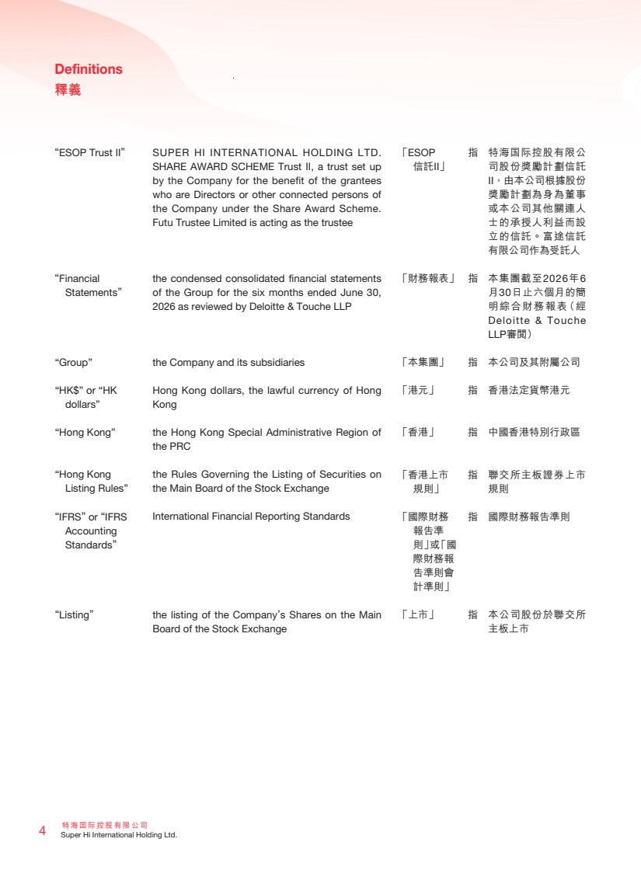 | 特海國際控股有限公司 4 Super Hi International Holding Ltd. Definitions 釋義 「ESOP 信託II」 指 特海国际控股有限公 司股份獎勵計劃信託 II，由本公司根據股份 獎勵計劃為身為董事 或本公司其他關連人 士的承授人利益而設 立的信託。富途信託 有限公司作為受託人 「財務報表」 指 本集團截至2026年6 月30日止六個月的簡 明綜合財務報表（經 Deloitte & Touche LLP審閱） 「本集團」 指 本公司及其附屬公司 「港元」 指 香港法定貨幣港元 「香港」 指 中國香港特別行政區 「香港上市 規則」 指 聯交所主板證券上市 規則 「國際財務 報告準 則」或「國 際財務報 告準則會 計準則」 指 國際財務報告準則 「上市」 指 本公司股份於聯交所 主板上市 “ESOP Trust II” SUPER HI INTERNATIONAL HOLDING LTD. SHARE AWARD SCHEME Trust II, a trust set up by the Company for the benefit of the grantees who are Directors or other connected persons of the Company under the Share Award Scheme. Futu Trustee Limited is acting as the trustee “Financial Statements” the condensed consolidated financial statements of the Group for the six months ended June 30, 2026 as reviewed by Deloitte & Touche LLP “Group” the Company and its subsidiaries “HK$” or “HK dollars” Hong Kong dollars, the lawful currency of Hong Kong “Hong Kong” the Hong Kong Special Administrative Region of the PRC “Hong Kong Listing Rules” the Rules Governing the Listing of Securities on the Main Board of the Stock Exchange “IFRS” or “IFRS Accounting Standards” International Financial Reporting Standards “Listing” the listing of the Company’s Shares on the Main Board of the Stock Exchange
 | 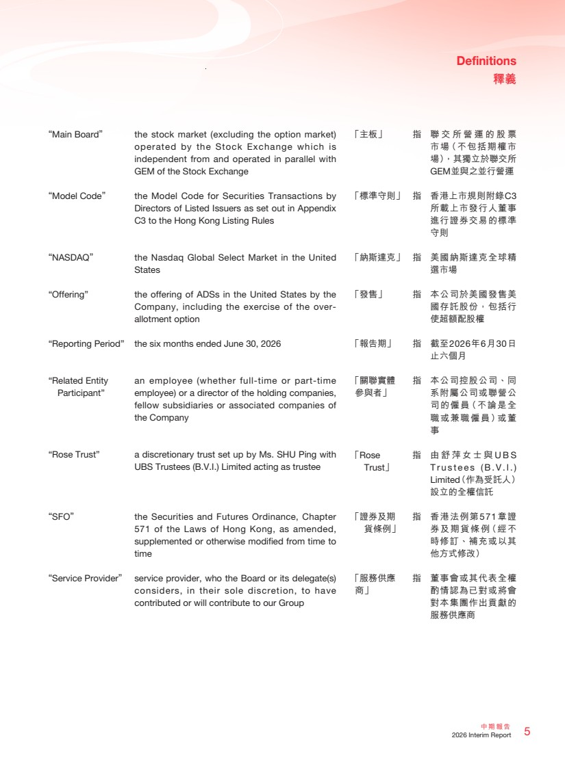 | 5 中期報告 2026 Interim Report Definitions 釋義 「主板」 指 聯交所營運的股票 市場（不包括期權市 場），其獨立於聯交所 GEM並與之並行營運 「標準守則」 指 香港上市規則附錄C3 所載上市發行人董事 進行證券交易的標準 守則 「納斯達克」 指 美國納斯達克全球精 選市場 「發售」 指 本公司於美國發售美 國存託股份，包括行 使超額配股權 「報告期」 指 截至2026年6月30日 止六個月 「關聯實體 參與者」 指 本公司控股公司、同 系附屬公司或聯營公 司的僱員（不論是全 職或兼職僱員）或董 事 「Rose Trust」 指 由舒萍女士與 U B S T r u s t e e s ( B . V . I . ) Limited（作為受託人） 設立的全權信託 「證券及期 貨條例」 指 香港法例第571章證 券及期貨條例（經不 時修訂、補充或以其 他方式修改） 「服務供應 商」 指 董事會或其代表全權 酌情認為已對或將會 對本集團作出貢獻的 服務供應商 “Main Board” the stock market (excluding the option market) operated by the Stock Exchange which is independent from and operated in parallel with GEM of the Stock Exchange “Model Code” the Model Code for Securities Transactions by Directors of Listed Issuers as set out in Appendix C3 to the Hong Kong Listing Rules “NASDAQ” the Nasdaq Global Select Market in the United States “Offering” the offering of ADSs in the United States by the Company, including the exercise of the over-allotment option “Reporting Period” the six months ended June 30, 2026 “Related Entity Participant” an employee (whether full-time or part-time employee) or a director of the holding companies, fellow subsidiaries or associated companies of the Company “Rose Trust” a discretionary trust set up by Ms. SHU Ping with UBS Trustees (B.V.I.) Limited acting as trustee “SFO” the Securities and Futures Ordinance, Chapter 571 of the Laws of Hong Kong, as amended, supplemented or otherwise modified from time to time “Service Provider” service provider, who the Board or its delegate(s) considers, in their sole discretion, to have contributed or will contribute to our Group
 | 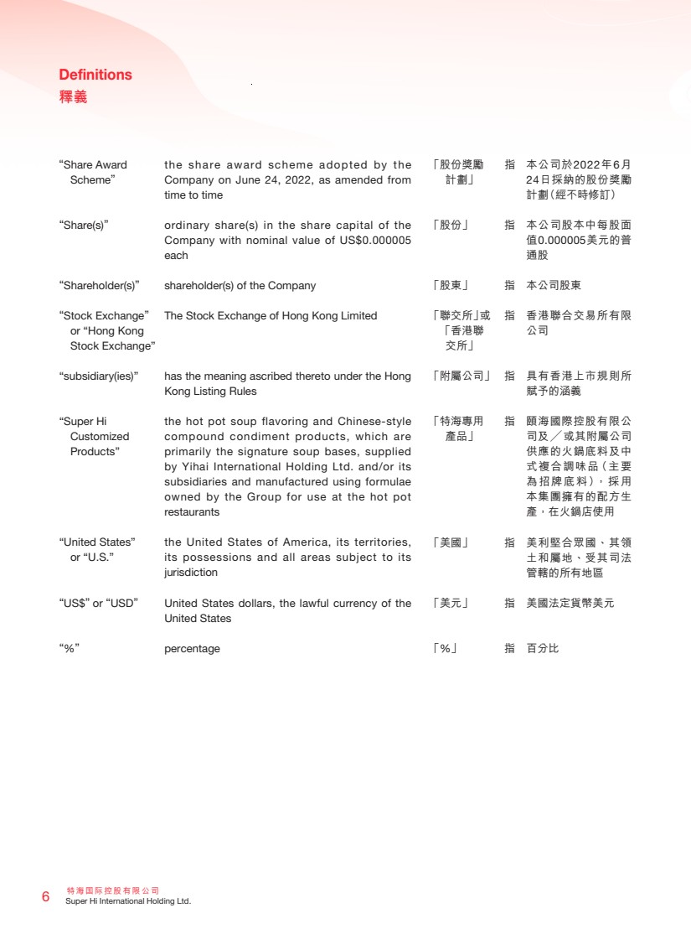 | 特海國際控股有限公司 6 Super Hi International Holding Ltd. Definitions 釋義 「股份獎勵 計劃」 指 本公司於2022年6月 24日採納的股份獎勵 計劃（經不時修訂） 「股份」 指 本公司股本中每股面 值0.000005美元的普 通股 「股東」 指 本公司股東 「聯交所」或 「香港聯 交所」 指 香港聯合交易所有限 公司 「附屬公司」 指 具有香港上市規則所 賦予的涵義 「特海專用 產品」 指 頤海國際控股有限公 司及╱或其附屬公司 供應的火鍋底料及中 式複合調味品（主要 為招牌底料），採用 本集團擁有的配方生 產，在火鍋店使用 「美國」 指 美利堅合眾國、其領 土和屬地、受其司法 管轄的所有地區 「美元」 指 美國法定貨幣美元 「%」 指 百分比 “Share Award Scheme” the share award scheme adopted by the Company on June 24, 2022, as amended from time to time “Share(s)” ordinary share(s) in the share capital of the Company with nominal value of US$0.000005 each “Shareholder(s)” shareholder(s) of the Company “Stock Exchange” or “Hong Kong Stock Exchange” The Stock Exchange of Hong Kong Limited “subsidiary(ies)” has the meaning ascribed thereto under the Hong Kong Listing Rules “Super Hi Customized Products” the hot pot soup flavoring and Chinese-style compound condiment products, which are primarily the signature soup bases, supplied by Yihai International Holding Ltd. and/or its subsidiaries and manufactured using formulae owned by the Group for use at the hot pot restaurants “United States” or “U.S.” the United States of America, its territories, its possessions and all areas subject to its jurisdiction “US$” or “USD” United States dollars, the lawful currency of the United States “%” percentage
 | 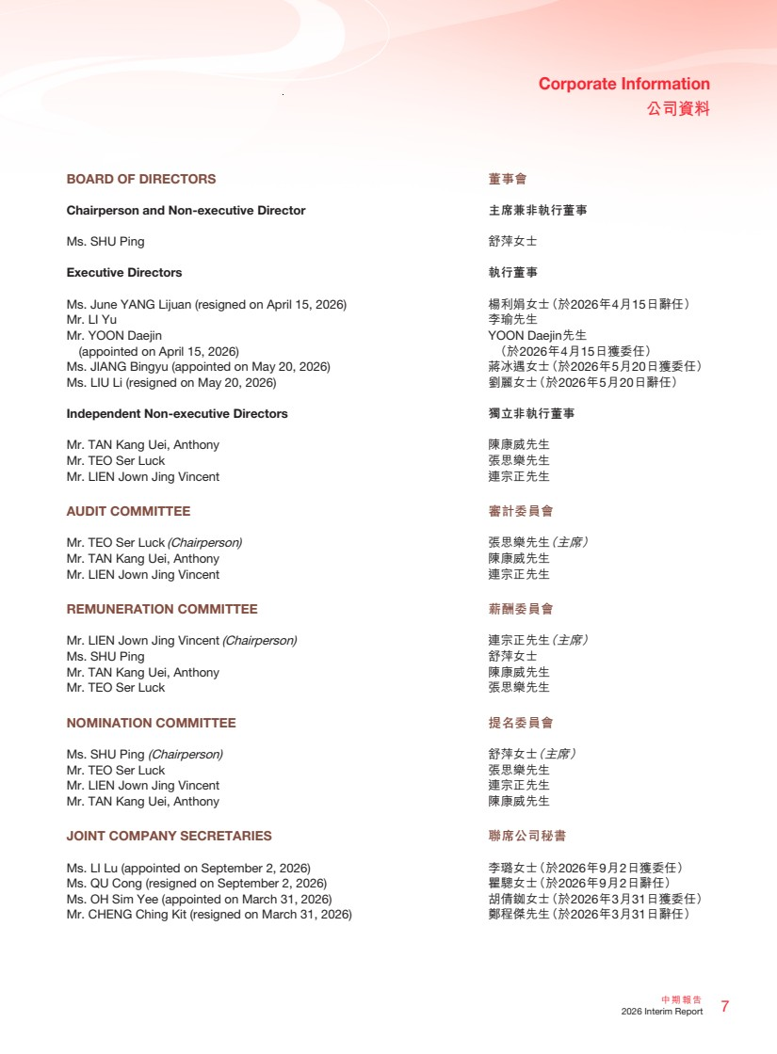 | 7 中期報告 2026 Interim Report Corporate Information 公司資料 BOARD OF DIRECTORS Chairperson and Non-executive Director Ms. SHU Ping Executive Directors Ms. June YANG Lijuan (resigned on April 15, 2026) Mr. LI Yu Mr. YOON Daejin (appointed on April 15, 2026) Ms. JIANG Bingyu (appointed on May 20, 2026) Ms. LIU Li (resigned on May 20, 2026) Independent Non-executive Directors Mr. TAN Kang Uei, Anthony Mr. TEO Ser Luck Mr. LIEN Jown Jing Vincent AUDIT COMMITTEE Mr. TEO Ser Luck (Chairperson) Mr. TAN Kang Uei, Anthony Mr. LIEN Jown Jing Vincent REMUNERATION COMMITTEE Mr. LIEN Jown Jing Vincent (Chairperson) Ms. SHU Ping Mr. TAN Kang Uei, Anthony Mr. TEO Ser Luck NOMINATION COMMITTEE Ms. SHU Ping (Chairperson) Mr. TEO Ser Luck Mr. LIEN Jown Jing Vincent Mr. TAN Kang Uei, Anthony JOINT COMPANY SECRETARIES Ms. LI Lu (appointed on September 2, 2026) Ms. QU Cong (resigned on September 2, 2026) Ms. OH Sim Yee (appointed on March 31, 2026) Mr. CHENG Ching Kit (resigned on March 31, 2026) 董事會 主席兼非執行董事 舒萍女士 執行董事 楊利娟女士（於2026年4月15日辭任） 李瑜先生 YOON Daejin先生 （於2026年4月15日獲委任） 蔣冰遇女士（於2026年5月20日獲委任） 劉麗女士（於2026年5月20日辭任） 獨立非執行董事 陳康威先生 張思樂先生 連宗正先生 審計委員會 張思樂先生（主席） 陳康威先生 連宗正先生 薪酬委員會 連宗正先生（主席） 舒萍女士 陳康威先生 張思樂先生 提名委員會 舒萍女士（主席） 張思樂先生 連宗正先生 陳康威先生 聯席公司秘書 李璐女士（於2026年9月2日獲委任） 瞿驄女士（於2026年9月2日辭任） 胡倩銣女士（於2026年3月31日獲委任） 鄭程傑先生（於2026年3月31日辭任）
 | 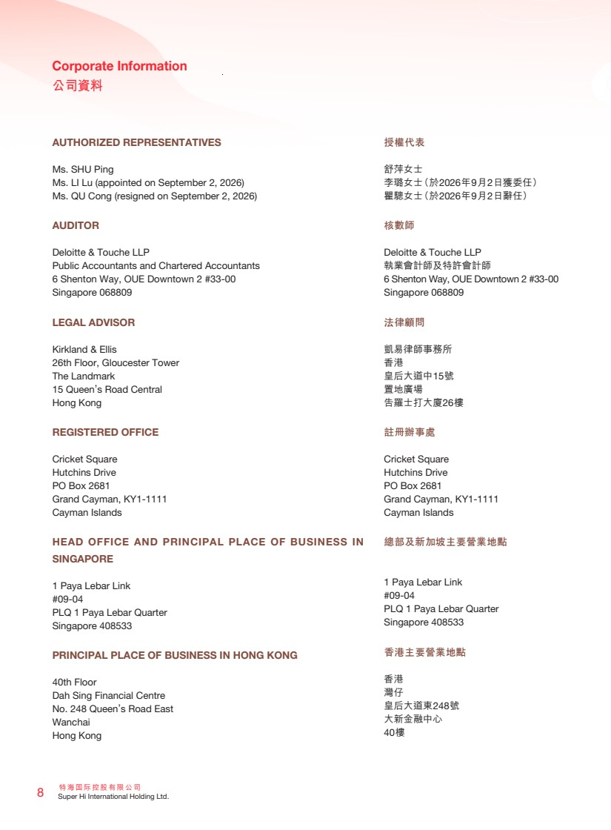 | 特海國際控股有限公司 8 Super Hi International Holding Ltd. Corporate Information 公司資料 AUTHORIZED REPRESENTATIVES Ms. SHU Ping Ms. LI Lu (appointed on September 2, 2026) Ms. QU Cong (resigned on September 2, 2026) AUDITOR Deloitte & Touche LLP Public Accountants and Chartered Accountants 6 Shenton Way, OUE Downtown 2 #33-00 Singapore 068809 LEGAL ADVISOR Kirkland & Ellis 26th Floor, Gloucester Tower The Landmark 15 Queen’s Road Central Hong Kong REGISTERED OFFICE Cricket Square Hutchins Drive PO Box 2681 Grand Cayman, KY1-1111 Cayman Islands HEAD OFFICE AND PRINCIPAL PLACE OF BUSINESS IN SINGAPORE 1 Paya Lebar Link #09-04 PLQ 1 Paya Lebar Quarter Singapore 408533 PRINCIPAL PLACE OF BUSINESS IN HONG KONG 40th Floor Dah Sing Financial Centre No. 248 Queen’s Road East Wanchai Hong Kong 授權代表 舒萍女士 李璐女士（於2026年9月2日獲委任） 瞿驄女士（於2026年9月2日辭任） 核數師 Deloitte & Touche LLP 執業會計師及特許會計師 6 Shenton Way, OUE Downtown 2 #33-00 Singapore 068809 法律顧問 凱易律師事務所 香港 皇后大道中15號 置地廣場 告羅士打大廈26樓 註冊辦事處 Cricket Square Hutchins Drive PO Box 2681 Grand Cayman, KY1-1111 Cayman Islands 總部及新加坡主要營業地點 1 Paya Lebar Link #09-04 PLQ 1 Paya Lebar Quarter Singapore 408533 香港主要營業地點 香港 灣仔 皇后大道東248號 大新金融中心 40樓
 | 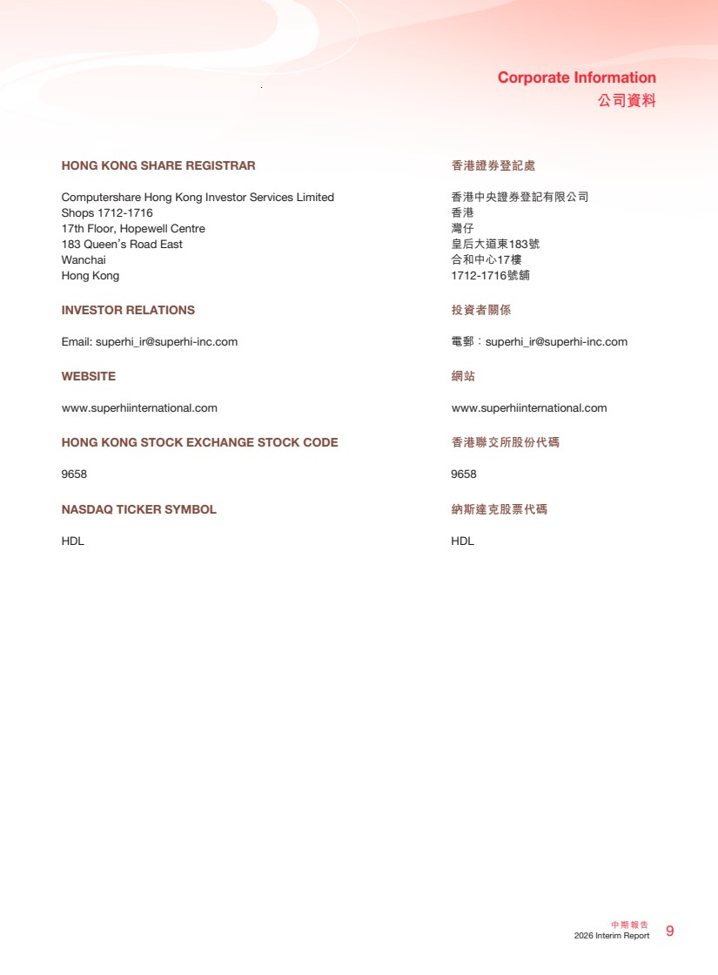 | 9 中期報告 2026 Interim Report Corporate Information 公司資料 香港證券登記處 香港中央證券登記有限公司 香港 灣仔 皇后大道東183號 合和中心17樓 1712-1716號舖 投資者關係 電郵：superhi_ir@superhi-inc.com 網站 www.superhiinternational.com 香港聯交所股份代碼 9658 納斯達克股票代碼 HDL HONG KONG SHARE REGISTRAR Computershare Hong Kong Investor Services Limited Shops 1712-1716 17th Floor, Hopewell Centre 183 Queen’s Road East Wanchai Hong Kong INVESTOR RELATIONS Email: superhi_ir@superhi-inc.com WEBSITE www.superhiinternational.com HONG KONG STOCK EXCHANGE STOCK CODE 9658 NASDAQ TICKER SYMBOL HDL
 | 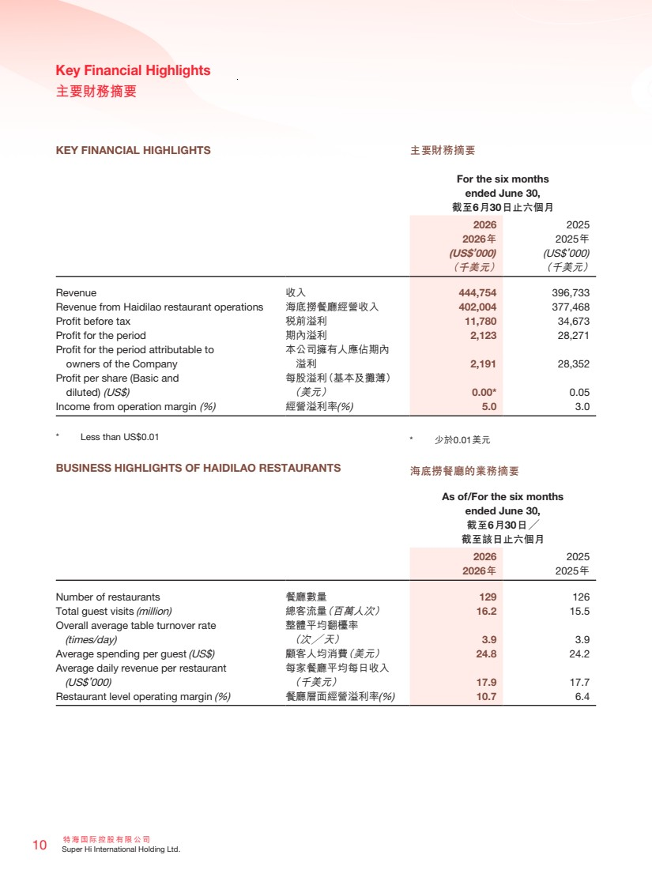 | 特海國際控股有限公司 10 Super Hi International Holding Ltd. Key Financial Highlights 主要財務摘要 * 少於0.01美元 海底撈餐廳的業務摘要 KEY FINANCIAL HIGHLIGHTS For the six months ended June 30, 截至6月30日止六個月 2026 2025 2026年 2025年 (US$’000) (US$’000) （千美元） （千美元） Revenue 收入 444,754 396,733 Revenue from Haidilao restaurant operations 海底撈餐廳經營收入 402,004 377,468 Profit before tax 稅前溢利 11,780 34,673 Profit for the period 期內溢利 2,123 28,271 Profit for the period attributable to owners of the Company 本公司擁有人應佔期內 溢利 2,191 28,352 Profit per share (Basic and diluted) (US$) 每股溢利（基本及攤薄） （美元） 0.00* 0.05 Income from operation margin (%) 經營溢利率(%) 5.0 3.0 * Less than US$0.01 BUSINESS HIGHLIGHTS OF HAIDILAO RESTAURANTS As of/For the six months ended June 30, 截至6月30日╱ 截至該日止六個月 2026 2025 2026年 2025年 Number of restaurants 餐廳數量 129 126 Total guest visits (million) 總客流量（百萬人次） 16.2 15.5 Overall average table turnover rate (times/day) 整體平均翻檯率 （次╱天） 3.9 3.9 Average spending per guest (US$) 顧客人均消費（美元） 24.8 24.2 Average daily revenue per restaurant (US$’000) 每家餐廳平均每日收入 （千美元） 17.9 17.7 Restaurant level operating margin (%) 餐廳層面經營溢利率(%) 10.7 6.4 主要財務摘要
 | 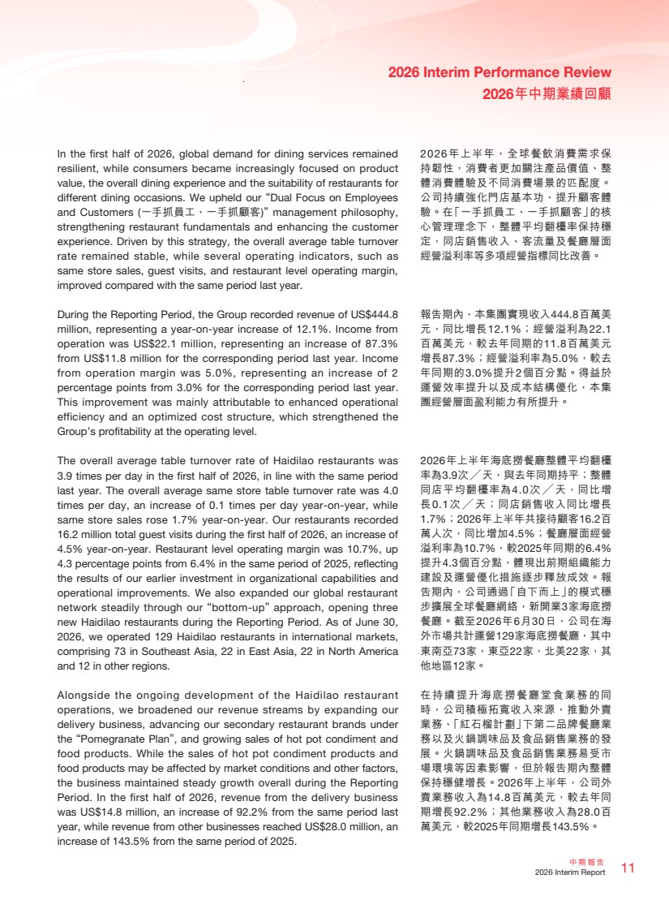 | 11 中期報告 2026 Interim Report 2026 Interim Performance Review 2026年中期業績回顧 In the first half of 2026, global demand for dining services remained resilient, while consumers became increasingly focused on product value, the overall dining experience and the suitability of restaurants for different dining occasions. We upheld our “Dual Focus on Employees and Customers (一手抓員工、一手抓顧客)” management philosophy, strengthening restaurant fundamentals and enhancing the customer experience. Driven by this strategy, the overall average table turnover rate remained stable, while several operating indicators, such as same store sales, guest visits, and restaurant level operating margin, improved compared with the same period last year. During the Reporting Period, the Group recorded revenue of US$444.8 million, representing a year-on-year increase of 12.1%. Income from operation was US$22.1 million, representing an increase of 87.3% from US$11.8 million for the corresponding period last year. Income from operation margin was 5.0%, representing an increase of 2 percentage points from 3.0% for the corresponding period last year. This improvement was mainly attributable to enhanced operational efficiency and an optimized cost structure, which strengthened the Group’s profitability at the operating level. The overall average table turnover rate of Haidilao restaurants was 3.9 times per day in the first half of 2026, in line with the same period last year. The overall average same store table turnover rate was 4.0 times per day, an increase of 0.1 times per day year-on-year, while same store sales rose 1.7% year-on-year. Our restaurants recorded 16.2 million total guest visits during the first half of 2026, an increase of 4.5% year-on-year. Restaurant level operating margin was 10.7%, up 4.3 percentage points from 6.4% in the same period of 2025, reflecting the results of our earlier investment in organizational capabilities and operational improvements. We also expanded our global restaurant network steadily through our “bottom-up” approach, opening three new Haidilao restaurants during the Reporting Period. As of June 30, 2026, we operated 129 Haidilao restaurants in international markets, comprising 73 in Southeast Asia, 22 in East Asia, 22 in North America and 12 in other regions. Alongside the ongoing development of the Haidilao restaurant operations, we broadened our revenue streams by expanding our delivery business, advancing our secondary restaurant brands under the “Pomegranate Plan”, and growing sales of hot pot condiment and food products. While the sales of hot pot condiment products and food products may be affected by market conditions and other factors, the business maintained steady growth overall during the Reporting Period. In the first half of 2026, revenue from the delivery business was US$14.8 million, an increase of 92.2% from the same period last year, while revenue from other businesses reached US$28.0 million, an increase of 143.5% from the same period of 2025. 2026年上半年，全球餐飲消費需求保 持韌性，消費者更加關注產品價值、整 體消費體驗及不同消費場景的匹配度。 公司持續強化門店基本功、提升顧客體 驗。在「一手抓員工、一手抓顧客」的核 心管理理念下，整體平均翻檯率保持穩 定，同店銷售收入、客流量及餐廳層面 經營溢利率等多項經營指標同比改善。 報告期內，本集團實現收入444.8百萬美 元，同比增長12.1%；經營溢利為22.1 百萬美元，較去年同期的11.8百萬美元 增長87.3%；經營溢利率為5.0%，較去 年同期的3.0%提升2個百分點。得益於 運營效率提升以及成本結構優化，本集 團經營層面盈利能力有所提升。 2026年上半年海底撈餐廳整體平均翻檯 率為3.9次╱天，與去年同期持平；整體 同店平均翻檯率為4.0次╱天，同比增 長0.1次╱天；同店銷售收入同比增長 1.7%；2026年上半年共接待顧客16.2百 萬人次，同比增加4.5%；餐廳層面經營 溢利率為10.7%，較2025年同期的6.4% 提升4.3個百分點，體現出前期組織能力 建設及運營優化措施逐步釋放成效。報 告期內，公司通過「自下而上」的模式穩 步擴展全球餐廳網絡，新開業3家海底撈 餐廳。截至2026年6月30日，公司在海 外市場共計運營129家海底撈餐廳，其中 東南亞73家，東亞22家，北美22家，其 他地區12家。 在持續提升海底撈餐廳堂食業務的同 時，公司積極拓寬收入來源，推動外賣 業務、「紅石榴計劃」下第二品牌餐廳業 務以及火鍋調味品及食品銷售業務的發 展。火鍋調味品及食品銷售業務易受市 場環境等因素影響，但於報告期內整體 保持穩健增長。2026年上半年，公司外 賣業務收入為14.8百萬美元，較去年同 期增長92.2%；其他業務收入為28.0百 萬美元，較2025年同期增長143.5%。
 | 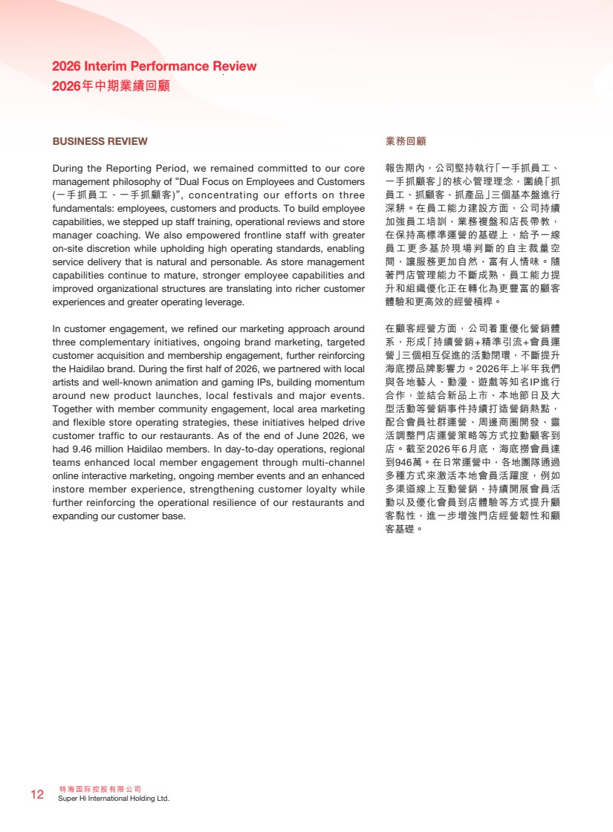 | 特海國際控股有限公司 12 Super Hi International Holding Ltd. 2026 Interim Performance Review 2026年中期業績回顧 業務回顧 報告期內，公司堅持執行「一手抓員工、 一手抓顧客」的核心管理理念，圍繞「抓 員工、抓顧客、抓產品」三個基本盤進行 深耕。在員工能力建設方面，公司持續 加強員工培訓、業務複盤和店長帶教， 在保持高標準運營的基礎上，給予一線 員工更多基於現場判斷的自主裁量空 間，讓服務更加自然、富有人情味。隨 著門店管理能力不斷成熟，員工能力提 升和組織優化正在轉化為更豐富的顧客 體驗和更高效的經營槓桿。 在顧客經營方面，公司着重優化營銷體 系，形成「持續營銷+精準引流+會員運 營」三個相互促進的活動閉環，不斷提升 海底撈品牌影響力。2026年上半年我們 與各地藝人、動漫、遊戲等知名IP進行 合作，並結合新品上市、本地節日及大 型活動等營銷事件持續打造營銷熱點， 配合會員社群運營、周邊商圈開發、靈 活調整門店運營策略等方式拉動顧客到 店。截至2026年6月底，海底撈會員達 到946萬。在日常運營中，各地團隊通過 多種方式來激活本地會員活躍度，例如 多渠道線上互動營銷、持續開展會員活 動以及優化會員到店體驗等方式提升顧 客黏性，進一步增強門店經營韌性和顧 客基礎。 BUSINESS REVIEW During the Reporting Period, we remained committed to our core management philosophy of “Dual Focus on Employees and Customers (一手抓員工、一手抓顧客)”, concentrating our efforts on three fundamentals: employees, customers and products. To build employee capabilities, we stepped up staff training, operational reviews and store manager coaching. We also empowered frontline staff with greater on-site discretion while upholding high operating standards, enabling service delivery that is natural and personable. As store management capabilities continue to mature, stronger employee capabilities and improved organizational structures are translating into richer customer experiences and greater operating leverage. In customer engagement, we refined our marketing approach around three complementary initiatives, ongoing brand marketing, targeted customer acquisition and membership engagement, further reinforcing the Haidilao brand. During the first half of 2026, we partnered with local artists and well-known animation and gaming IPs, building momentum around new product launches, local festivals and major events. Together with member community engagement, local area marketing and flexible store operating strategies, these initiatives helped drive customer traffic to our restaurants. As of the end of June 2026, we had 9.46 million Haidilao members. In day-to-day operations, regional teams enhanced local member engagement through multi-channel online interactive marketing, ongoing member events and an enhanced instore member experience, strengthening customer loyalty while further reinforcing the operational resilience of our restaurants and expanding our customer base.
 | 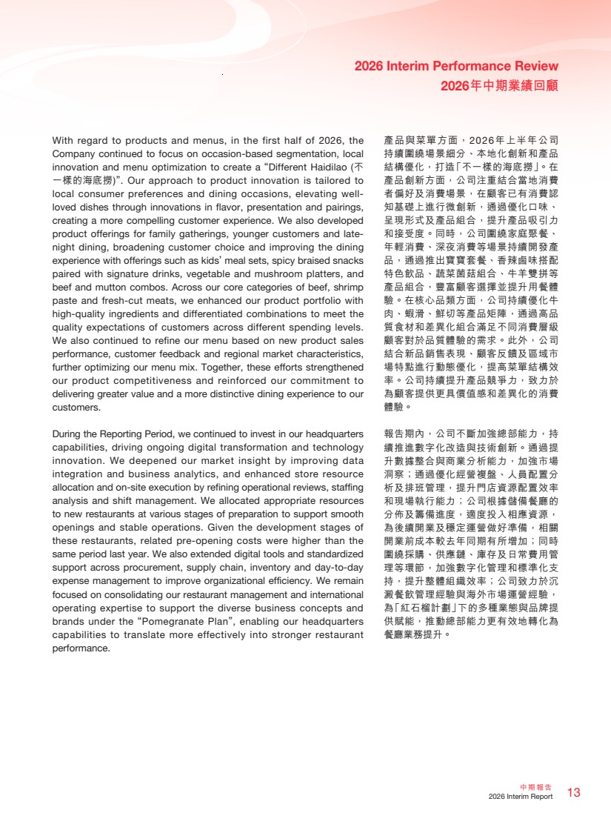 | 13 中期報告 2026 Interim Report 2026 Interim Performance Review 2026年中期業績回顧 產品與菜單方面，2026年上半年公司 持續圍繞場景細分、本地化創新和產品 結構優化，打造「不一樣的海底撈」。在 產品創新方面，公司注重結合當地消費 者偏好及消費場景，在顧客已有消費認 知基礎上進行微創新，通過優化口味、 呈現形式及產品組合，提升產品吸引力 和接受度。同時，公司圍繞家庭聚餐、 年輕消費、深夜消費等場景持續開發產 品，通過推出寶寶套餐、香辣鹵味搭配 特色飲品、蔬菜菌菇組合、牛羊雙拼等 產品組合，豐富顧客選擇並提升用餐體 驗。在核心品類方面，公司持續優化牛 肉、蝦滑、鮮切等產品矩陣，通過高品 質食材和差異化組合滿足不同消費層級 顧客對於品質體驗的需求。此外，公司 結合新品銷售表現、顧客反饋及區域市 場特點進行動態優化，提高菜單結構效 率。公司持續提升產品競爭力，致力於 為顧客提供更具價值感和差異化的消費 體驗。 報告期內，公司不斷加強總部能力，持 續推進數字化改造與技術創新。通過提 升數據整合與商業分析能力，加強市場 洞察；通過優化經營複盤、人員配置分 析及排班管理，提升門店資源配置效率 和現場執行能力；公司根據儲備餐廳的 分佈及籌備進度，適度投入相應資源， 為後續開業及穩定運營做好準備，相關 開業前成本較去年同期有所增加；同時 圍繞採購、供應鏈、庫存及日常費用管 理等環節，加強數字化管理和標準化支 持，提升整體組織效率；公司致力於沉 澱餐飲管理經驗與海外市場運營經驗， 為「紅石榴計劃」下的多種業態與品牌提 供賦能，推動總部能力更有效地轉化為 餐廳業務提升。 With regard to products and menus, in the first half of 2026, the Company continued to focus on occasion-based segmentation, local innovation and menu optimization to create a “Different Haidilao (不 一樣的海底撈)”. Our approach to product innovation is tailored to local consumer preferences and dining occasions, elevating well-loved dishes through innovations in flavor, presentation and pairings, creating a more compelling customer experience. We also developed product offerings for family gatherings, younger customers and late-night dining, broadening customer choice and improving the dining experience with offerings such as kids’ meal sets, spicy braised snacks paired with signature drinks, vegetable and mushroom platters, and beef and mutton combos. Across our core categories of beef, shrimp paste and fresh-cut meats, we enhanced our product portfolio with high-quality ingredients and differentiated combinations to meet the quality expectations of customers across different spending levels. We also continued to refine our menu based on new product sales performance, customer feedback and regional market characteristics, further optimizing our menu mix. Together, these efforts strengthened our product competitiveness and reinforced our commitment to delivering greater value and a more distinctive dining experience to our customers. During the Reporting Period, we continued to invest in our headquarters capabilities, driving ongoing digital transformation and technology innovation. We deepened our market insight by improving data integration and business analytics, and enhanced store resource allocation and on-site execution by refining operational reviews, staffing analysis and shift management. We allocated appropriate resources to new restaurants at various stages of preparation to support smooth openings and stable operations. Given the development stages of these restaurants, related pre-opening costs were higher than the same period last year. We also extended digital tools and standardized support across procurement, supply chain, inventory and day-to-day expense management to improve organizational efficiency. We remain focused on consolidating our restaurant management and international operating expertise to support the diverse business concepts and brands under the “Pomegranate Plan”, enabling our headquarters capabilities to translate more effectively into stronger restaurant performance.
 | 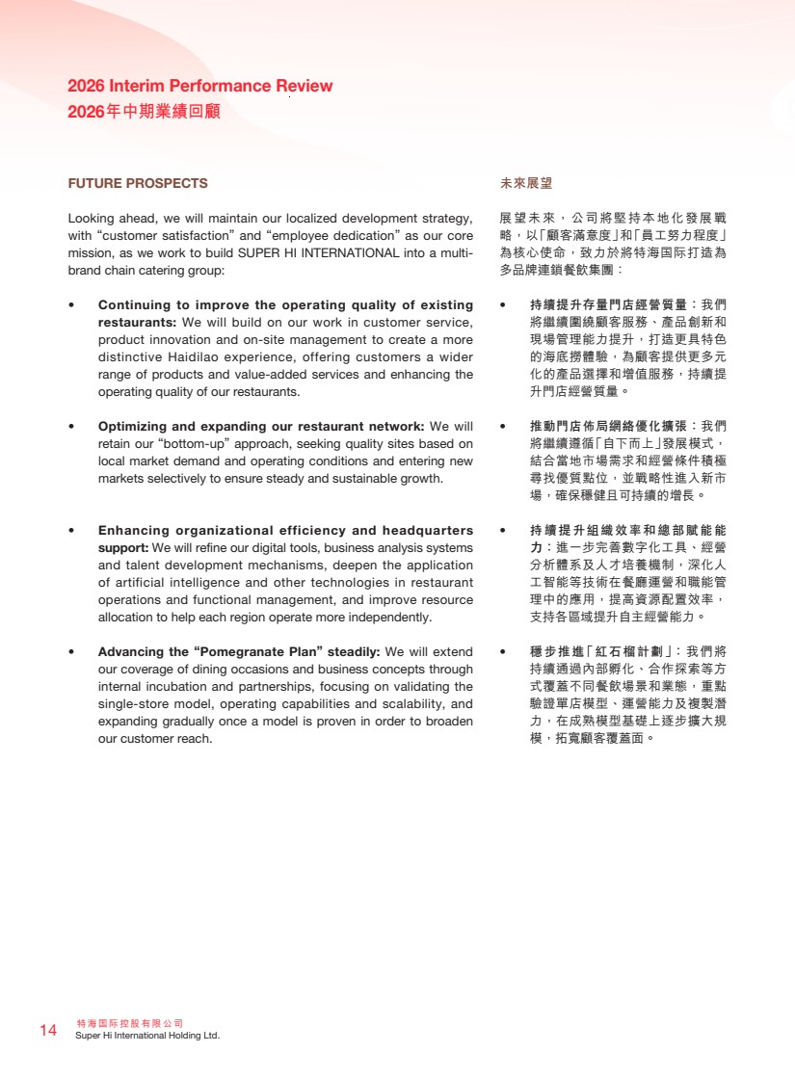 | 特海國際控股有限公司 14 Super Hi International Holding Ltd. 2026 Interim Performance Review 2026年中期業績回顧 未來展望 展望未來，公司將堅持本地化發展戰 略，以「顧客滿意度」和「員工努力程度」 為核心使命，致力於將特海国際打造為 多品牌連鎖餐飲集團： • 持續提升存量門店經營質量：我們 將繼續圍繞顧客服務、產品創新和 現場管理能力提升，打造更具特色 的海底撈體驗，為顧客提供更多元 化的產品選擇和增值服務，持續提 升門店經營質量。 • 推動門店佈局網絡優化擴張：我們 將繼續遵循「自下而上」發展模式， 結合當地市場需求和經營條件積極 尋找優質點位，並戰略性進入新市 場，確保穩健且可持續的增長。 • 持續提升組織效率和總部賦能能 力：進一步完善數字化工具、經營 分析體系及人才培養機制，深化人 工智能等技術在餐廳運營和職能管 理中的應用，提高資源配置效率， 支持各區域提升自主經營能力。 • 穩步推進「紅石榴計劃」：我們將 持續通過內部孵化、合作探索等方 式覆蓋不同餐飲場景和業態，重點 驗證單店模型、運營能力及複製潛 力，在成熟模型基礎上逐步擴大規 模，拓寬顧客覆蓋面。 FUTURE PROSPECTS Looking ahead, we will maintain our localized development strategy, with “customer satisfaction” and “employee dedication” as our core mission, as we work to build SUPER HI INTERNATIONAL into a multi-brand chain catering group: • Continuing to improve the operating quality of existing restaurants: We will build on our work in customer service, product innovation and on-site management to create a more distinctive Haidilao experience, offering customers a wider range of products and value-added services and enhancing the operating quality of our restaurants. • Optimizing and expanding our restaurant network: We will retain our “bottom-up” approach, seeking quality sites based on local market demand and operating conditions and entering new markets selectively to ensure steady and sustainable growth. • Enhancing organizational efficiency and headquarters support: We will refine our digital tools, business analysis systems and talent development mechanisms, deepen the application of artificial intelligence and other technologies in restaurant operations and functional management, and improve resource allocation to help each region operate more independently. • Advancing the “Pomegranate Plan” steadily: We will extend our coverage of dining occasions and business concepts through internal incubation and partnerships, focusing on validating the single-store model, operating capabilities and scalability, and expanding gradually once a model is proven in order to broaden our customer reach.
 | 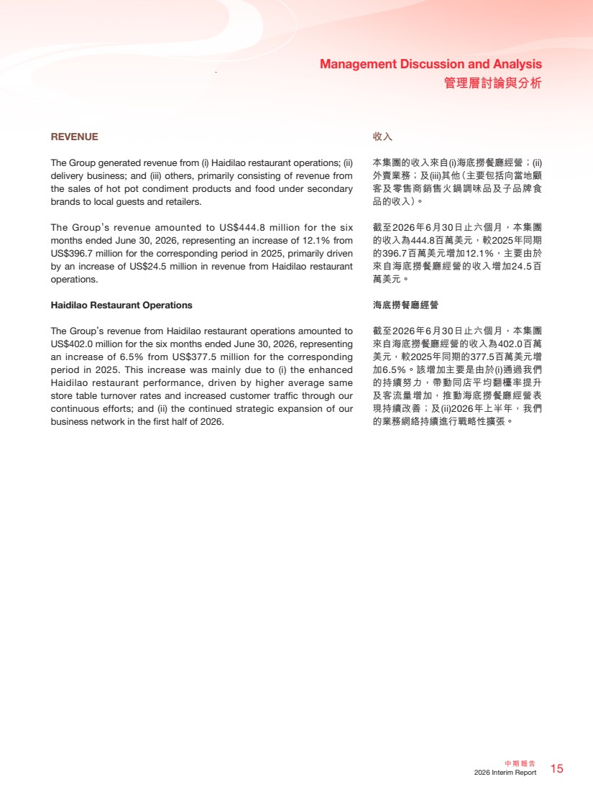 | 15 中期報告 2026 Interim Report Management Discussion and Analysis 管理層討論與分析 REVENUE The Group generated revenue from (i) Haidilao restaurant operations; (ii) delivery business; and (iii) others, primarily consisting of revenue from the sales of hot pot condiment products and food under secondary brands to local guests and retailers. The Group’s revenue amounted to US$444.8 million for the six months ended June 30, 2026, representing an increase of 12.1% from US$396.7 million for the corresponding period in 2025, primarily driven by an increase of US$24.5 million in revenue from Haidilao restaurant operations. Haidilao Restaurant Operations The Group’s revenue from Haidilao restaurant operations amounted to US$402.0 million for the six months ended June 30, 2026, representing an increase of 6.5% from US$377.5 million for the corresponding period in 2025. This increase was mainly due to (i) the enhanced Haidilao restaurant performance, driven by higher average same store table turnover rates and increased customer traffic through our continuous efforts; and (ii) the continued strategic expansion of our business network in the first half of 2026. 收入 本集團的收入來自(i)海底撈餐廳經營；(ii) 外賣業務；及(iii)其他（主要包括向當地顧 客及零售商銷售火鍋調味品及子品牌食 品的收入）。 截至2026年6月30日止六個月，本集團 的收入為444.8百萬美元，較2025年同期 的396.7百萬美元增加12.1%，主要由於 來自海底撈餐廳經營的收入增加24.5百 萬美元。 海底撈餐廳經營 截至2026年6月30日止六個月，本集團 來自海底撈餐廳經營的收入為402.0百萬 美元，較2025年同期的377.5百萬美元增 加6.5%。該增加主要是由於(i)通過我們 的持續努力，帶動同店平均翻檯率提升 及客流量增加，推動海底撈餐廳經營表 現持續改善；及(ii)2026年上半年，我們 的業務網絡持續進行戰略性擴張。
 | 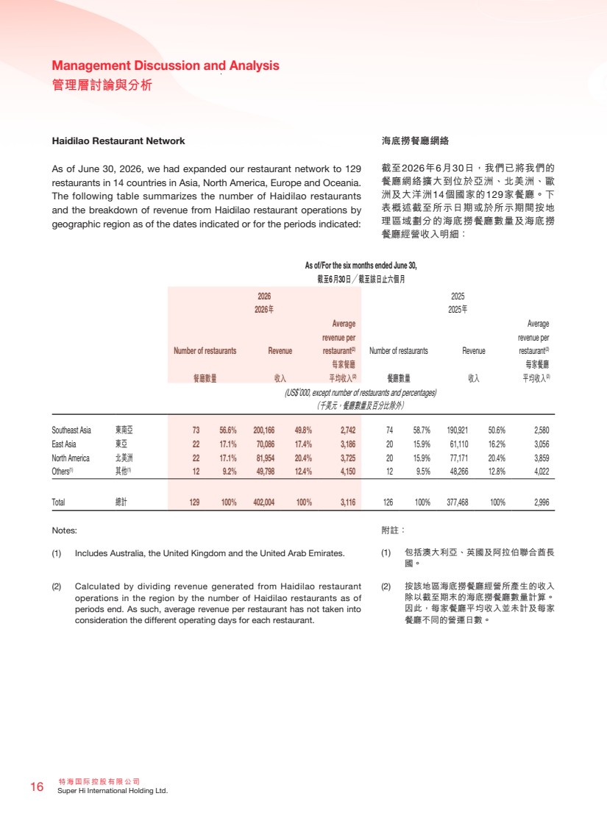 | 特海國際控股有限公司 16 Super Hi International Holding Ltd. Management Discussion and Analysis 管理層討論與分析 Haidilao Restaurant Network As of June 30, 2026, we had expanded our restaurant network to 129 restaurants in 14 countries in Asia, North America, Europe and Oceania. The following table summarizes the number of Haidilao restaurants and the breakdown of revenue from Haidilao restaurant operations by geographic region as of the dates indicated or for the periods indicated: As of/For the six months ended June 30, 截至6月30日╱截至該日止六個月 2026 2025 2026年 2025年 Number of restaurants Revenue Average revenue per restaurant(2) Number of restaurants Revenue Average revenue per restaurant(2) 餐廳數量 收入 每家餐廳 平均收入(2) 餐廳數量 收入 每家餐廳 平均收入(2) (US$’000, except number of restaurants and percentages) （千美元，餐廳數量及百分比除外） Southeast Asia 東南亞 73 56.6% 200,166 49.8% 2,742 74 58.7% 190,921 50.6% 2,580 East Asia 東亞 22 17.1% 70,086 17.4% 3,186 20 15.9% 61,110 16.2% 3,056 North America 北美洲 22 17.1% 81,954 20.4% 3,725 20 15.9% 77,171 20.4% 3,859 Others(1) 其他(1) 12 9.2% 49,798 12.4% 4,150 12 9.5% 48,266 12.8% 4,022 Total 總計 129 100% 402,004 100% 3,116 126 100% 377,468 100% 2,996 Notes: (1) Includes Australia, the United Kingdom and the United Arab Emirates. (2) Calculated by dividing revenue generated from Haidilao restaurant operations in the region by the number of Haidilao restaurants as of periods end. As such, average revenue per restaurant has not taken into consideration the different operating days for each restaurant. 海底撈餐廳網絡 截至2026年6月30日，我們已將我們的 餐廳網絡擴大到位於亞洲、北美洲、歐 洲及大洋洲14個國家的129家餐廳。下 表概述截至所示日期或於所示期間按地 理區域劃分的海底撈餐廳數量及海底撈 餐廳經營收入明細： 附註： (1) 包括澳大利亞、英國及阿拉伯聯合酋長 國。 (2) 按該地區海底撈餐廳經營所產生的收入 除以截至期末的海底撈餐廳數量計算。 因此，每家餐廳平均收入並未計及每家 餐廳不同的營運日數。
 | 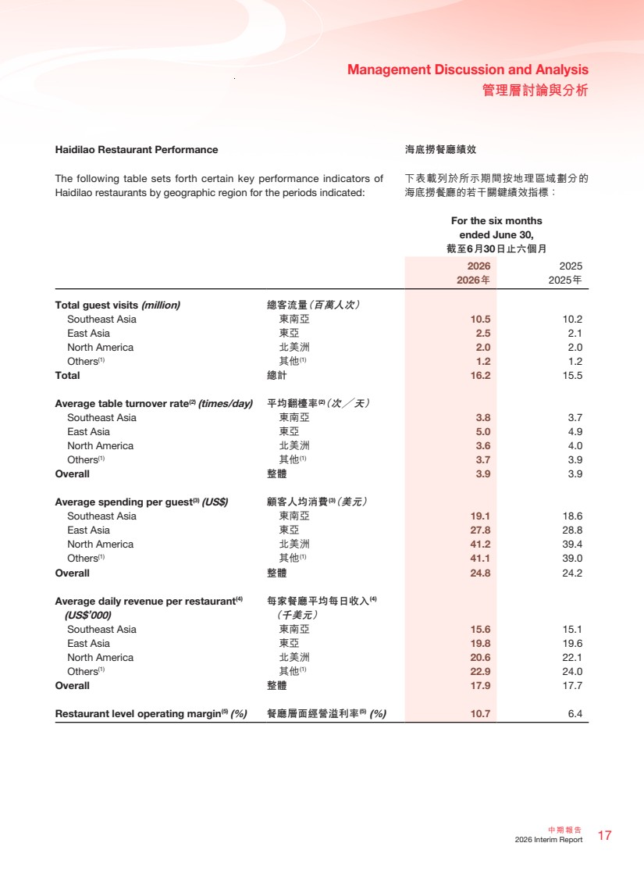 | 17 中期報告 2026 Interim Report Management Discussion and Analysis 管理層討論與分析 海底撈餐廳績效 下表載列於所示期間按地理區域劃分的 海底撈餐廳的若干關鍵績效指標： Haidilao Restaurant Performance The following table sets forth certain key performance indicators of Haidilao restaurants by geographic region for the periods indicated: For the six months ended June 30, 截至6月30日止六個月 2026 2025 2026年 2025年 Total guest visits (million) 總客流量（百萬人次） Southeast Asia 東南亞 10.5 10.2 East Asia 東亞 2.5 2.1 North America 北美洲 2.0 2.0 Others(1) 其他(1) 1.2 1.2 Total 總計 16.2 15.5 Average table turnover rate(2) (times/day) 平均翻檯率(2)（次╱天） Southeast Asia 東南亞 3.8 3.7 East Asia 東亞 5.0 4.9 North America 北美洲 3.6 4.0 Others(1) 其他(1) 3.7 3.9 Overall 整體 3.9 3.9 Average spending per guest(3) (US$) 顧客人均消費(3)（美元） Southeast Asia 東南亞 19.1 18.6 East Asia 東亞 27.8 28.8 North America 北美洲 41.2 39.4 Others(1) 其他(1) 41.1 39.0 Overall 整體 24.8 24.2 Average daily revenue per restaurant(4) (US$’000) 每家餐廳平均每日收入(4) （千美元） Southeast Asia 東南亞 15.6 15.1 East Asia 東亞 19.8 19.6 North America 北美洲 20.6 22.1 Others(1) 其他(1) 22.9 24.0 Overall 整體 17.9 17.7 Restaurant level operating margin(5) (%) 餐廳層面經營溢利率(5) (%) 10.7 6.4
 | 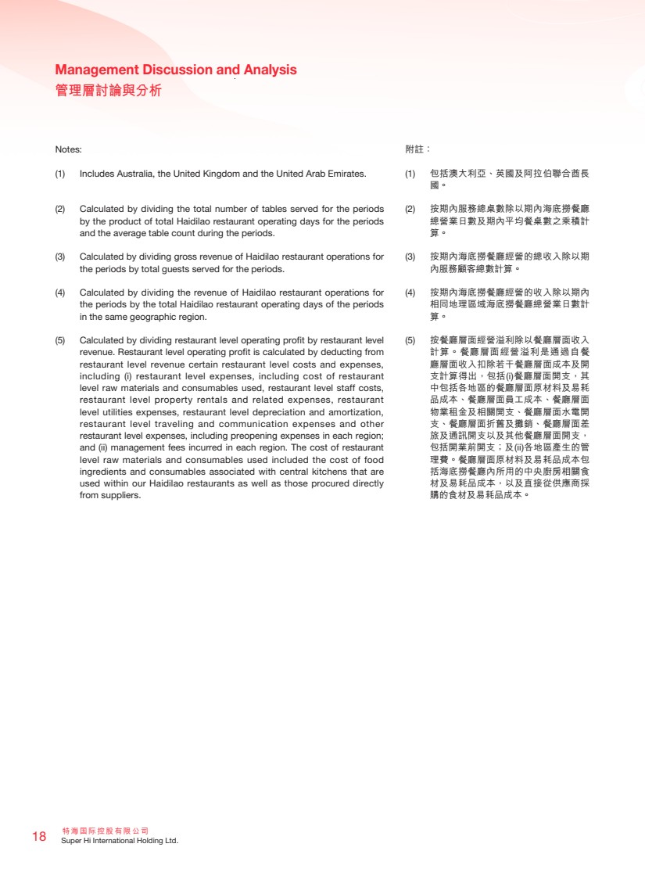 | 特海國際控股有限公司 18 Super Hi International Holding Ltd. Management Discussion and Analysis 管理層討論與分析 Notes: (1) Includes Australia, the United Kingdom and the United Arab Emirates. (2) Calculated by dividing the total number of tables served for the periods by the product of total Haidilao restaurant operating days for the periods and the average table count during the periods. (3) Calculated by dividing gross revenue of Haidilao restaurant operations for the periods by total guests served for the periods. (4) Calculated by dividing the revenue of Haidilao restaurant operations for the periods by the total Haidilao restaurant operating days of the periods in the same geographic region. (5) Calculated by dividing restaurant level operating profit by restaurant level revenue. Restaurant level operating profit is calculated by deducting from restaurant level revenue certain restaurant level costs and expenses, including (i) restaurant level expenses, including cost of restaurant level raw materials and consumables used, restaurant level staff costs, restaurant level property rentals and related expenses, restaurant level utilities expenses, restaurant level depreciation and amortization, restaurant level traveling and communication expenses and other restaurant level expenses, including preopening expenses in each region; and (ii) management fees incurred in each region. The cost of restaurant level raw materials and consumables used included the cost of food ingredients and consumables associated with central kitchens that are used within our Haidilao restaurants as well as those procured directly from suppliers. 附註： (1) 包括澳大利亞、英國及阿拉伯聯合酋長 國。 (2) 按期內服務總桌數除以期內海底撈餐廳 總營業日數及期內平均餐桌數之乘積計 算。 (3) 按期內海底撈餐廳經營的總收入除以期 內服務顧客總數計算。 (4) 按期內海底撈餐廳經營的收入除以期內 相同地理區域海底撈餐廳總營業日數計 算。 (5) 按餐廳層面經營溢利除以餐廳層面收入 計算。餐廳層面經營溢利是通過自餐 廳層面收入扣除若干餐廳層面成本及開 支計算得出，包括(i)餐廳層面開支，其 中包括各地區的餐廳層面原材料及易耗 品成本、餐廳層面員工成本、餐廳層面 物業租金及相關開支、餐廳層面水電開 支、餐廳層面折舊及攤銷、餐廳層面差 旅及通訊開支以及其他餐廳層面開支， 包括開業前開支；及(ii)各地區產生的管 理費。餐廳層面原材料及易耗品成本包 括海底撈餐廳內所用的中央廚房相關食 材及易耗品成本，以及直接從供應商採 購的食材及易耗品成本。
 | 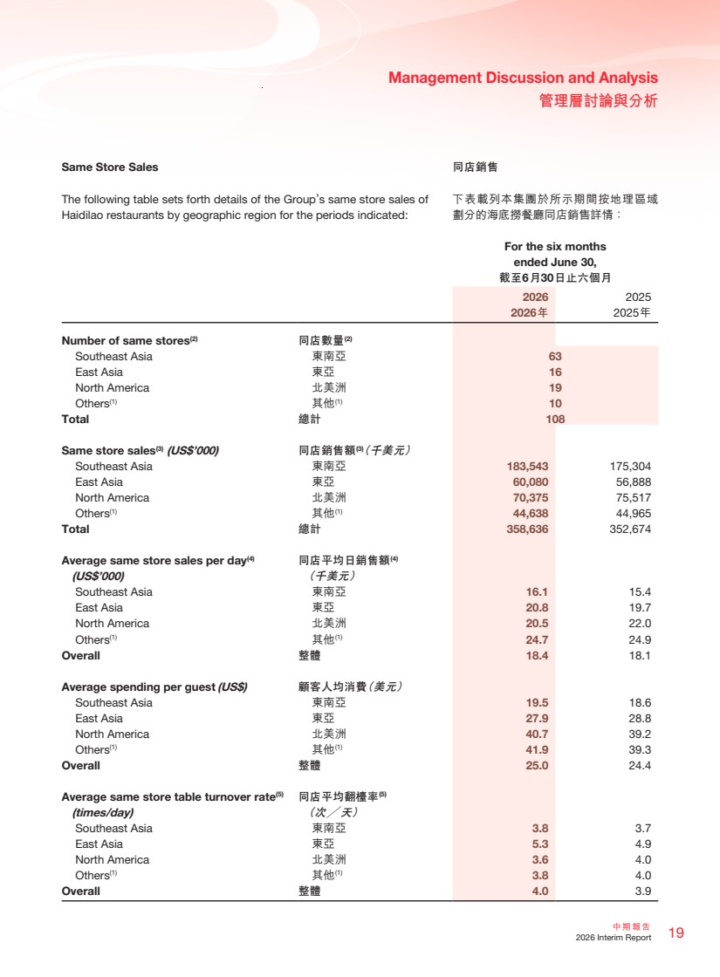 | 19 中期報告 2026 Interim Report Management Discussion and Analysis 管理層討論與分析 同店銷售 下表載列本集團於所示期間按地理區域 劃分的海底撈餐廳同店銷售詳情： Same Store Sales The following table sets forth details of the Group’s same store sales of Haidilao restaurants by geographic region for the periods indicated: For the six months ended June 30, 截至6月30日止六個月 2026 2025 2026年 2025年 Number of same stores(2) 同店數量(2) Southeast Asia 東南亞 63 East Asia 東亞 16 North America 北美洲 19 Others(1) 其他(1) 10 Total 總計 108 Same store sales(3) (US$’000) 同店銷售額(3)（千美元） Southeast Asia 東南亞 183,543 175,304 East Asia 東亞 60,080 56,888 North America 北美洲 70,375 75,517 Others(1) 其他(1) 44,638 44,965 Total 總計 358,636 352,674 Average same store sales per day(4) (US$’000) 同店平均日銷售額(4) （千美元） Southeast Asia 東南亞 16.1 15.4 East Asia 東亞 20.8 19.7 North America 北美洲 20.5 22.0 Others(1) 其他(1) 24.7 24.9 Overall 整體 18.4 18.1 Average spending per guest (US$) 顧客人均消費（美元） Southeast Asia 東南亞 19.5 18.6 East Asia 東亞 27.9 28.8 North America 北美洲 40.7 39.2 Others(1) 其他(1) 41.9 39.3 Overall 整體 25.0 24.4 Average same store table turnover rate(5) (times/day) 同店平均翻檯率(5) （次╱天） Southeast Asia 東南亞 3.8 3.7 East Asia 東亞 5.3 4.9 North America 北美洲 3.6 4.0 Others(1) 其他(1) 3.8 4.0 Overall 整體 4.0 3.9
 | 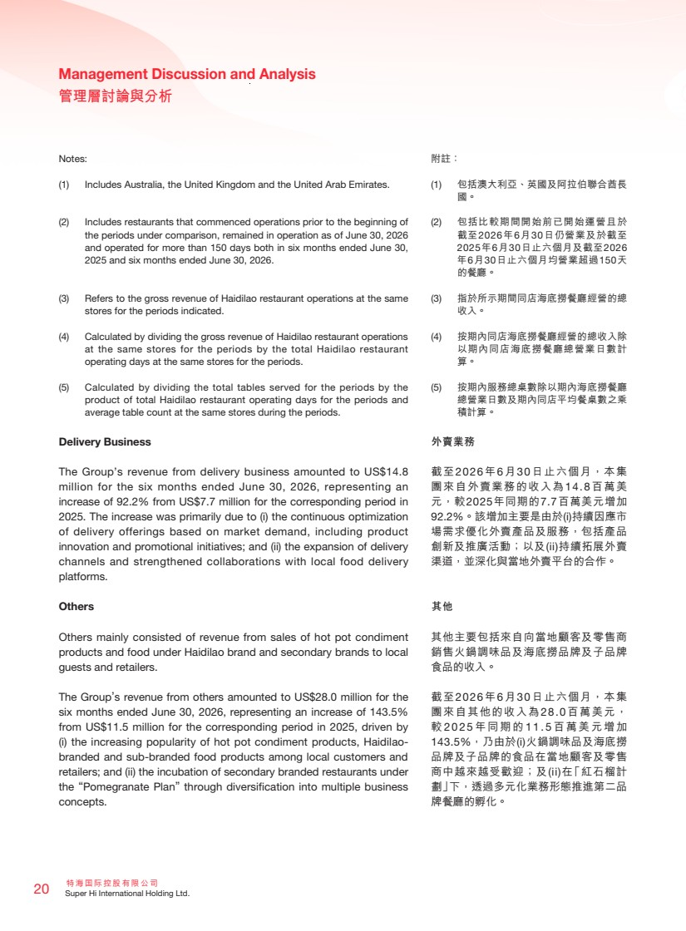 | 特海國際控股有限公司 20 Super Hi International Holding Ltd. Management Discussion and Analysis 管理層討論與分析 Notes: (1) Includes Australia, the United Kingdom and the United Arab Emirates. (2) Includes restaurants that commenced operations prior to the beginning of the periods under comparison, remained in operation as of June 30, 2026 and operated for more than 150 days both in six months ended June 30, 2025 and six months ended June 30, 2026. (3) Refers to the gross revenue of Haidilao restaurant operations at the same stores for the periods indicated. (4) Calculated by dividing the gross revenue of Haidilao restaurant operations at the same stores for the periods by the total Haidilao restaurant operating days at the same stores for the periods. (5) Calculated by dividing the total tables served for the periods by the product of total Haidilao restaurant operating days for the periods and average table count at the same stores during the periods. Delivery Business The Group’s revenue from delivery business amounted to US$14.8 million for the six months ended June 30, 2026, representing an increase of 92.2% from US$7.7 million for the corresponding period in 2025. The increase was primarily due to (i) the continuous optimization of delivery offerings based on market demand, including product innovation and promotional initiatives; and (ii) the expansion of delivery channels and strengthened collaborations with local food delivery platforms. Others Others mainly consisted of revenue from sales of hot pot condiment products and food under Haidilao brand and secondary brands to local guests and retailers. The Group’s revenue from others amounted to US$28.0 million for the six months ended June 30, 2026, representing an increase of 143.5% from US$11.5 million for the corresponding period in 2025, driven by (i) the increasing popularity of hot pot condiment products, Haidilao-branded and sub-branded food products among local customers and retailers; and (ii) the incubation of secondary branded restaurants under the “Pomegranate Plan” through diversification into multiple business concepts. 附註： (1) 包括澳大利亞、英國及阿拉伯聯合酋長 國。 (2) 包括比較期間開始前已開始運營且於 截至2026年6月30日仍營業及於截至 2025年6月30日止六個月及截至2026 年6月30日止六個月均營業超過150天 的餐廳。 (3) 指於所示期間同店海底撈餐廳經營的總 收入。 (4) 按期內同店海底撈餐廳經營的總收入除 以期內同店海底撈餐廳總營業日數計 算。 (5) 按期內服務總桌數除以期內海底撈餐廳 總營業日數及期內同店平均餐桌數之乘 積計算。 外賣業務 截至2026年6月30日止六個月，本集 團來自外賣業務的收入為14.8百萬美 元，較2025年同期的7.7百萬美元增加 92.2%。該增加主要是由於(i)持續因應市 場需求優化外賣產品及服務，包括產品 創新及推廣活動；以及(ii)持續拓展外賣 渠道，並深化與當地外賣平台的合作。 其他 其他主要包括來自向當地顧客及零售商 銷售火鍋調味品及海底撈品牌及子品牌 食品的收入。 截至2026年6月30日止六個月，本集 團來自其他的收入為28.0百萬美元， 較 2025 年同期的 11.5 百萬美元增加 143.5%，乃由於(i)火鍋調味品及海底撈 品牌及子品牌的食品在當地顧客及零售 商中越來越受歡迎；及(ii)在「紅石榴計 劃」下，透過多元化業務形態推進第二品 牌餐廳的孵化。
 | 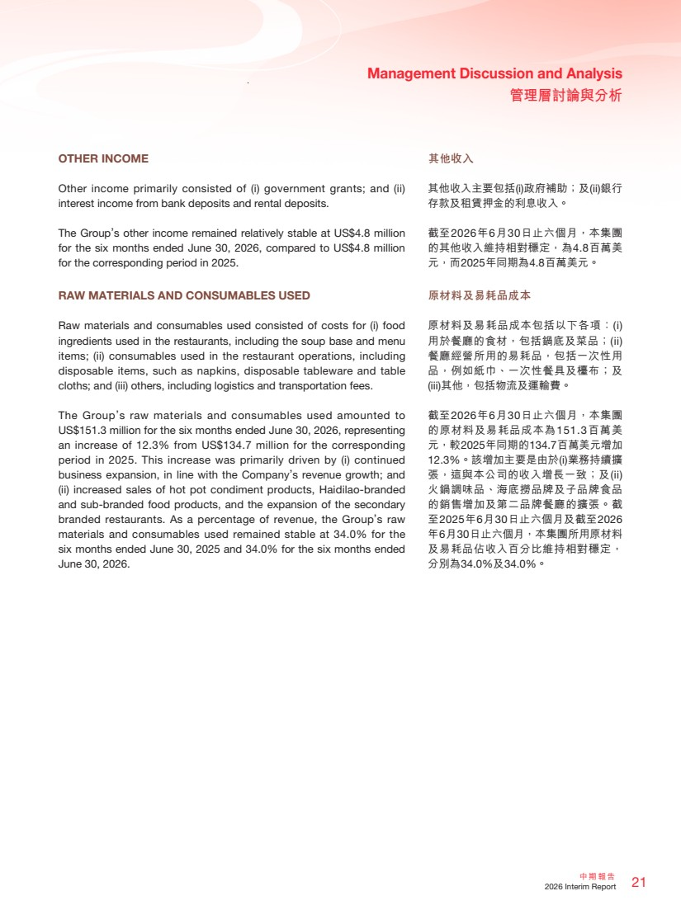 | 21 中期報告 2026 Interim Report Management Discussion and Analysis 管理層討論與分析 其他收入 其他收入主要包括(i)政府補助；及(ii)銀行 存款及租賃押金的利息收入。 截至2026年6月30日止六個月，本集團 的其他收入維持相對穩定，為4.8百萬美 元，而2025年同期為4.8百萬美元。 原材料及易耗品成本 原材料及易耗品成本包括以下各項：(i) 用於餐廳的食材，包括鍋底及菜品；(ii) 餐廳經營所用的易耗品，包括一次性用 品，例如紙巾、一次性餐具及檯布；及 (iii)其他，包括物流及運輸費。 截至2026年6月30日止六個月，本集團 的原材料及易耗品成本為151.3百萬美 元，較2025年同期的134.7百萬美元增加 12.3%。該增加主要是由於(i)業務持續擴 張，這與本公司的收入增長一致；及(ii) 火鍋調味品、海底撈品牌及子品牌食品 的銷售增加及第二品牌餐廳的擴張。截 至2025年6月30日止六個月及截至2026 年6月30日止六個月，本集團所用原材料 及易耗品佔收入百分比維持相對穩定， 分別為34.0%及34.0%。 OTHER INCOME Other income primarily consisted of (i) government grants; and (ii) interest income from bank deposits and rental deposits. The Group’s other income remained relatively stable at US$4.8 million for the six months ended June 30, 2026, compared to US$4.8 million for the corresponding period in 2025. RAW MATERIALS AND CONSUMABLES USED Raw materials and consumables used consisted of costs for (i) food ingredients used in the restaurants, including the soup base and menu items; (ii) consumables used in the restaurant operations, including disposable items, such as napkins, disposable tableware and table cloths; and (iii) others, including logistics and transportation fees. The Group’s raw materials and consumables used amounted to US$151.3 million for the six months ended June 30, 2026, representing an increase of 12.3% from US$134.7 million for the corresponding period in 2025. This increase was primarily driven by (i) continued business expansion, in line with the Company’s revenue growth; and (ii) increased sales of hot pot condiment products, Haidilao-branded and sub-branded food products, and the expansion of the secondary branded restaurants. As a percentage of revenue, the Group’s raw materials and consumables used remained stable at 34.0% for the six months ended June 30, 2025 and 34.0% for the six months ended June 30, 2026.
 | 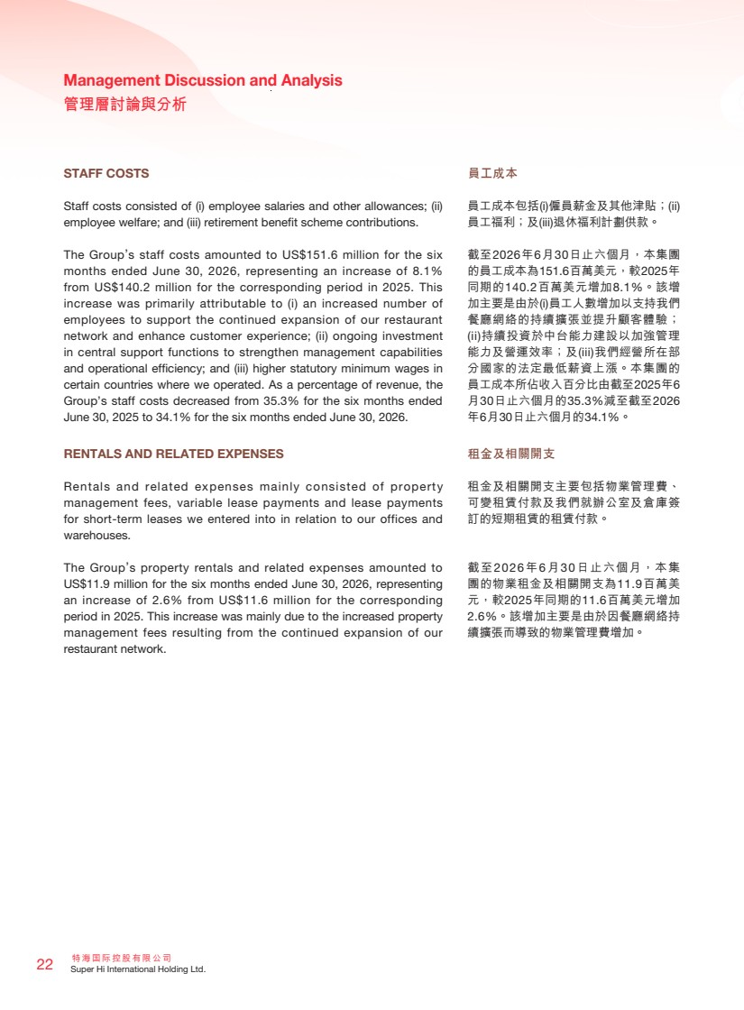 | 特海國際控股有限公司 22 Super Hi International Holding Ltd. Management Discussion and Analysis 管理層討論與分析 STAFF COSTS Staff costs consisted of (i) employee salaries and other allowances; (ii) employee welfare; and (iii) retirement benefit scheme contributions. The Group’s staff costs amounted to US$151.6 million for the six months ended June 30, 2026, representing an increase of 8.1% from US$140.2 million for the corresponding period in 2025. This increase was primarily attributable to (i) an increased number of employees to support the continued expansion of our restaurant network and enhance customer experience; (ii) ongoing investment in central support functions to strengthen management capabilities and operational efficiency; and (iii) higher statutory minimum wages in certain countries where we operated. As a percentage of revenue, the Group’s staff costs decreased from 35.3% for the six months ended June 30, 2025 to 34.1% for the six months ended June 30, 2026. RENTALS AND RELATED EXPENSES Rentals and related expenses mainly consisted of property management fees, variable lease payments and lease payments for short-term leases we entered into in relation to our offices and warehouses. The Group’s property rentals and related expenses amounted to US$11.9 million for the six months ended June 30, 2026, representing an increase of 2.6% from US$11.6 million for the corresponding period in 2025. This increase was mainly due to the increased property management fees resulting from the continued expansion of our restaurant network. 員工成本 員工成本包括(i)僱員薪金及其他津貼；(ii) 員工福利；及(iii)退休福利計劃供款。 截至2026年6月30日止六個月，本集團 的員工成本為151.6百萬美元，較2025年 同期的140.2百萬美元增加8.1%。該增 加主要是由於(i)員工人數增加以支持我們 餐廳網絡的持續擴張並提升顧客體驗； (ii)持續投資於中台能力建設以加強管理 能力及營運效率；及(iii)我們經營所在部 分國家的法定最低薪資上漲。本集團的 員工成本所佔收入百分比由截至2025年6 月30日止六個月的35.3%減至截至2026 年6月30日止六個月的34.1%。 租金及相關開支 租金及相關開支主要包括物業管理費、 可變租賃付款及我們就辦公室及倉庫簽 訂的短期租賃的租賃付款。 截至2026年6月30日止六個月，本集 團的物業租金及相關開支為11.9百萬美 元，較2025年同期的11.6百萬美元增加 2.6%。該增加主要是由於因餐廳網絡持 續擴張而導致的物業管理費增加。
 | 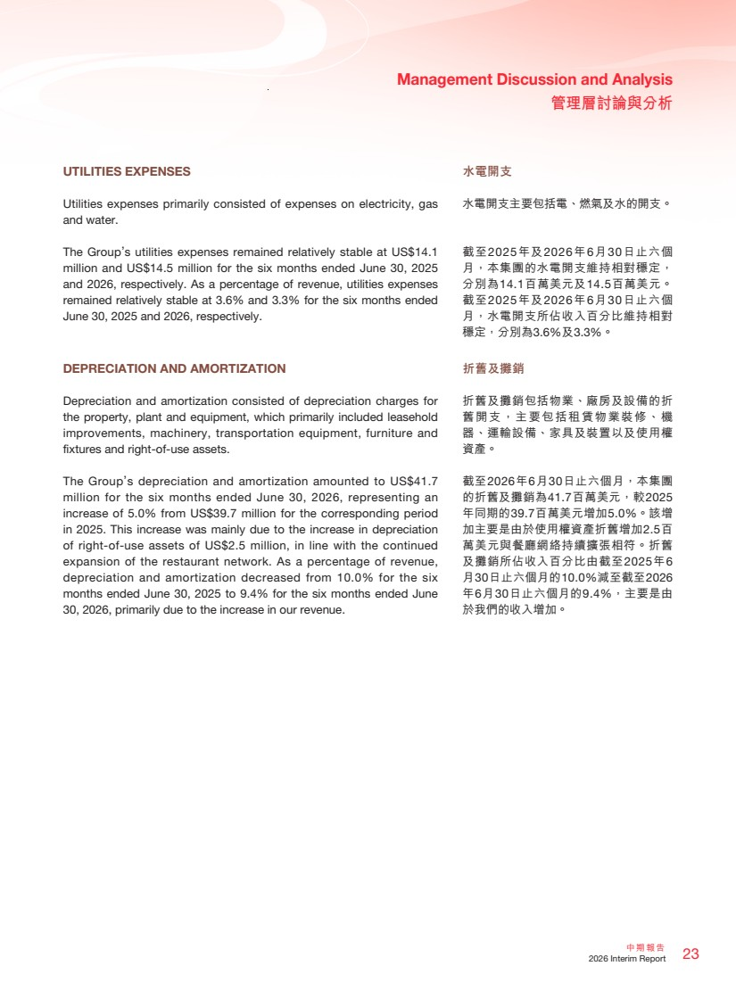 | 23 中期報告 2026 Interim Report Management Discussion and Analysis 管理層討論與分析 水電開支 水電開支主要包括電、燃氣及水的開支。 截至2025年及2026年6月30日止六個 月，本集團的水電開支維持相對穩定， 分別為14.1百萬美元及14.5百萬美元。 截至2025年及2026年6月30日止六個 月，水電開支所佔收入百分比維持相對 穩定，分別為3.6%及3.3%。 折舊及攤銷 折舊及攤銷包括物業、廠房及設備的折 舊開支，主要包括租賃物業裝修、機 器、運輸設備、家具及裝置以及使用權 資產。 截至2026年6月30日止六個月，本集團 的折舊及攤銷為41.7百萬美元，較2025 年同期的39.7百萬美元增加5.0%。該增 加主要是由於使用權資產折舊增加2.5百 萬美元與餐廳網絡持續擴張相符。折舊 及攤銷所佔收入百分比由截至2025年6 月30日止六個月的10.0%減至截至2026 年6月30日止六個月的9.4%，主要是由 於我們的收入增加。 UTILITIES EXPENSES Utilities expenses primarily consisted of expenses on electricity, gas and water. The Group’s utilities expenses remained relatively stable at US$14.1 million and US$14.5 million for the six months ended June 30, 2025 and 2026, respectively. As a percentage of revenue, utilities expenses remained relatively stable at 3.6% and 3.3% for the six months ended June 30, 2025 and 2026, respectively. DEPRECIATION AND AMORTIZATION Depreciation and amortization consisted of depreciation charges for the property, plant and equipment, which primarily included leasehold improvements, machinery, transportation equipment, furniture and fixtures and right-of-use assets. The Group’s depreciation and amortization amounted to US$41.7 million for the six months ended June 30, 2026, representing an increase of 5.0% from US$39.7 million for the corresponding period in 2025. This increase was mainly due to the increase in depreciation of right-of-use assets of US$2.5 million, in line with the continued expansion of the restaurant network. As a percentage of revenue, depreciation and amortization decreased from 10.0% for the six months ended June 30, 2025 to 9.4% for the six months ended June 30, 2026, primarily due to the increase in our revenue.
 | 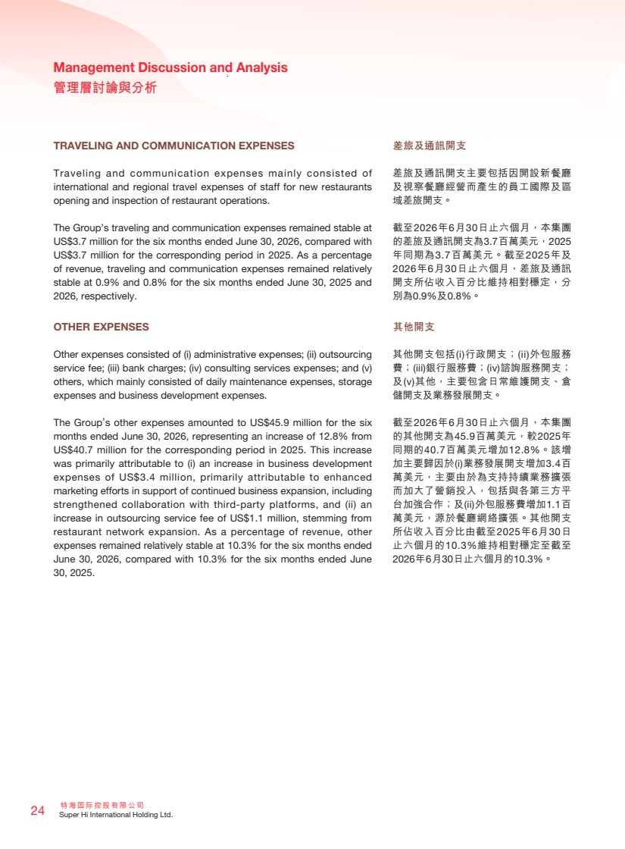 | 特海國際控股有限公司 24 Super Hi International Holding Ltd. Management Discussion and Analysis 管理層討論與分析 TRAVELING AND COMMUNICATION EXPENSES Traveling and communication expenses mainly consisted of international and regional travel expenses of staff for new restaurants opening and inspection of restaurant operations. The Group’s traveling and communication expenses remained stable at US$3.7 million for the six months ended June 30, 2026, compared with US$3.7 million for the corresponding period in 2025. As a percentage of revenue, traveling and communication expenses remained relatively stable at 0.9% and 0.8% for the six months ended June 30, 2025 and 2026, respectively. OTHER EXPENSES Other expenses consisted of (i) administrative expenses; (ii) outsourcing service fee; (iii) bank charges; (iv) consulting services expenses; and (v) others, which mainly consisted of daily maintenance expenses, storage expenses and business development expenses. The Group’s other expenses amounted to US$45.9 million for the six months ended June 30, 2026, representing an increase of 12.8% from US$40.7 million for the corresponding period in 2025. This increase was primarily attributable to (i) an increase in business development expenses of US$3.4 million, primarily attributable to enhanced marketing efforts in support of continued business expansion, including strengthened collaboration with third-party platforms, and (ii) an increase in outsourcing service fee of US$1.1 million, stemming from restaurant network expansion. As a percentage of revenue, other expenses remained relatively stable at 10.3% for the six months ended June 30, 2026, compared with 10.3% for the six months ended June 30, 2025. 差旅及通訊開支 差旅及通訊開支主要包括因開設新餐廳 及視察餐廳經營而產生的員工國際及區 域差旅開支。 截至2026年6月30日止六個月，本集團 的差旅及通訊開支為3.7百萬美元，2025 年同期為3.7百萬美元。截至2025年及 2026年6月30日止六個月，差旅及通訊 開支所佔收入百分比維持相對穩定，分 別為0.9%及0.8%。 其他開支 其他開支包括(i)行政開支；(ii)外包服務 費；(iii)銀行服務費；(iv)諮詢服務開支； 及(v)其他，主要包含日常維護開支、倉 儲開支及業務發展開支。 截至2026年6月30日止六個月，本集團 的其他開支為45.9百萬美元，較2025年 同期的40.7百萬美元增加12.8%。該增 加主要歸因於(i)業務發展開支增加3.4百 萬美元，主要由於為支持持續業務擴張 而加大了營銷投入，包括與各第三方平 台加強合作；及(ii)外包服務費增加1.1百 萬美元，源於餐廳網絡擴張。其他開支 所佔收入百分比由截至2025年6月30日 止六個月的10.3%維持相對穩定至截至 2026年6月30日止六個月的10.3%。
 | 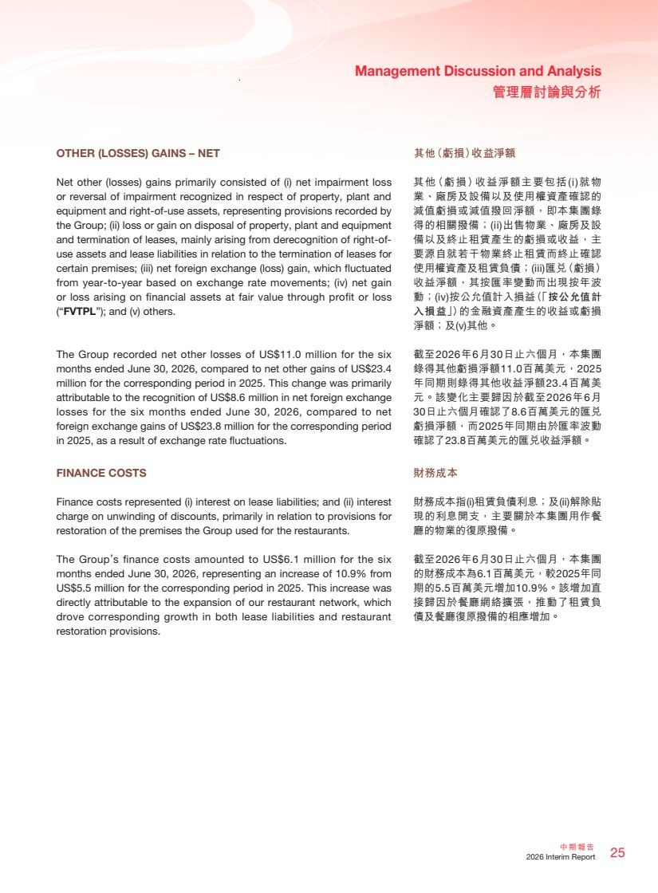 | 25 中期報告 2026 Interim Report Management Discussion and Analysis 管理層討論與分析 其他（虧損）收益淨額 其他（虧損）收益淨額主要包括(i)就物 業、廠房及設備以及使用權資產確認的 減值虧損或減值撥回淨額，即本集團錄 得的相關撥備；(ii)出售物業、廠房及設 備以及終止租賃產生的虧損或收益，主 要源自就若干物業終止租賃而終止確認 使用權資產及租賃負債；(iii)匯兌（虧損） 收益淨額，其按匯率變動而出現按年波 動；(iv)按公允值計入損益（「按公允值計 入損益」）的金融資產產生的收益或虧損 淨額；及(v)其他。 截至2026年6月30日止六個月，本集團 錄得其他虧損淨額11.0百萬美元，2025 年同期則錄得其他收益淨額23.4百萬美 元。該變化主要歸因於截至2026年6月 30日止六個月確認了8.6百萬美元的匯兌 虧損淨額，而2025年同期由於匯率波動 確認了23.8百萬美元的匯兌收益淨額。 財務成本 財務成本指(i)租賃負債利息；及(ii)解除貼 現的利息開支，主要關於本集團用作餐 廳的物業的復原撥備。 截至2026年6月30日止六個月，本集團 的財務成本為6.1百萬美元，較2025年同 期的5.5百萬美元增加10.9%。該增加直 接歸因於餐廳網絡擴張，推動了租賃負 債及餐廳復原撥備的相應增加。 OTHER (LOSSES) GAINS – NET Net other (losses) gains primarily consisted of (i) net impairment loss or reversal of impairment recognized in respect of property, plant and equipment and right-of-use assets, representing provisions recorded by the Group; (ii) loss or gain on disposal of property, plant and equipment and termination of leases, mainly arising from derecognition of right-of-use assets and lease liabilities in relation to the termination of leases for certain premises; (iii) net foreign exchange (loss) gain, which fluctuated from year-to-year based on exchange rate movements; (iv) net gain or loss arising on financial assets at fair value through profit or loss (“FVTPL”); and (v) others. The Group recorded net other losses of US$11.0 million for the six months ended June 30, 2026, compared to net other gains of US$23.4 million for the corresponding period in 2025. This change was primarily attributable to the recognition of US$8.6 million in net foreign exchange losses for the six months ended June 30, 2026, compared to net foreign exchange gains of US$23.8 million for the corresponding period in 2025, as a result of exchange rate fluctuations. FINANCE COSTS Finance costs represented (i) interest on lease liabilities; and (ii) interest charge on unwinding of discounts, primarily in relation to provisions for restoration of the premises the Group used for the restaurants. The Group’s finance costs amounted to US$6.1 million for the six months ended June 30, 2026, representing an increase of 10.9% from US$5.5 million for the corresponding period in 2025. This increase was directly attributable to the expansion of our restaurant network, which drove corresponding growth in both lease liabilities and restaurant restoration provisions.
 | 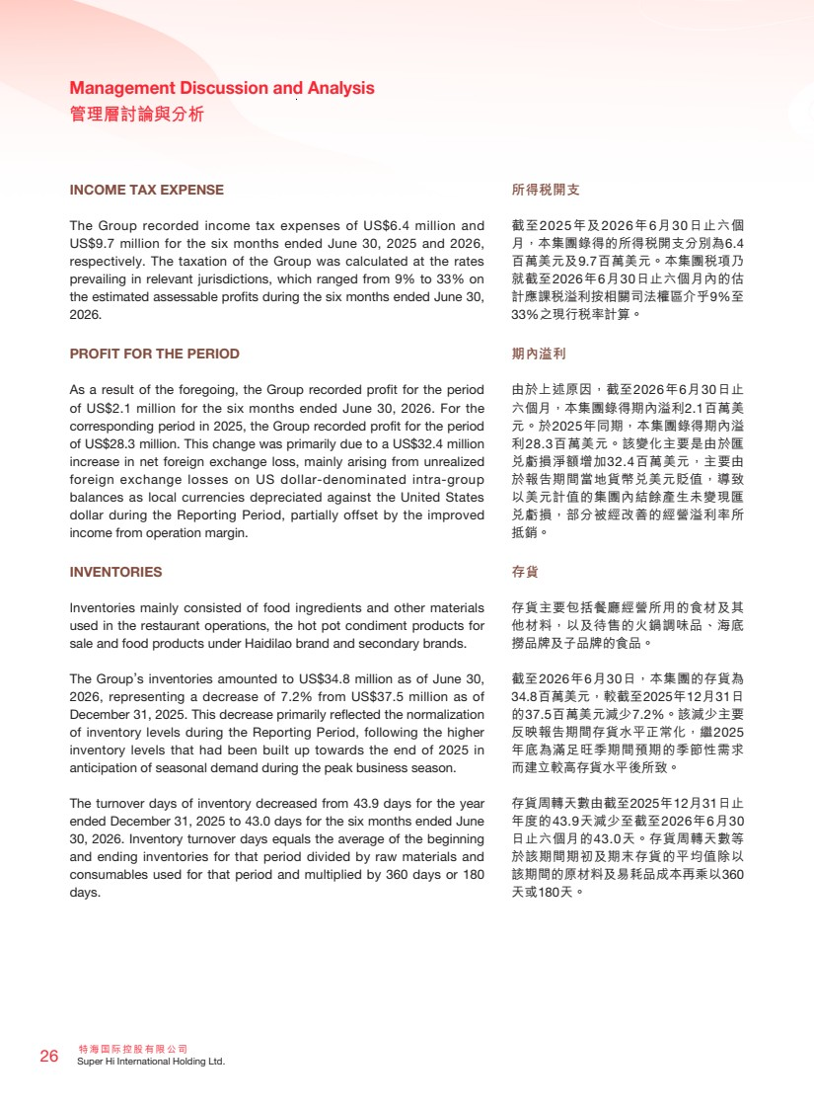 | 特海國際控股有限公司 26 Super Hi International Holding Ltd. Management Discussion and Analysis 管理層討論與分析 INCOME TAX EXPENSE The Group recorded income tax expenses of US$6.4 million and US$9.7 million for the six months ended June 30, 2025 and 2026, respectively. The taxation of the Group was calculated at the rates prevailing in relevant jurisdictions, which ranged from 9% to 33% on the estimated assessable profits during the six months ended June 30, 2026. PROFIT FOR THE PERIOD As a result of the foregoing, the Group recorded profit for the period of US$2.1 million for the six months ended June 30, 2026. For the corresponding period in 2025, the Group recorded profit for the period of US$28.3 million. This change was primarily due to a US$32.4 million increase in net foreign exchange loss, mainly arising from unrealized foreign exchange losses on US dollar-denominated intra-group balances as local currencies depreciated against the United States dollar during the Reporting Period, partially offset by the improved income from operation margin. INVENTORIES Inventories mainly consisted of food ingredients and other materials used in the restaurant operations, the hot pot condiment products for sale and food products under Haidilao brand and secondary brands. The Group’s inventories amounted to US$34.8 million as of June 30, 2026, representing a decrease of 7.2% from US$37.5 million as of December 31, 2025. This decrease primarily reflected the normalization of inventory levels during the Reporting Period, following the higher inventory levels that had been built up towards the end of 2025 in anticipation of seasonal demand during the peak business season. The turnover days of inventory decreased from 43.9 days for the year ended December 31, 2025 to 43.0 days for the six months ended June 30, 2026. Inventory turnover days equals the average of the beginning and ending inventories for that period divided by raw materials and consumables used for that period and multiplied by 360 days or 180 days. 所得稅開支 截至2025年及2026年6月30日止六個 月，本集團錄得的所得稅開支分別為6.4 百萬美元及9.7百萬美元。本集團稅項乃 就截至2026年6月30日止六個月內的估 計應課稅溢利按相關司法權區介乎9%至 33%之現行稅率計算。 期內溢利 由於上述原因，截至2026年6月30日止 六個月，本集團錄得期內溢利2.1百萬美 元。於2025年同期，本集團錄得期內溢 利28.3百萬美元。該變化主要是由於匯 兌虧損淨額增加32.4百萬美元，主要由 於報告期間當地貨幣兌美元貶值，導致 以美元計值的集團內結餘產生未變現匯 兌虧損，部分被經改善的經營溢利率所 抵銷。 存貨 存貨主要包括餐廳經營所用的食材及其 他材料，以及待售的火鍋調味品、海底 撈品牌及子品牌的食品。 截至2026年6月30日，本集團的存貨為 34.8百萬美元，較截至2025年12月31日 的37.5百萬美元減少7.2%。該減少主要 反映報告期間存貨水平正常化，繼2025 年底為滿足旺季期間預期的季節性需求 而建立較高存貨水平後所致。 存貨周轉天數由截至2025年12月31日止 年度的43.9天減少至截至2026年6月30 日止六個月的43.0天。存貨周轉天數等 於該期間期初及期末存貨的平均值除以 該期間的原材料及易耗品成本再乘以360 天或180天。
 | 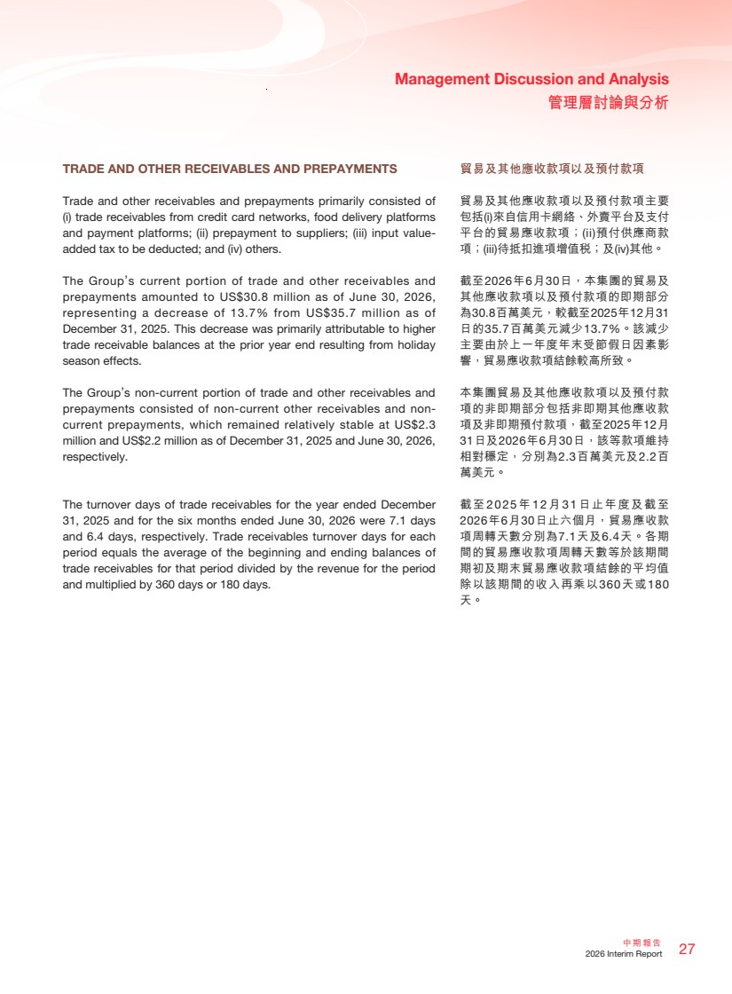 | 27 中期報告 2026 Interim Report Management Discussion and Analysis 管理層討論與分析 貿易及其他應收款項以及預付款項 貿易及其他應收款項以及預付款項主要 包括(i)來自信用卡網絡、外賣平台及支付 平台的貿易應收款項；(ii)預付供應商款 項；(iii)待抵扣進項增值稅；及(iv)其他。 截至2026年6月30日，本集團的貿易及 其他應收款項以及預付款項的即期部分 為30.8百萬美元，較截至2025年12月31 日的35.7百萬美元減少13.7%。該減少 主要由於上一年度年末受節假日因素影 響，貿易應收款項結餘較高所致。 本集團貿易及其他應收款項以及預付款 項的非即期部分包括非即期其他應收款 項及非即期預付款項，截至2025年12月 31日及2026年6月30日，該等款項維持 相對穩定，分別為2.3百萬美元及2.2百 萬美元。 截至2025 年12 月31 日止年度及截至 2026年6月30日止六個月，貿易應收款 項周轉天數分別為7.1天及6.4天。各期 間的貿易應收款項周轉天數等於該期間 期初及期末貿易應收款項結餘的平均值 除以該期間的收入再乘以360天或180 天。 TRADE AND OTHER RECEIVABLES AND PREPAYMENTS Trade and other receivables and prepayments primarily consisted of (i) trade receivables from credit card networks, food delivery platforms and payment platforms; (ii) prepayment to suppliers; (iii) input value-added tax to be deducted; and (iv) others. The Group’s current portion of trade and other receivables and prepayments amounted to US$30.8 million as of June 30, 2026, representing a decrease of 13.7% from US$35.7 million as of December 31, 2025. This decrease was primarily attributable to higher trade receivable balances at the prior year end resulting from holiday season effects. The Group’s non-current portion of trade and other receivables and prepayments consisted of non-current other receivables and non-current prepayments, which remained relatively stable at US$2.3 million and US$2.2 million as of December 31, 2025 and June 30, 2026, respectively. The turnover days of trade receivables for the year ended December 31, 2025 and for the six months ended June 30, 2026 were 7.1 days and 6.4 days, respectively. Trade receivables turnover days for each period equals the average of the beginning and ending balances of trade receivables for that period divided by the revenue for the period and multiplied by 360 days or 180 days.
 | 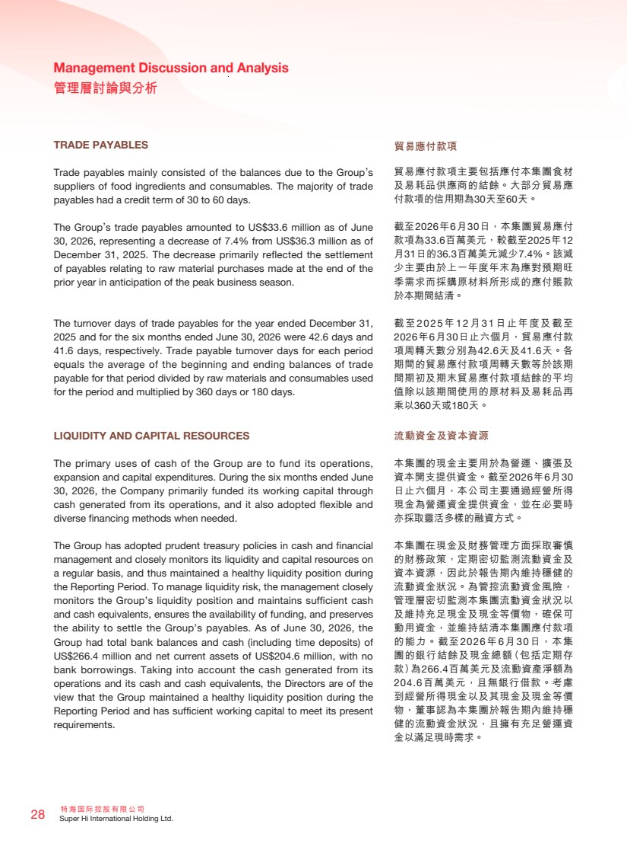 | 特海國際控股有限公司 28 Super Hi International Holding Ltd. Management Discussion and Analysis 管理層討論與分析 TRADE PAYABLES Trade payables mainly consisted of the balances due to the Group’s suppliers of food ingredients and consumables. The majority of trade payables had a credit term of 30 to 60 days. The Group’s trade payables amounted to US$33.6 million as of June 30, 2026, representing a decrease of 7.4% from US$36.3 million as of December 31, 2025. The decrease primarily reflected the settlement of payables relating to raw material purchases made at the end of the prior year in anticipation of the peak business season. The turnover days of trade payables for the year ended December 31, 2025 and for the six months ended June 30, 2026 were 42.6 days and 41.6 days, respectively. Trade payable turnover days for each period equals the average of the beginning and ending balances of trade payable for that period divided by raw materials and consumables used for the period and multiplied by 360 days or 180 days. LIQUIDITY AND CAPITAL RESOURCES The primary uses of cash of the Group are to fund its operations, expansion and capital expenditures. During the six months ended June 30, 2026, the Company primarily funded its working capital through cash generated from its operations, and it also adopted flexible and diverse financing methods when needed. The Group has adopted prudent treasury policies in cash and financial management and closely monitors its liquidity and capital resources on a regular basis, and thus maintained a healthy liquidity position during the Reporting Period. To manage liquidity risk, the management closely monitors the Group’s liquidity position and maintains sufficient cash and cash equivalents, ensures the availability of funding, and preserves the ability to settle the Group’s payables. As of June 30, 2026, the Group had total bank balances and cash (including time deposits) of US$266.4 million and net current assets of US$204.6 million, with no bank borrowings. Taking into account the cash generated from its operations and its cash and cash equivalents, the Directors are of the view that the Group maintained a healthy liquidity position during the Reporting Period and has sufficient working capital to meet its present requirements. 貿易應付款項 貿易應付款項主要包括應付本集團食材 及易耗品供應商的結餘。大部分貿易應 付款項的信用期為30天至60天。 截至2026年6月30日，本集團貿易應付 款項為33.6百萬美元，較截至2025年12 月31日的36.3百萬美元減少7.4%。該減 少主要由於上一年度年末為應對預期旺 季需求而採購原材料所形成的應付賬款 於本期間結清。 截至2025 年12 月31 日止年度及截至 2026年6月30日止六個月，貿易應付款 項周轉天數分別為42.6天及41.6天。各 期間的貿易應付款項周轉天數等於該期 間期初及期末貿易應付款項結餘的平均 值除以該期間使用的原材料及易耗品再 乘以360天或180天。 流動資金及資本資源 本集團的現金主要用於為營運、擴張及 資本開支提供資金。截至2026年6月30 日止六個月，本公司主要通過經營所得 現金為營運資金提供資金，並在必要時 亦採取靈活多樣的融資方式。 本集團在現金及財務管理方面採取審慎 的財務政策，定期密切監測流動資金及 資本資源，因此於報告期內維持穩健的 流動資金狀況。為管控流動資金風險， 管理層密切監測本集團流動資金狀況以 及維持充足現金及現金等價物，確保可 動用資金，並維持結清本集團應付款項 的能力。截至2026年6月30日，本集 團的銀行結餘及現金總額（包括定期存 款）為266.4百萬美元及流動資產淨額為 204.6百萬美元，且無銀行借款。考慮 到經營所得現金以及其現金及現金等價 物，董事認為本集團於報告期內維持穩 健的流動資金狀況，且擁有充足營運資 金以滿足現時需求。
 | 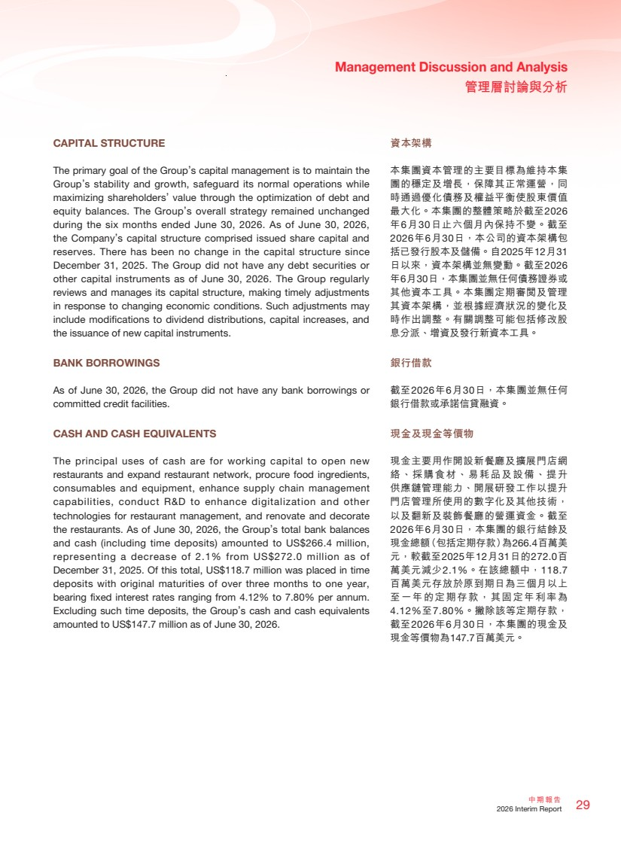 | 29 中期報告 2026 Interim Report Management Discussion and Analysis 管理層討論與分析 資本架構 本集團資本管理的主要目標為維持本集 團的穩定及增長，保障其正常運營，同 時通過優化債務及權益平衡使股東價值 最大化。本集團的整體策略於截至2026 年6月30日止六個月內保持不變。截至 2026年6月30日，本公司的資本架構包 括已發行股本及儲備。自2025年12月31 日以來，資本架構並無變動。截至2026 年6月30日，本集團並無任何債務證券或 其他資本工具。本集團定期審閱及管理 其資本架構，並根據經濟狀況的變化及 時作出調整。有關調整可能包括修改股 息分派、增資及發行新資本工具。 銀行借款 截至2026年6月30日，本集團並無任何 銀行借款或承諾信貸融資。 現金及現金等價物 現金主要用作開設新餐廳及擴展門店網 絡、採購食材、易耗品及設備、提升 供應鏈管理能力、開展研發工作以提升 門店管理所使用的數字化及其他技術， 以及翻新及裝飾餐廳的營運資金。截至 2026年6月30日，本集團的銀行結餘及 現金總額（包括定期存款）為266.4百萬美 元，較截至2025年12月31日的272.0百 萬美元減少2.1%。在該總額中，118.7 百萬美元存放於原到期日為三個月以上 至一年的定期存款，其固定年利率為 4.12%至7.80%。撇除該等定期存款， 截至2026年6月30日，本集團的現金及 現金等價物為147.7百萬美元。 CAPITAL STRUCTURE The primary goal of the Group’s capital management is to maintain the Group’s stability and growth, safeguard its normal operations while maximizing shareholders’ value through the optimization of debt and equity balances. The Group’s overall strategy remained unchanged during the six months ended June 30, 2026. As of June 30, 2026, the Company’s capital structure comprised issued share capital and reserves. There has been no change in the capital structure since December 31, 2025. The Group did not have any debt securities or other capital instruments as of June 30, 2026. The Group regularly reviews and manages its capital structure, making timely adjustments in response to changing economic conditions. Such adjustments may include modifications to dividend distributions, capital increases, and the issuance of new capital instruments. BANK BORROWINGS As of June 30, 2026, the Group did not have any bank borrowings or committed credit facilities. CASH AND CASH EQUIVALENTS The principal uses of cash are for working capital to open new restaurants and expand restaurant network, procure food ingredients, consumables and equipment, enhance supply chain management capabilities, conduct R&D to enhance digitalization and other technologies for restaurant management, and renovate and decorate the restaurants. As of June 30, 2026, the Group’s total bank balances and cash (including time deposits) amounted to US$266.4 million, representing a decrease of 2.1% from US$272.0 million as of December 31, 2025. Of this total, US$118.7 million was placed in time deposits with original maturities of over three months to one year, bearing fixed interest rates ranging from 4.12% to 7.80% per annum. Excluding such time deposits, the Group’s cash and cash equivalents amounted to US$147.7 million as of June 30, 2026.
 | 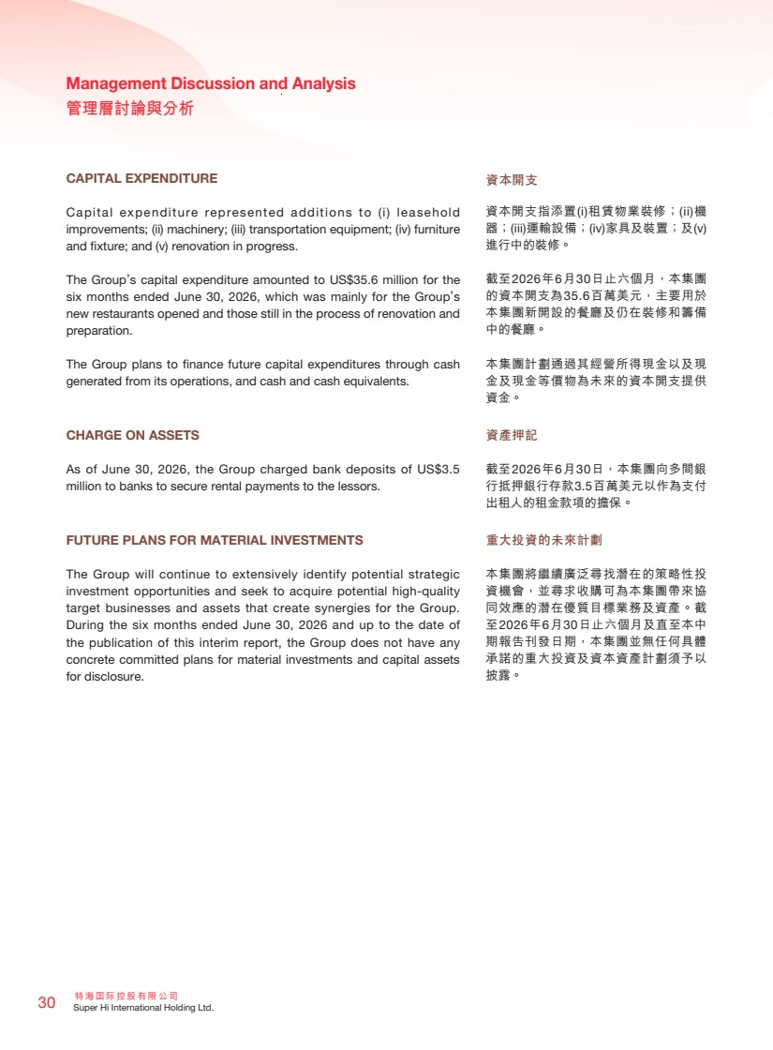 | 特海國際控股有限公司 30 Super Hi International Holding Ltd. Management Discussion and Analysis 管理層討論與分析 CAPITAL EXPENDITURE Capital expenditure represented additions to (i) leasehold improvements; (ii) machinery; (iii) transportation equipment; (iv) furniture and fixture; and (v) renovation in progress. The Group’s capital expenditure amounted to US$35.6 million for the six months ended June 30, 2026, which was mainly for the Group’s new restaurants opened and those still in the process of renovation and preparation. The Group plans to finance future capital expenditures through cash generated from its operations, and cash and cash equivalents. CHARGE ON ASSETS As of June 30, 2026, the Group charged bank deposits of US$3.5 million to banks to secure rental payments to the lessors. FUTURE PLANS FOR MATERIAL INVESTMENTS The Group will continue to extensively identify potential strategic investment opportunities and seek to acquire potential high-quality target businesses and assets that create synergies for the Group. During the six months ended June 30, 2026 and up to the date of the publication of this interim report, the Group does not have any concrete committed plans for material investments and capital assets for disclosure. 資本開支 資本開支指添置(i)租賃物業裝修；(ii)機 器；(iii)運輸設備；(iv)家具及裝置；及(v) 進行中的裝修。 截至2026年6月30日止六個月，本集團 的資本開支為35.6百萬美元，主要用於 本集團新開設的餐廳及仍在裝修和籌備 中的餐廳。 本集團計劃通過其經營所得現金以及現 金及現金等價物為未來的資本開支提供 資金。 資產押記 截至2026年6月30日，本集團向多間銀 行抵押銀行存款3.5百萬美元以作為支付 出租人的租金款項的擔保。 重大投資的未來計劃 本集團將繼續廣泛尋找潛在的策略性投 資機會，並尋求收購可為本集團帶來協 同效應的潛在優質目標業務及資產。截 至2026年6月30日止六個月及直至本中 期報告刊發日期，本集團並無任何具體 承諾的重大投資及資本資產計劃須予以 披露。
 | 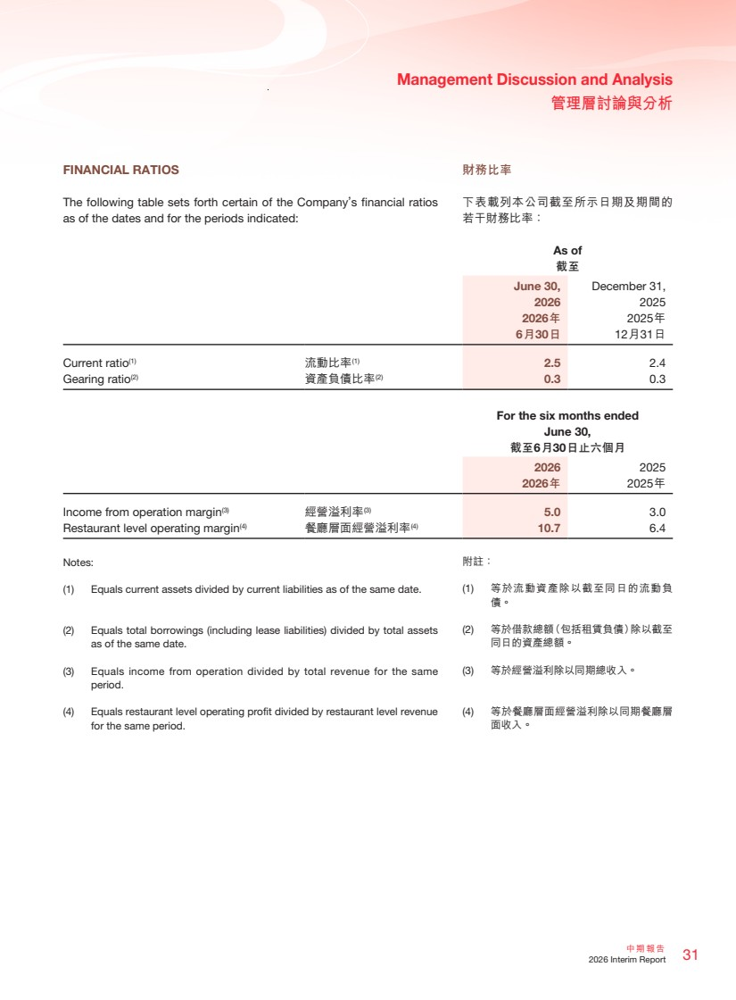 | 31 中期報告 2026 Interim Report Management Discussion and Analysis 管理層討論與分析 財務比率 下表載列本公司截至所示日期及期間的 若干財務比率： FINANCIAL RATIOS The following table sets forth certain of the Company’s financial ratios as of the dates and for the periods indicated: As of 截至 June 30, 2026 December 31, 2025 2026年 6月30日 2025年 12月31日 Current ratio(1) 流動比率(1) 2.5 2.4 Gearing ratio(2) 資產負債比率(2) 0.3 0.3 For the six months ended June 30, 截至6月30日止六個月 2026 2025 2026年 2025年 Income from operation margin(3) 經營溢利率(3) 5.0 3.0 Restaurant level operating margin(4) 餐廳層面經營溢利率(4) 10.7 6.4 Notes: (1) Equals current assets divided by current liabilities as of the same date. (2) Equals total borrowings (including lease liabilities) divided by total assets as of the same date. (3) Equals income from operation divided by total revenue for the same period. (4) Equals restaurant level operating profit divided by restaurant level revenue for the same period. 附註： (1) 等於流動資產除以截至同日的流動負 債。 (2) 等於借款總額（包括租賃負債）除以截至 同日的資產總額。 (3) 等於經營溢利除以同期總收入。 (4) 等於餐廳層面經營溢利除以同期餐廳層 面收入。
 | 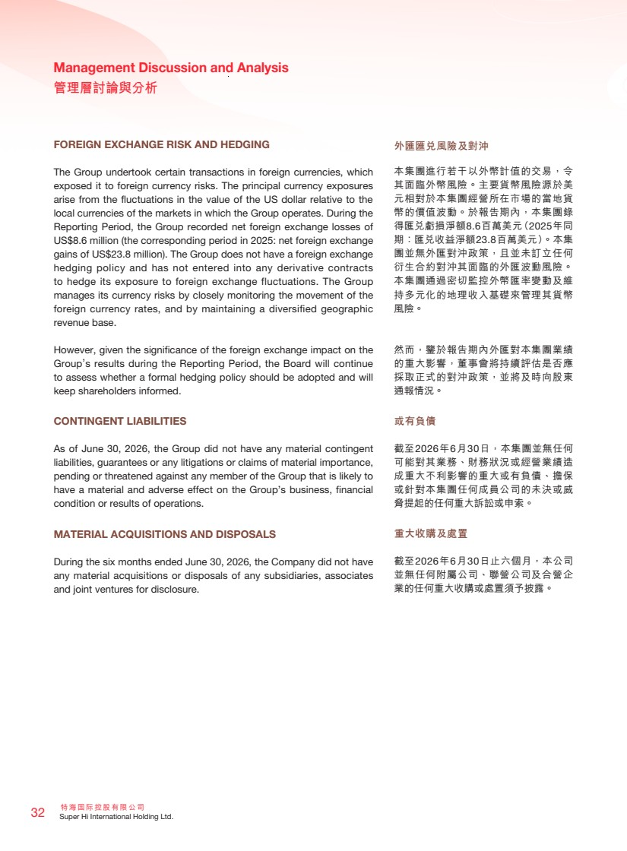 | 特海國際控股有限公司 32 Super Hi International Holding Ltd. Management Discussion and Analysis 管理層討論與分析 FOREIGN EXCHANGE RISK AND HEDGING The Group undertook certain transactions in foreign currencies, which exposed it to foreign currency risks. The principal currency exposures arise from the fluctuations in the value of the US dollar relative to the local currencies of the markets in which the Group operates. During the Reporting Period, the Group recorded net foreign exchange losses of US$8.6 million (the corresponding period in 2025: net foreign exchange gains of US$23.8 million). The Group does not have a foreign exchange hedging policy and has not entered into any derivative contracts to hedge its exposure to foreign exchange fluctuations. The Group manages its currency risks by closely monitoring the movement of the foreign currency rates, and by maintaining a diversified geographic revenue base. However, given the significance of the foreign exchange impact on the Group’s results during the Reporting Period, the Board will continue to assess whether a formal hedging policy should be adopted and will keep shareholders informed. CONTINGENT LIABILITIES As of June 30, 2026, the Group did not have any material contingent liabilities, guarantees or any litigations or claims of material importance, pending or threatened against any member of the Group that is likely to have a material and adverse effect on the Group’s business, financial condition or results of operations. MATERIAL ACQUISITIONS AND DISPOSALS During the six months ended June 30, 2026, the Company did not have any material acquisitions or disposals of any subsidiaries, associates and joint ventures for disclosure. 外匯匯兌風險及對沖 本集團進行若干以外幣計值的交易，令 其面臨外幣風險。主要貨幣風險源於美 元相對於本集團經營所在市場的當地貨 幣的價值波動。於報告期內，本集團錄 得匯兌虧損淨額8.6百萬美元（2025年同 期：匯兌收益淨額23.8百萬美元）。本集 團並無外匯對沖政策，且並未訂立任何 衍生合約對沖其面臨的外匯波動風險。 本集團通過密切監控外幣匯率變動及維 持多元化的地理收入基礎來管理其貨幣 風險。 然而，鑒於報告期內外匯對本集團業績 的重大影響，董事會將持續評估是否應 採取正式的對沖政策，並將及時向股東 通報情況。 或有負債 截至2026年6月30日，本集團並無任何 可能對其業務、財務狀況或經營業績造 成重大不利影響的重大或有負債、擔保 或針對本集團任何成員公司的未決或威 脅提起的任何重大訴訟或申索。 重大收購及處置 截至2026年6月30日止六個月，本公司 並無任何附屬公司、聯營公司及合營企 業的任何重大收購或處置須予披露。
 | 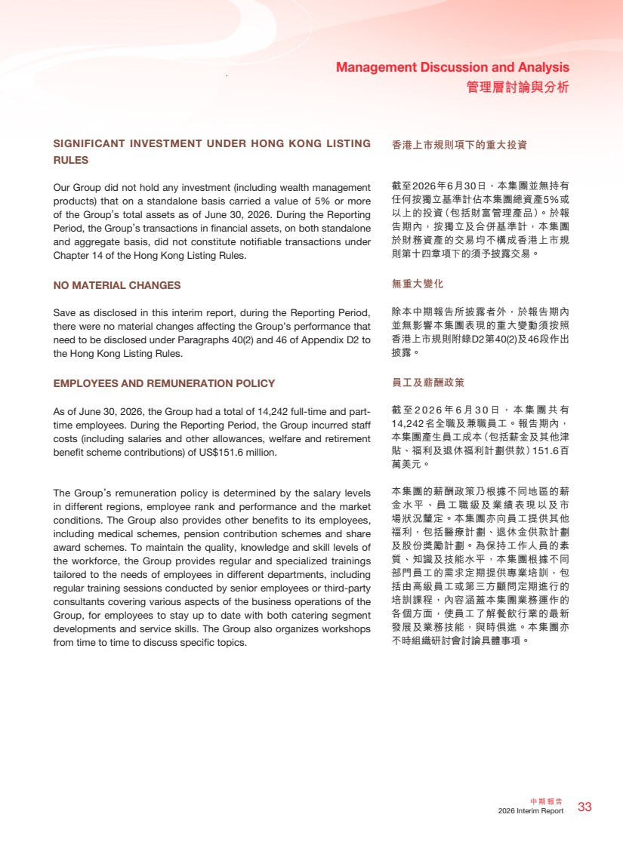 | 33 中期報告 2026 Interim Report Management Discussion and Analysis 管理層討論與分析 香港上市規則項下的重大投資 截至2026年6月30日，本集團並無持有 任何按獨立基準計佔本集團總資產5%或 以上的投資（包括財富管理產品）。於報 告期內，按獨立及合併基準計，本集團 於財務資產的交易均不構成香港上市規 則第十四章項下的須予披露交易。 無重大變化 除本中期報告所披露者外，於報告期內 並無影響本集團表現的重大變動須按照 香港上市規則附錄D2第40(2)及46段作出 披露。 員工及薪酬政策 截 至 2026 年 6 月 3 0 日，本集團共有 14,242名全職及兼職員工。報告期內， 本集團產生員工成本（包括薪金及其他津 貼、福利及退休福利計劃供款）151.6百 萬美元。 本集團的薪酬政策乃根據不同地區的薪 金水平、員工職級及業績表現以及市 場狀況釐定。本集團亦向員工提供其他 福利，包括醫療計劃、退休金供款計劃 及股份獎勵計劃。為保持工作人員的素 質、知識及技能水平，本集團根據不同 部門員工的需求定期提供專業培訓，包 括由高級員工或第三方顧問定期進行的 培訓課程，內容涵蓋本集團業務運作的 各個方面，使員工了解餐飲行業的最新 發展及業務技能，與時俱進。本集團亦 不時組織研討會討論具體事項。 SIGNIFICANT INVESTMENT UNDER HONG KONG LISTING RULES Our Group did not hold any investment (including wealth management products) that on a standalone basis carried a value of 5% or more of the Group’s total assets as of June 30, 2026. During the Reporting Period, the Group’s transactions in financial assets, on both standalone and aggregate basis, did not constitute notifiable transactions under Chapter 14 of the Hong Kong Listing Rules. NO MATERIAL CHANGES Save as disclosed in this interim report, during the Reporting Period, there were no material changes affecting the Group’s performance that need to be disclosed under Paragraphs 40(2) and 46 of Appendix D2 to the Hong Kong Listing Rules. EMPLOYEES AND REMUNERATION POLICY As of June 30, 2026, the Group had a total of 14,242 full-time and part-time employees. During the Reporting Period, the Group incurred staff costs (including salaries and other allowances, welfare and retirement benefit scheme contributions) of US$151.6 million. The Group’s remuneration policy is determined by the salary levels in different regions, employee rank and performance and the market conditions. The Group also provides other benefits to its employees, including medical schemes, pension contribution schemes and share award schemes. To maintain the quality, knowledge and skill levels of the workforce, the Group provides regular and specialized trainings tailored to the needs of employees in different departments, including regular training sessions conducted by senior employees or third-party consultants covering various aspects of the business operations of the Group, for employees to stay up to date with both catering segment developments and service skills. The Group also organizes workshops from time to time to discuss specific topics.
 | 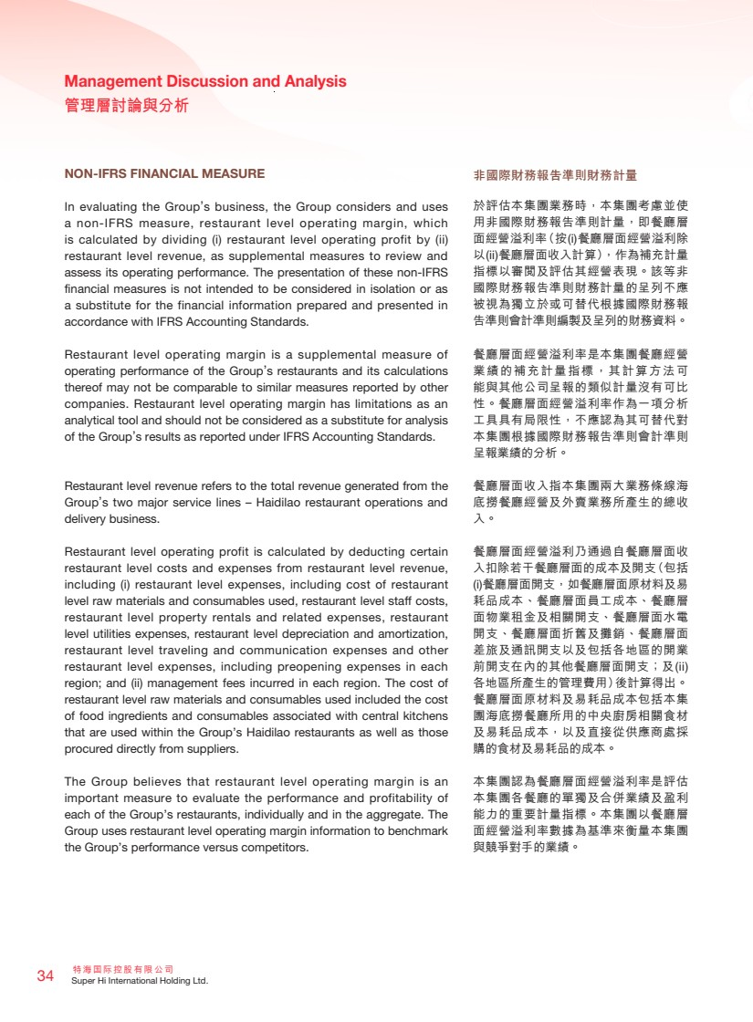 | 特海國際控股有限公司 34 Super Hi International Holding Ltd. Management Discussion and Analysis 管理層討論與分析 NON-IFRS FINANCIAL MEASURE In evaluating the Group’s business, the Group considers and uses a non-IFRS measure, restaurant level operating margin, which is calculated by dividing (i) restaurant level operating profit by (ii) restaurant level revenue, as supplemental measures to review and assess its operating performance. The presentation of these non-IFRS financial measures is not intended to be considered in isolation or as a substitute for the financial information prepared and presented in accordance with IFRS Accounting Standards. Restaurant level operating margin is a supplemental measure of operating performance of the Group’s restaurants and its calculations thereof may not be comparable to similar measures reported by other companies. Restaurant level operating margin has limitations as an analytical tool and should not be considered as a substitute for analysis of the Group’s results as reported under IFRS Accounting Standards. Restaurant level revenue refers to the total revenue generated from the Group’s two major service lines – Haidilao restaurant operations and delivery business. Restaurant level operating profit is calculated by deducting certain restaurant level costs and expenses from restaurant level revenue, including (i) restaurant level expenses, including cost of restaurant level raw materials and consumables used, restaurant level staff costs, restaurant level property rentals and related expenses, restaurant level utilities expenses, restaurant level depreciation and amortization, restaurant level traveling and communication expenses and other restaurant level expenses, including preopening expenses in each region; and (ii) management fees incurred in each region. The cost of restaurant level raw materials and consumables used included the cost of food ingredients and consumables associated with central kitchens that are used within the Group’s Haidilao restaurants as well as those procured directly from suppliers. The Group believes that restaurant level operating margin is an important measure to evaluate the performance and profitability of each of the Group’s restaurants, individually and in the aggregate. The Group uses restaurant level operating margin information to benchmark the Group’s performance versus competitors. 非國際財務報告準則財務計量 於評估本集團業務時，本集團考慮並使 用非國際財務報告準則計量，即餐廳層 面經營溢利率（按(i)餐廳層面經營溢利除 以(ii)餐廳層面收入計算），作為補充計量 指標以審閱及評估其經營表現。該等非 國際財務報告準則財務計量的呈列不應 被視為獨立於或可替代根據國際財務報 告準則會計準則編製及呈列的財務資料。 餐廳層面經營溢利率是本集團餐廳經營 業績的補充計量指標，其計算方法可 能與其他公司呈報的類似計量沒有可比 性。餐廳層面經營溢利率作為一項分析 工具具有局限性，不應認為其可替代對 本集團根據國際財務報告準則會計準則 呈報業績的分析。 餐廳層面收入指本集團兩大業務條線海 底撈餐廳經營及外賣業務所產生的總收 入。 餐廳層面經營溢利乃通過自餐廳層面收 入扣除若干餐廳層面的成本及開支（包括 (i)餐廳層面開支，如餐廳層面原材料及易 耗品成本、餐廳層面員工成本、餐廳層 面物業租金及相關開支、餐廳層面水電 開支、餐廳層面折舊及攤銷、餐廳層面 差旅及通訊開支以及包括各地區的開業 前開支在內的其他餐廳層面開支；及(ii) 各地區所產生的管理費用）後計算得出。 餐廳層面原材料及易耗品成本包括本集 團海底撈餐廳所用的中央廚房相關食材 及易耗品成本，以及直接從供應商處採 購的食材及易耗品的成本。 本集團認為餐廳層面經營溢利率是評估 本集團各餐廳的單獨及合併業績及盈利 能力的重要計量指標。本集團以餐廳層 面經營溢利率數據為基準來衡量本集團 與競爭對手的業績。
 | 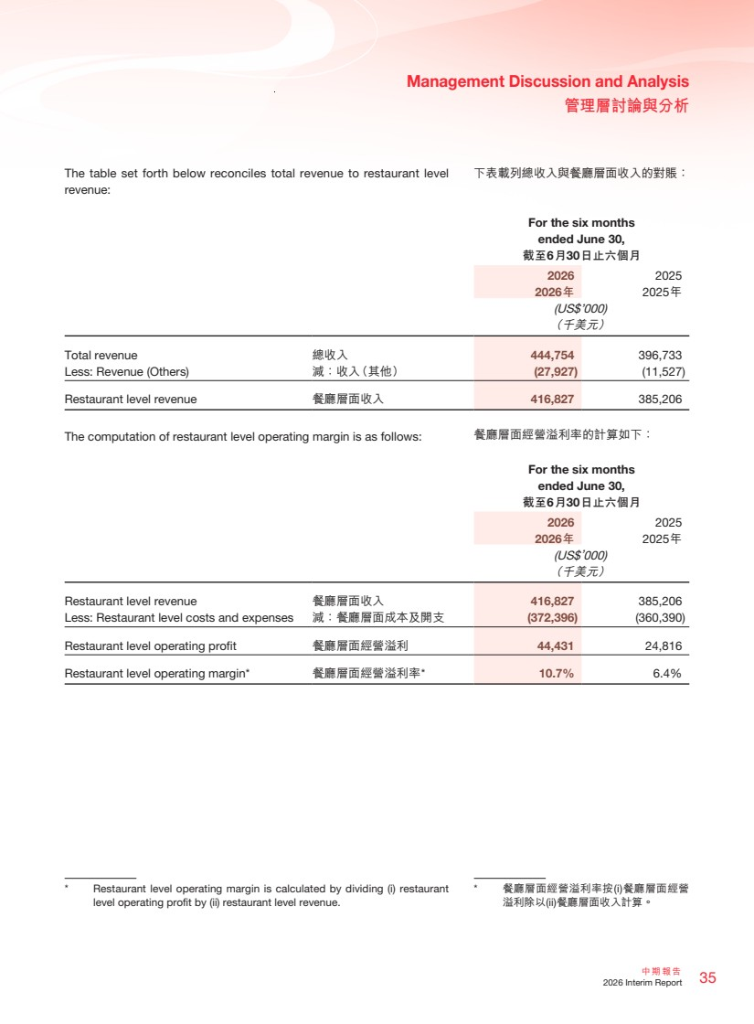 | 35 中期報告 2026 Interim Report Management Discussion and Analysis 管理層討論與分析 The table set forth below reconciles total revenue to restaurant level 下表載列總收入與餐廳層面收入的對賬： revenue: For the six months ended June 30, 截至6月30日止六個月 2026 2025 2026年 2025年 (US$’000) （千美元） Total revenue 總收入 444,754 396,733 Less: Revenue (Others) 減：收入（其他） (27,927) (11,527) Restaurant level revenue 餐廳層面收入 416,827 385,206 The computation of restaurant level operating margin is as follows: For the six months ended June 30, 截至6月30日止六個月 2026 2025 2026年 2025年 (US$’000) （千美元） Restaurant level revenue 餐廳層面收入 416,827 385,206 Less: Restaurant level costs and expenses 減：餐廳層面成本及開支 (372,396) (360,390) Restaurant level operating profit 餐廳層面經營溢利 44,431 24,816 Restaurant level operating margin* 餐廳層面經營溢利率* 10.7% 6.4% * Restaurant level operating margin is calculated by dividing (i) restaurant level operating profit by (ii) restaurant level revenue. * 餐廳層面經營溢利率按(i)餐廳層面經營 溢利除以(ii)餐廳層面收入計算。 餐廳層面經營溢利率的計算如下：
 | 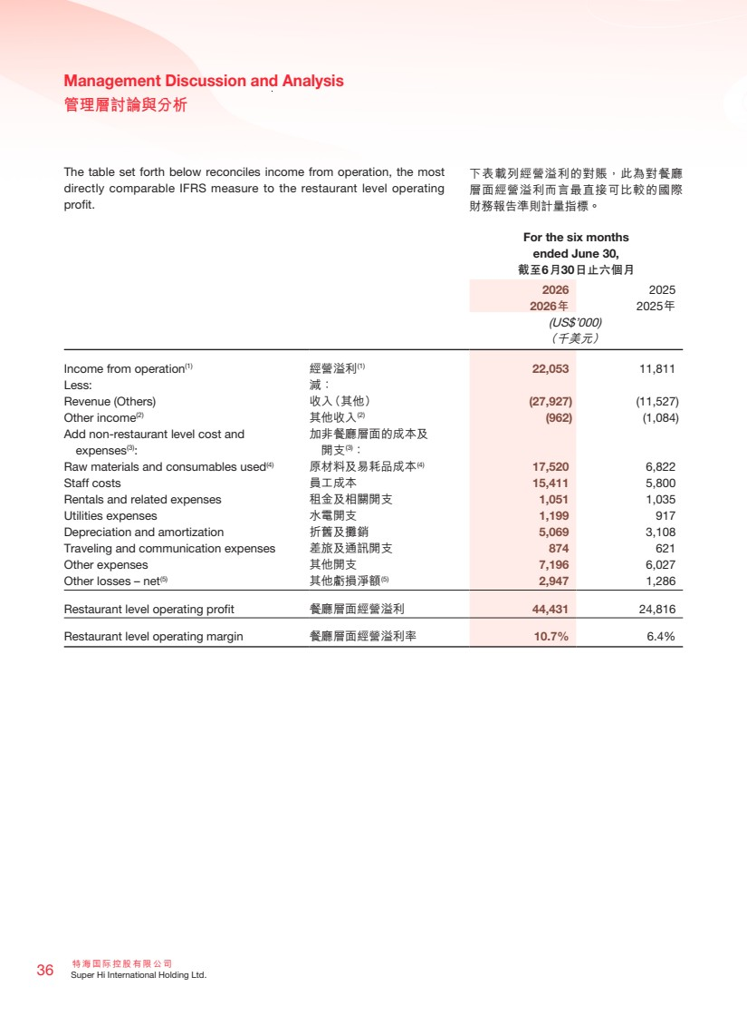 | 特海國際控股有限公司 36 Super Hi International Holding Ltd. Management Discussion and Analysis 管理層討論與分析 The table set forth below reconciles income from operation, the most directly comparable IFRS measure to the restaurant level operating profit. For the six months ended June 30, 截至6月30日止六個月 2026 2025 2026年 2025年 (US$’000) （千美元） Income from operation(1) 經營溢利(1) 22,053 11,811 Less: 減： Revenue (Others) 收入（其他） (27,927) (11,527) Other income(2) 其他收入(2) (962) (1,084) Add non-restaurant level cost and expenses(3): 加非餐廳層面的成本及 開支(3)： Raw materials and consumables used(4) 原材料及易耗品成本(4) 17,520 6,822 Staff costs 員工成本 15,411 5,800 Rentals and related expenses 租金及相關開支 1,051 1,035 Utilities expenses 水電開支 1,199 917 Depreciation and amortization 折舊及攤銷 5,069 3,108 Traveling and communication expenses 差旅及通訊開支 874 621 Other expenses 其他開支 7,196 6,027 Other losses – net(5) 其他虧損淨額(5) 2,947 1,286 Restaurant level operating profit 餐廳層面經營溢利 44,431 24,816 Restaurant level operating margin 餐廳層面經營溢利率 10.7% 6.4% 下表載列經營溢利的對賬，此為對餐廳 層面經營溢利而言最直接可比較的國際 財務報告準則計量指標。
 | 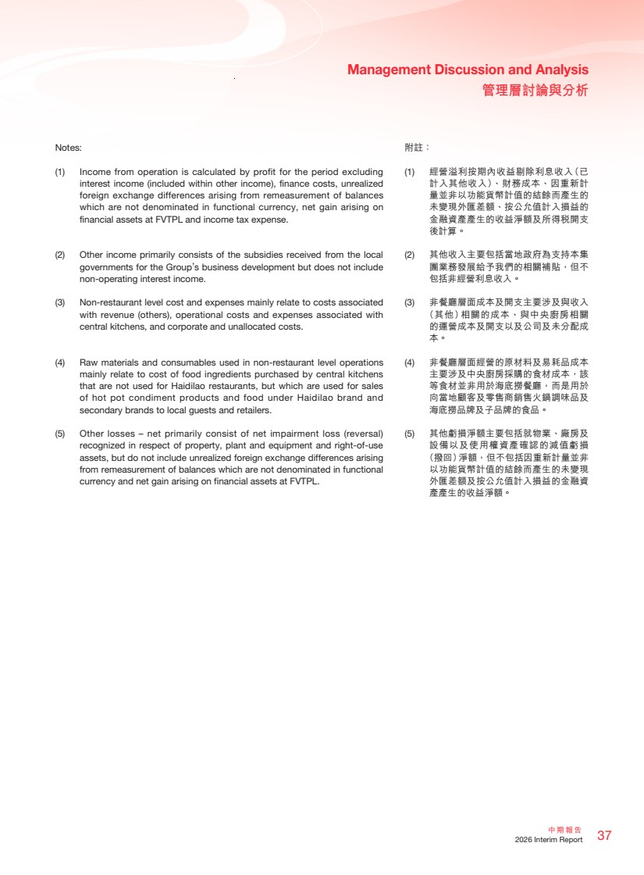 | 37 中期報告 2026 Interim Report Management Discussion and Analysis 管理層討論與分析 附註： (1) 經營溢利按期內收益剔除利息收入（已 計入其他收入）、財務成本、因重新計 量並非以功能貨幣計值的結餘而產生的 未變現外匯差額、按公允值計入損益的 金融資產產生的收益淨額及所得稅開支 後計算。 (2) 其他收入主要包括當地政府為支持本集 團業務發展給予我們的相關補貼，但不 包括非經營利息收入。 (3) 非餐廳層面成本及開支主要涉及與收入 （其他）相關的成本、與中央廚房相關 的運營成本及開支以及公司及未分配成 本。 (4) 非餐廳層面經營的原材料及易耗品成本 主要涉及中央廚房採購的食材成本，該 等食材並非用於海底撈餐廳，而是用於 向當地顧客及零售商銷售火鍋調味品及 海底撈品牌及子品牌的食品。 (5) 其他虧損淨額主要包括就物業、廠房及 設備以及使用權資產確認的減值虧損 （撥回）淨額，但不包括因重新計量並非 以功能貨幣計值的結餘而產生的未變現 外匯差額及按公允值計入損益的金融資 產產生的收益淨額。 Notes: (1) Income from operation is calculated by profit for the period excluding interest income (included within other income), finance costs, unrealized foreign exchange differences arising from remeasurement of balances which are not denominated in functional currency, net gain arising on financial assets at FVTPL and income tax expense. (2) Other income primarily consists of the subsidies received from the local governments for the Group’s business development but does not include non-operating interest income. (3) Non-restaurant level cost and expenses mainly relate to costs associated with revenue (others), operational costs and expenses associated with central kitchens, and corporate and unallocated costs. (4) Raw materials and consumables used in non-restaurant level operations mainly relate to cost of food ingredients purchased by central kitchens that are not used for Haidilao restaurants, but which are used for sales of hot pot condiment products and food under Haidilao brand and secondary brands to local guests and retailers. (5) Other losses – net primarily consist of net impairment loss (reversal) recognized in respect of property, plant and equipment and right-of-use assets, but do not include unrealized foreign exchange differences arising from remeasurement of balances which are not denominated in functional currency and net gain arising on financial assets at FVTPL.
 | 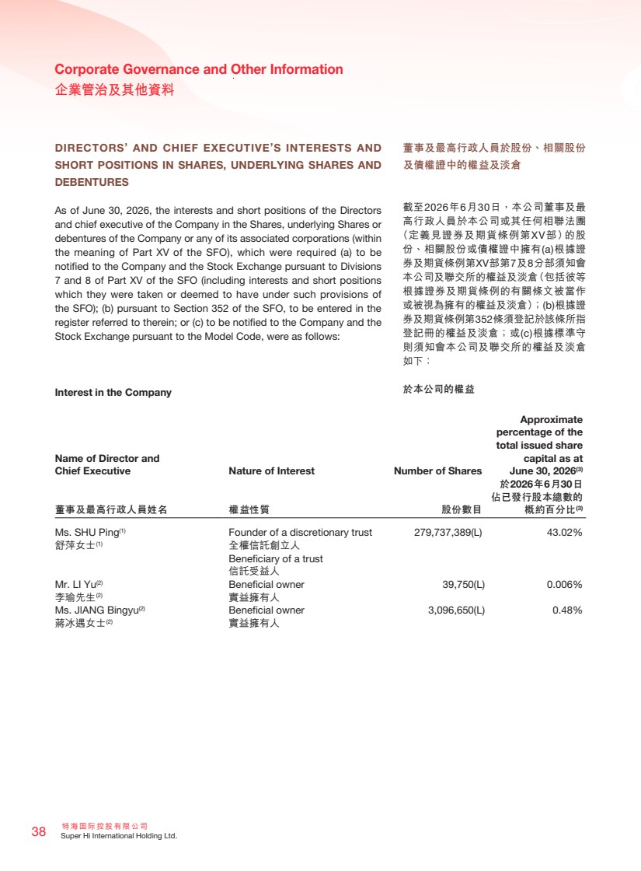 | 特海國際控股有限公司 38 Super Hi International Holding Ltd. Corporate Governance and Other Information 企業管治及其他資料 DIRECTORS’ AND CHIEF EXECUTIVE’S INTERESTS AND SHORT POSITIONS IN SHARES, UNDERLYING SHARES AND DEBENTURES As of June 30, 2026, the interests and short positions of the Directors and chief executive of the Company in the Shares, underlying Shares or debentures of the Company or any of its associated corporations (within the meaning of Part XV of the SFO), which were required (a) to be notified to the Company and the Stock Exchange pursuant to Divisions 7 and 8 of Part XV of the SFO (including interests and short positions which they were taken or deemed to have under such provisions of the SFO); (b) pursuant to Section 352 of the SFO, to be entered in the register referred to therein; or (c) to be notified to the Company and the Stock Exchange pursuant to the Model Code, were as follows: Interest in the Company Name of Director and Chief Executive Nature of Interest Number of Shares Approximate percentage of the total issued share capital as at June 30, 2026(3) 董事及最高行政人員姓名 權益性質 股份數目 於2026年6月30日 佔已發行股本總數的 概約百分比(3) Ms. SHU Ping(1) Founder of a discretionary trust 279,737,389(L) 43.02% 舒萍女士(1) 全權信託創立人 Beneficiary of a trust 信託受益人 Mr. LI Yu(2) Beneficial owner 39,750(L) 0.006% 李瑜先生(2) 實益擁有人 Ms. JIANG Bingyu(2) Beneficial owner 3,096,650(L) 0.48% 蔣冰遇女士(2) 實益擁有人 董事及最高行政人員於股份、相關股份 及債權證中的權益及淡倉 截至2026年6月30日，本公司董事及最 高行政人員於本公司或其任何相聯法團 （定義見證券及期貨條例第XV部）的股 份、相關股份或債權證中擁有(a)根據證 券及期貨條例第XV部第7及8分部須知會 本公司及聯交所的權益及淡倉（包括彼等 根據證券及期貨條例的有關條文被當作 或被視為擁有的權益及淡倉）；(b)根據證 券及期貨條例第352條須登記於該條所指 登記冊的權益及淡倉；或(c)根據標準守 則須知會本公司及聯交所的權益及淡倉 如下： 於本公司的權益
 | 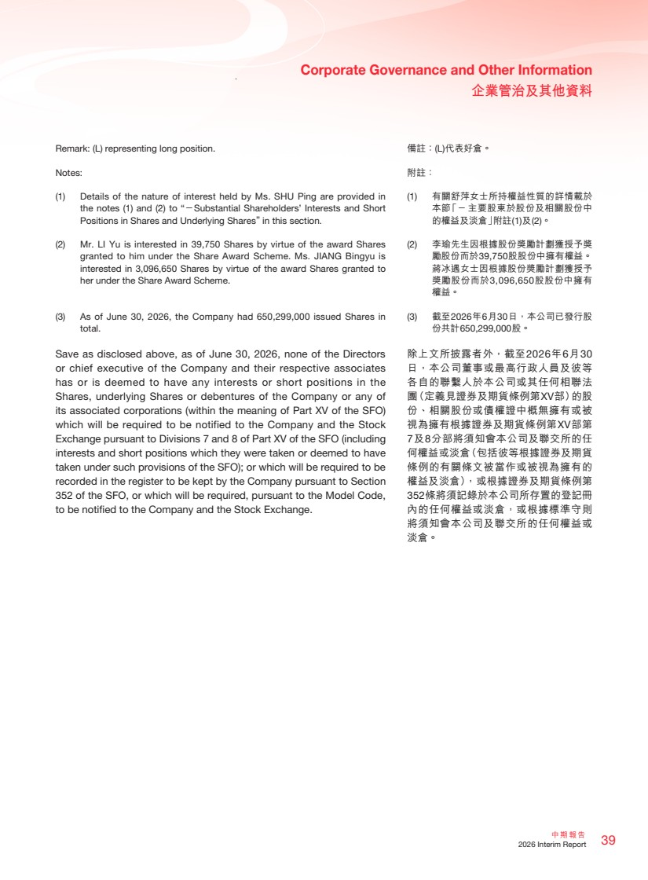 | 39 中期報告 2026 Interim Report Corporate Governance and Other Information 企業管治及其他資料 Remark: (L) representing long position. Notes: (1) Details of the nature of interest held by Ms. SHU Ping are provided in the notes (1) and (2) to “－Substantial Shareholders’ Interests and Short Positions in Shares and Underlying Shares” in this section. (2) Mr. LI Yu is interested in 39,750 Shares by virtue of the award Shares granted to him under the Share Award Scheme. Ms. JIANG Bingyu is interested in 3,096,650 Shares by virtue of the award Shares granted to her under the Share Award Scheme. (3) As of June 30, 2026, the Company had 650,299,000 issued Shares in total. Save as disclosed above, as of June 30, 2026, none of the Directors or chief executive of the Company and their respective associates has or is deemed to have any interests or short positions in the Shares, underlying Shares or debentures of the Company or any of its associated corporations (within the meaning of Part XV of the SFO) which will be required to be notified to the Company and the Stock Exchange pursuant to Divisions 7 and 8 of Part XV of the SFO (including interests and short positions which they were taken or deemed to have taken under such provisions of the SFO); or which will be required to be recorded in the register to be kept by the Company pursuant to Section 352 of the SFO, or which will be required, pursuant to the Model Code, to be notified to the Company and the Stock Exchange. 備註：(L)代表好倉。 附註： (1) 有關舒萍女士所持權益性質的詳情載於 本節「－ 主要股東於股份及相關股份中 的權益及淡倉」附註(1)及(2)。 (2) 李瑜先生因根據股份獎勵計劃獲授予獎 勵股份而於39,750股股份中擁有權益。 蔣冰遇女士因根據股份獎勵計劃獲授予 獎勵股份而於3,096,650股股份中擁有 權益。 (3) 截至2026年6月30日，本公司已發行股 份共計650,299,000股。 除上文所披露者外，截至2026年6月30 日，本公司董事或最高行政人員及彼等 各自的聯繫人於本公司或其任何相聯法 團（定義見證券及期貨條例第XV部）的股 份、相關股份或債權證中概無擁有或被 視為擁有根據證券及期貨條例第XV部第 7及8分部將須知會本公司及聯交所的任 何權益或淡倉（包括彼等根據證券及期貨 條例的有關條文被當作或被視為擁有的 權益及淡倉），或根據證券及期貨條例第 352條將須記錄於本公司所存置的登記冊 內的任何權益或淡倉，或根據標準守則 將須知會本公司及聯交所的任何權益或 淡倉。
 | 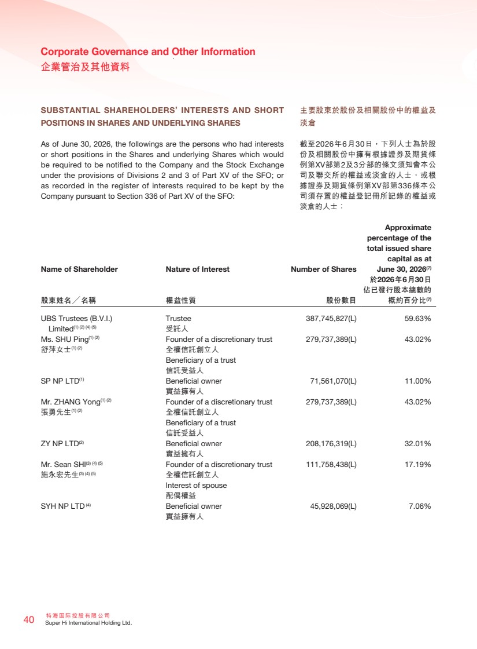 | 特海國際控股有限公司 40 Super Hi International Holding Ltd. Corporate Governance and Other Information 企業管治及其他資料 主要股東於股份及相關股份中的權益及 淡倉 截至2026年6月30日，下列人士為於股 份及相關股份中擁有根據證券及期貨條 例第XV部第2及3分部的條文須知會本公 司及聯交所的權益或淡倉的人士，或根 據證券及期貨條例第XV部第336條本公 司須存置的權益登記冊所記錄的權益或 淡倉的人士： SUBSTANTIAL SHAREHOLDERS’ INTERESTS AND SHORT POSITIONS IN SHARES AND UNDERLYING SHARES As of June 30, 2026, the followings are the persons who had interests or short positions in the Shares and underlying Shares which would be required to be notified to the Company and the Stock Exchange under the provisions of Divisions 2 and 3 of Part XV of the SFO; or as recorded in the register of interests required to be kept by the Company pursuant to Section 336 of Part XV of the SFO: Name of Shareholder Nature of Interest Number of Shares Approximate percentage of the total issued share capital as at June 30, 2026(7) 股東姓名╱名稱 權益性質 股份數目 於2026年6月30日 佔已發行股本總數的 概約百分比(7) UBS Trustees (B.V.I.) Limited(1) (2) (4) (5) Trustee 受託人 387,745,827(L) 59.63% Ms. SHU Ping(1) (2) Founder of a discretionary trust 279,737,389(L) 43.02% 舒萍女士(1) (2) 全權信託創立人 Beneficiary of a trust 信託受益人 SP NP LTD(1) Beneficial owner 71,561,070(L) 11.00% 實益擁有人 Mr. ZHANG Yong(1) (2) Founder of a discretionary trust 279,737,389(L) 43.02% 張勇先生(1) (2) 全權信託創立人 Beneficiary of a trust 信託受益人 ZY NP LTD(2) Beneficial owner 208,176,319(L) 32.01% 實益擁有人 Mr. Sean SHI(3) (4) (5) Founder of a discretionary trust 111,758,438(L) 17.19% 施永宏先生(3) (4) (5) 全權信託創立人 Interest of spouse 配偶權益 SYH NP LTD (4) Beneficial owner 45,928,069(L) 7.06% 實益擁有人
 | 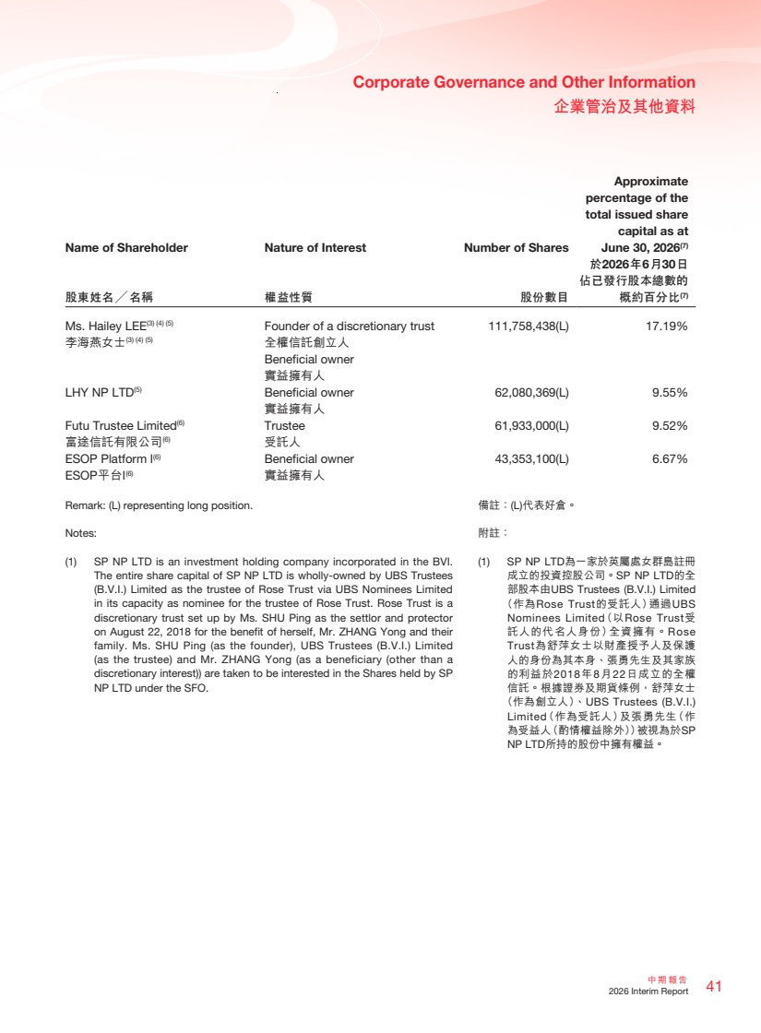 | 41 中期報告 2026 Interim Report Corporate Governance and Other Information 企業管治及其他資料 備註：(L)代表好倉。 附註： (1) SP NP LTD為一家於英屬處女群島註冊 成立的投資控股公司。SP NP LTD的全 部股本由UBS Trustees (B.V.I.) Limited （作為Rose Trust的受託人）通過UBS Nominees Limited（以Rose Trust受 託人的代名人身份）全資擁有。Rose Trust為舒萍女士以財產授予人及保護 人的身份為其本身、張勇先生及其家族 的利益於2018年8月22日成立的全權 信託。根據證券及期貨條例，舒萍女士 （作為創立人）、UBS Trustees (B.V.I.) Limited（作為受託人）及張勇先生（作 為受益人（酌情權益除外））被視為於SP NP LTD所持的股份中擁有權益。 Name of Shareholder Nature of Interest Number of Shares Approximate percentage of the total issued share capital as at June 30, 2026(7) 股東姓名╱名稱 權益性質 股份數目 於2026年6月30日 佔已發行股本總數的 概約百分比(7) Ms. Hailey LEE(3) (4) (5) Founder of a discretionary trust 111,758,438(L) 17.19% 李海燕女士(3) (4) (5) 全權信託創立人 Beneficial owner 實益擁有人 LHY NP LTD(5) Beneficial owner 62,080,369(L) 9.55% 實益擁有人 Futu Trustee Limited(6) Trustee 61,933,000(L) 9.52% 富途信託有限公司(6) 受託人 ESOP Platform I(6) Beneficial owner 43,353,100(L) 6.67% ESOP平台I (6) 實益擁有人 Remark: (L) representing long position. Notes: (1) SP NP LTD is an investment holding company incorporated in the BVI. The entire share capital of SP NP LTD is wholly-owned by UBS Trustees (B.V.I.) Limited as the trustee of Rose Trust via UBS Nominees Limited in its capacity as nominee for the trustee of Rose Trust. Rose Trust is a discretionary trust set up by Ms. SHU Ping as the settlor and protector on August 22, 2018 for the benefit of herself, Mr. ZHANG Yong and their family. Ms. SHU Ping (as the founder), UBS Trustees (B.V.I.) Limited (as the trustee) and Mr. ZHANG Yong (as a beneficiary (other than a discretionary interest)) are taken to be interested in the Shares held by SP NP LTD under the SFO.
 | 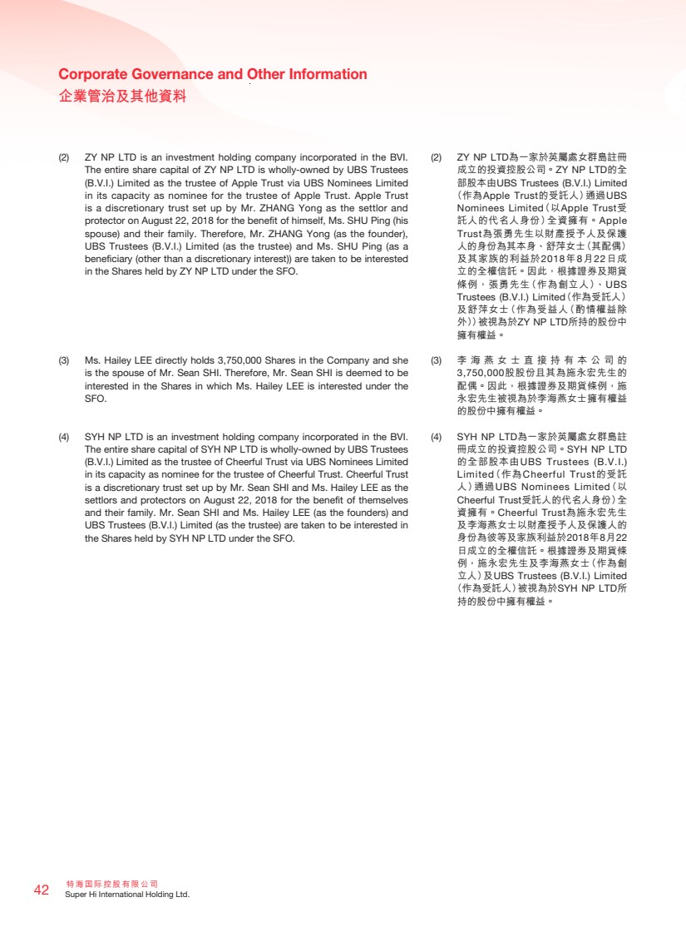 | 特海國際控股有限公司 42 Super Hi International Holding Ltd. Corporate Governance and Other Information 企業管治及其他資料 (2) ZY NP LTD為一家於英屬處女群島註冊 成立的投資控股公司。ZY NP LTD的全 部股本由UBS Trustees (B.V.I.) Limited （作為Apple Trust的受託人）通過UBS Nominees Limited（以Apple Trust受 託人的代名人身份）全資擁有。Apple Trust為張勇先生以財產授予人及保護 人的身份為其本身、舒萍女士（其配偶） 及其家族的利益於2018年8月22日成 立的全權信託。因此，根據證券及期貨 條例，張勇先生（作為創立人）、UBS Trustees (B.V.I.) Limited（作為受託人） 及舒萍女士（作為受益人（酌情權益除 外））被視為於ZY NP LTD所持的股份中 擁有權益。 (3) 李海燕女士直接持有本公司的 3,750,000股股份且其為施永宏先生的 配偶。因此，根據證券及期貨條例，施 永宏先生被視為於李海燕女士擁有權益 的股份中擁有權益。 (4) SYH NP LTD為一家於英屬處女群島註 冊成立的投資控股公司。SYH NP LTD 的全部股本由UBS Trustees (B.V.I.) Limited（作為Cheerful Trust的受託 人）通過UBS Nominees Limited（以 Cheerful Trust受託人的代名人身份）全 資擁有。Cheerful Trust為施永宏先生 及李海燕女士以財產授予人及保護人的 身份為彼等及家族利益於2018年8月22 日成立的全權信託。根據證券及期貨條 例，施永宏先生及李海燕女士（作為創 立人）及UBS Trustees (B.V.I.) Limited （作為受託人）被視為於SYH NP LTD所 持的股份中擁有權益。 (2) ZY NP LTD is an investment holding company incorporated in the BVI. The entire share capital of ZY NP LTD is wholly-owned by UBS Trustees (B.V.I.) Limited as the trustee of Apple Trust via UBS Nominees Limited in its capacity as nominee for the trustee of Apple Trust. Apple Trust is a discretionary trust set up by Mr. ZHANG Yong as the settlor and protector on August 22, 2018 for the benefit of himself, Ms. SHU Ping (his spouse) and their family. Therefore, Mr. ZHANG Yong (as the founder), UBS Trustees (B.V.I.) Limited (as the trustee) and Ms. SHU Ping (as a beneficiary (other than a discretionary interest)) are taken to be interested in the Shares held by ZY NP LTD under the SFO. (3) Ms. Hailey LEE directly holds 3,750,000 Shares in the Company and she is the spouse of Mr. Sean SHI. Therefore, Mr. Sean SHI is deemed to be interested in the Shares in which Ms. Hailey LEE is interested under the SFO. (4) SYH NP LTD is an investment holding company incorporated in the BVI. The entire share capital of SYH NP LTD is wholly-owned by UBS Trustees (B.V.I.) Limited as the trustee of Cheerful Trust via UBS Nominees Limited in its capacity as nominee for the trustee of Cheerful Trust. Cheerful Trust is a discretionary trust set up by Mr. Sean SHI and Ms. Hailey LEE as the settlors and protectors on August 22, 2018 for the benefit of themselves and their family. Mr. Sean SHI and Ms. Hailey LEE (as the founders) and UBS Trustees (B.V.I.) Limited (as the trustee) are taken to be interested in the Shares held by SYH NP LTD under the SFO.
 | 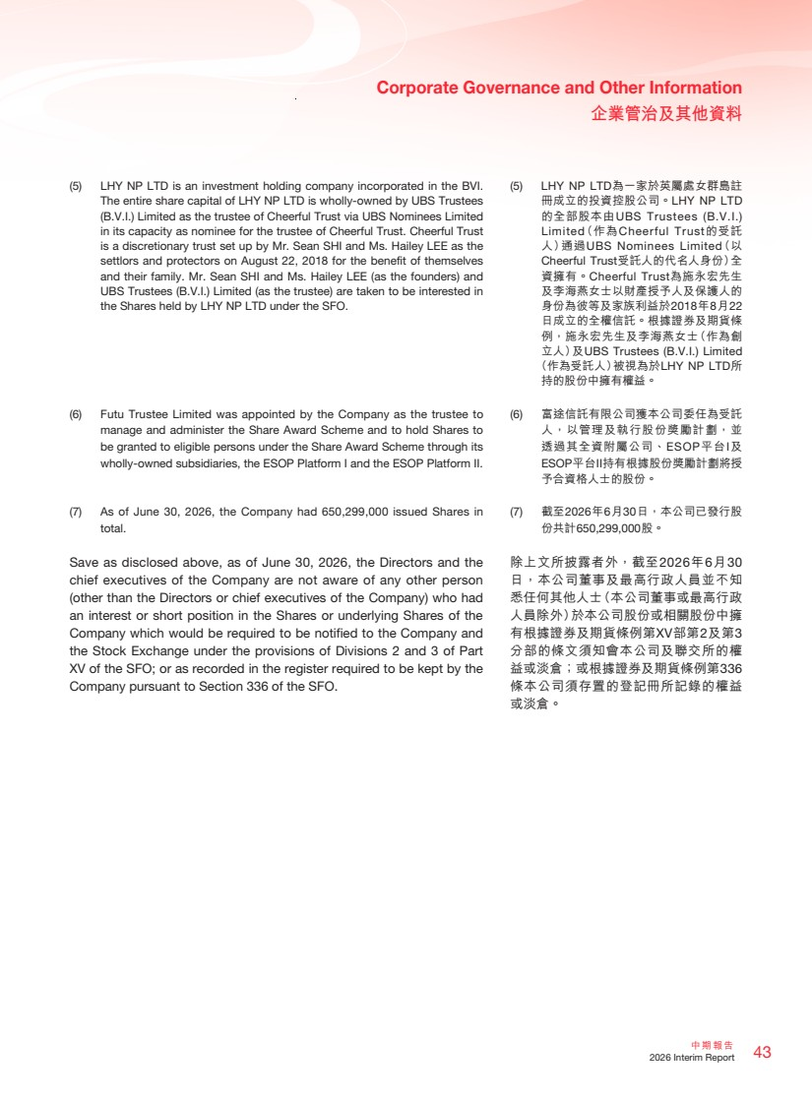 | 43 中期報告 2026 Interim Report Corporate Governance and Other Information 企業管治及其他資料 (5) LHY NP LTD為一家於英屬處女群島註 冊成立的投資控股公司。LHY NP LTD 的全部股本由UBS Trustees (B.V.I.) Limited（作為Cheerful Trust的受託 人）通過UBS Nominees Limited（以 Cheerful Trust受託人的代名人身份）全 資擁有。Cheerful Trust為施永宏先生 及李海燕女士以財產授予人及保護人的 身份為彼等及家族利益於2018年8月22 日成立的全權信託。根據證券及期貨條 例，施永宏先生及李海燕女士（作為創 立人）及UBS Trustees (B.V.I.) Limited （作為受託人）被視為於LHY NP LTD所 持的股份中擁有權益。 (6) 富途信託有限公司獲本公司委任為受託 人，以管理及執行股份獎勵計劃，並 透過其全資附屬公司、ESOP平台I及 ESOP平台II持有根據股份獎勵計劃將授 予合資格人士的股份。 (7) 截至2026年6月30日，本公司已發行股 份共計650,299,000股。 除上文所披露者外，截至2026年6月30 日，本公司董事及最高行政人員並不知 悉任何其他人士（本公司董事或最高行政 人員除外）於本公司股份或相關股份中擁 有根據證券及期貨條例第XV部第2及第3 分部的條文須知會本公司及聯交所的權 益或淡倉；或根據證券及期貨條例第336 條本公司須存置的登記冊所記錄的權益 或淡倉。 (5) LHY NP LTD is an investment holding company incorporated in the BVI. The entire share capital of LHY NP LTD is wholly-owned by UBS Trustees (B.V.I.) Limited as the trustee of Cheerful Trust via UBS Nominees Limited in its capacity as nominee for the trustee of Cheerful Trust. Cheerful Trust is a discretionary trust set up by Mr. Sean SHI and Ms. Hailey LEE as the settlors and protectors on August 22, 2018 for the benefit of themselves and their family. Mr. Sean SHI and Ms. Hailey LEE (as the founders) and UBS Trustees (B.V.I.) Limited (as the trustee) are taken to be interested in the Shares held by LHY NP LTD under the SFO. (6) Futu Trustee Limited was appointed by the Company as the trustee to manage and administer the Share Award Scheme and to hold Shares to be granted to eligible persons under the Share Award Scheme through its wholly-owned subsidiaries, the ESOP Platform I and the ESOP Platform II. (7) As of June 30, 2026, the Company had 650,299,000 issued Shares in total. Save as disclosed above, as of June 30, 2026, the Directors and the chief executives of the Company are not aware of any other person (other than the Directors or chief executives of the Company) who had an interest or short position in the Shares or underlying Shares of the Company which would be required to be notified to the Company and the Stock Exchange under the provisions of Divisions 2 and 3 of Part XV of the SFO; or as recorded in the register required to be kept by the Company pursuant to Section 336 of the SFO.
 | 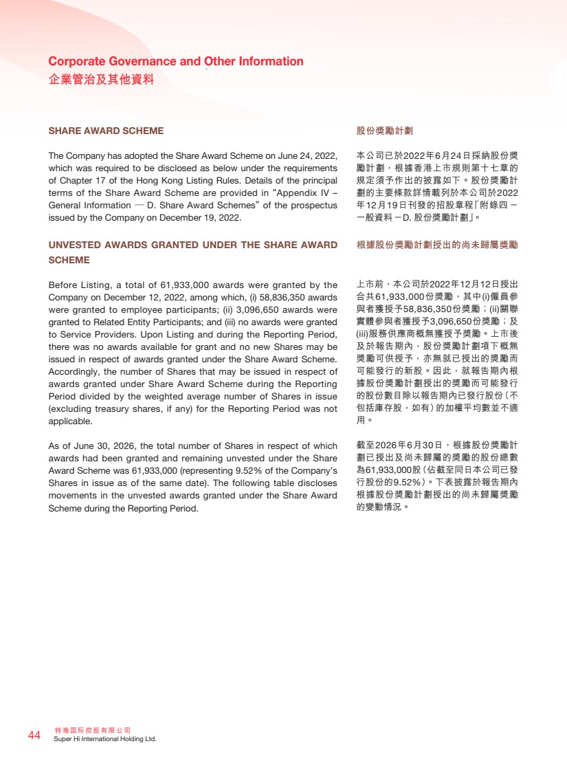 | 特海國際控股有限公司 44 Super Hi International Holding Ltd. Corporate Governance and Other Information 企業管治及其他資料 股份獎勵計劃 本公司已於2022年6月24日採納股份獎 勵計劃，根據香港上市規則第十七章的 規定須予作出的披露如下。股份獎勵計 劃的主要條款詳情載列於本公司於2022 年12月19日刊發的招股章程「附錄四 － 一般資料－D. 股份獎勵計劃」。 根據股份獎勵計劃授出的尚未歸屬獎勵 上市前，本公司於2022年12月12日授出 合共61,933,000份獎勵，其中(i)僱員參 與者獲授予58,836,350份獎勵；(ii)關聯 實體參與者獲授予3,096,650份獎勵；及 (iii)服務供應商概無獲授予獎勵。上市後 及於報告期內，股份獎勵計劃項下概無 獎勵可供授予，亦無就已授出的獎勵而 可能發行的新股。因此，就報告期內根 據股份獎勵計劃授出的獎勵而可能發行 的股份數目除以報告期內已發行股份（不 包括庫存股，如有）的加權平均數並不適 用。 截至2026年6月30日，根據股份獎勵計 劃已授出及尚未歸屬的獎勵的股份總數 為61,933,000股（佔截至同日本公司已發 行股份的9.52%）。下表披露於報告期內 根據股份獎勵計劃授出的尚未歸屬獎勵 的變動情況。 SHARE AWARD SCHEME The Company has adopted the Share Award Scheme on June 24, 2022, which was required to be disclosed as below under the requirements of Chapter 17 of the Hong Kong Listing Rules. Details of the principal terms of the Share Award Scheme are provided in “Appendix IV – General Information — D. Share Award Schemes” of the prospectus issued by the Company on December 19, 2022. UNVESTED AWARDS GRANTED UNDER THE SHARE AWARD SCHEME Before Listing, a total of 61,933,000 awards were granted by the Company on December 12, 2022, among which, (i) 58,836,350 awards were granted to employee participants; (ii) 3,096,650 awards were granted to Related Entity Participants; and (iii) no awards were granted to Service Providers. Upon Listing and during the Reporting Period, there was no awards available for grant and no new Shares may be issued in respect of awards granted under the Share Award Scheme. Accordingly, the number of Shares that may be issued in respect of awards granted under Share Award Scheme during the Reporting Period divided by the weighted average number of Shares in issue (excluding treasury shares, if any) for the Reporting Period was not applicable. As of June 30, 2026, the total number of Shares in respect of which awards had been granted and remaining unvested under the Share Award Scheme was 61,933,000 (representing 9.52% of the Company’s Shares in issue as of the same date). The following table discloses movements in the unvested awards granted under the Share Award Scheme during the Reporting Period.
 | 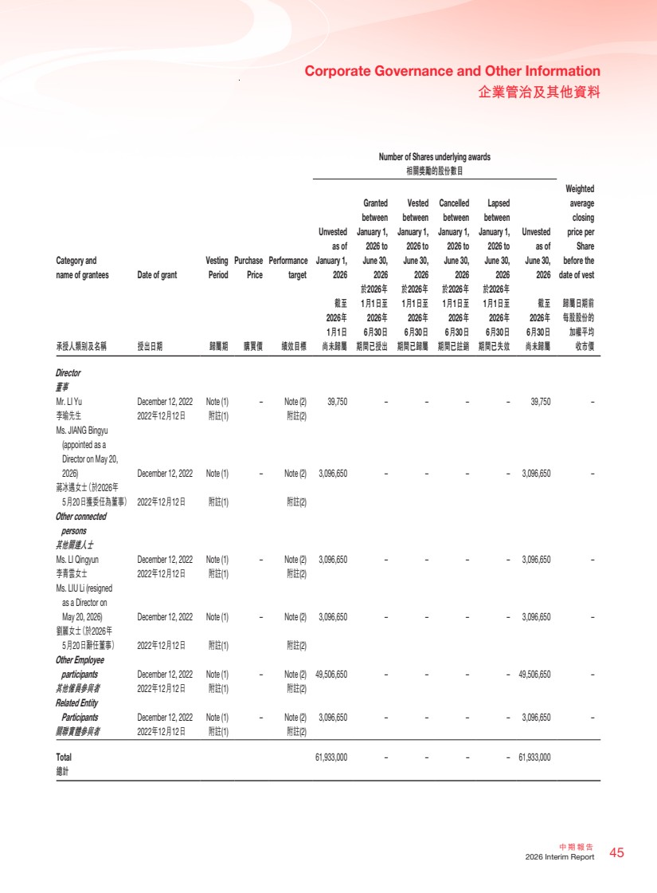 | 45 中期報告 2026 Interim Report Corporate Governance and Other Information 企業管治及其他資料 Number of Shares underlying awards 相關獎勵的股份數目 Category and name of grantees Date of grant Vesting Period Purchase Price Performance target Unvested as of January 1, 2026 Granted between January 1, 2026 to June 30, 2026 Vested between January 1, 2026 to June 30, 2026 Cancelled between January 1, 2026 to June 30, 2026 Lapsed between January 1, 2026 to June 30, 2026 Unvested as of June 30, 2026 Weighted average closing price per Share before the date of vest 承授人類別及名稱 授出日期 歸屬期 購買價 績效目標 截至 2026年 1月1日 尚未歸屬 於2026年 1月1日至 2026年 6月30日 期間已授出 於2026年 1月1日至 2026年 6月30日 期間已歸屬 於2026年 1月1日至 2026年 6月30日 期間已註銷 於2026年 1月1日至 2026年 6月30日 期間已失效 截至 2026年 6月30日 尚未歸屬 歸屬日期前 每股股份的 加權平均 收市價 Director 董事 Mr. LI Yu December 12, 2022 Note (1) – Note (2) 39,750 – – – – 39,750 – 李瑜先生 2022年12月12日 附註(1) 附註(2) Ms. JIANG Bingyu (appointed as a Director on May 20, 2026) December 12, 2022 Note (1) – Note (2) 3,096,650 – – – – 3,096,650 – 蔣冰遇女士（於2026年 5月20日獲委任為董事） 2022年12月12日 附註(1) 附註(2) Other connected persons 其他關連人士 Ms. LI Qingyun December 12, 2022 Note (1) – Note (2) 3,096,650 – – – – 3,096,650 – 李青雲女士 2022年12月12日 附註(1) 附註(2) Ms. LIU Li (resigned as a Director on May 20, 2026) December 12, 2022 Note (1) – Note (2) 3,096,650 – – – – 3,096,650 – 劉麗女士（於2026年 5月20日辭任董事） 2022年12月12日 附註(1) 附註(2) Other Employee participants December 12, 2022 Note (1) – Note (2) 49,506,650 – – – – 49,506,650 – 其他僱員參與者 2022年12月12日 附註(1) 附註(2) Related Entity Participants December 12, 2022 Note (1) – Note (2) 3,096,650 – – – – 3,096,650 – 關聯實體參與者 2022年12月12日 附註(1) 附註(2) Total 61,933,000 – – – – 61,933,000 總計
 | 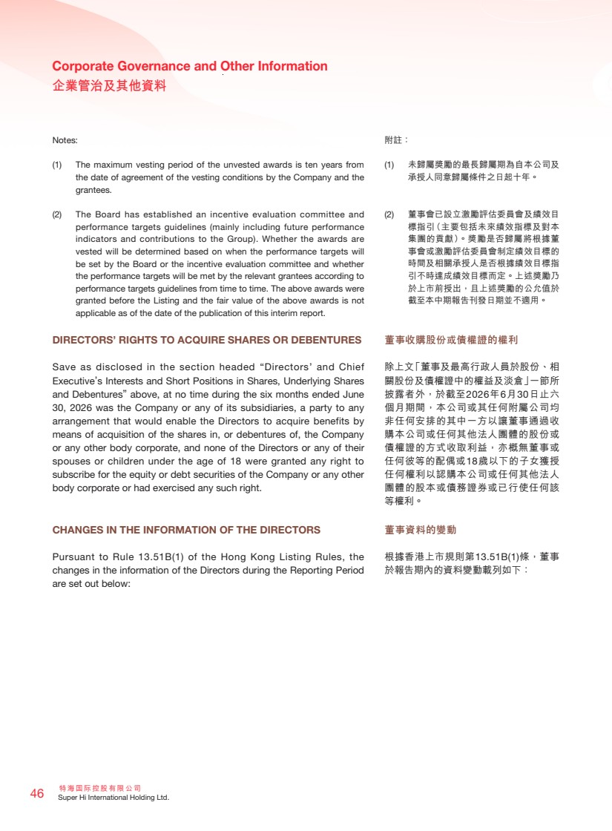 | 特海國際控股有限公司 46 Super Hi International Holding Ltd. Corporate Governance and Other Information 企業管治及其他資料 附註： (1) 未歸屬獎勵的最長歸屬期為自本公司及 承授人同意歸屬條件之日起十年。 (2) 董事會已設立激勵評估委員會及績效目 標指引（主要包括未來績效指標及對本 集團的貢獻）。獎勵是否歸屬將根據董 事會或激勵評估委員會制定績效目標的 時間及相關承授人是否根據績效目標指 引不時達成績效目標而定。上述獎勵乃 於上市前授出，且上述獎勵的公允值於 截至本中期報告刊發日期並不適用。 董事收購股份或債權證的權利 除上文「董事及最高行政人員於股份、相 關股份及債權證中的權益及淡倉」一節所 披露者外，於截至2026年6月30日止六 個月期間，本公司或其任何附屬公司均 非任何安排的其中一方以讓董事通過收 購本公司或任何其他法人團體的股份或 債權證的方式收取利益，亦概無董事或 任何彼等的配偶或18歲以下的子女獲授 任何權利以認購本公司或任何其他法人 團體的股本或債務證券或已行使任何該 等權利。 董事資料的變動 根據香港上市規則第13.51B(1)條，董事 於報告期內的資料變動載列如下： Notes: (1) The maximum vesting period of the unvested awards is ten years from the date of agreement of the vesting conditions by the Company and the grantees. (2) The Board has established an incentive evaluation committee and performance targets guidelines (mainly including future performance indicators and contributions to the Group). Whether the awards are vested will be determined based on when the performance targets will be set by the Board or the incentive evaluation committee and whether the performance targets will be met by the relevant grantees according to performance targets guidelines from time to time. The above awards were granted before the Listing and the fair value of the above awards is not applicable as of the date of the publication of this interim report. DIRECTORS’ RIGHTS TO ACQUIRE SHARES OR DEBENTURES Save as disclosed in the section headed “Directors’ and Chief Executive’s Interests and Short Positions in Shares, Underlying Shares and Debentures” above, at no time during the six months ended June 30, 2026 was the Company or any of its subsidiaries, a party to any arrangement that would enable the Directors to acquire benefits by means of acquisition of the shares in, or debentures of, the Company or any other body corporate, and none of the Directors or any of their spouses or children under the age of 18 were granted any right to subscribe for the equity or debt securities of the Company or any other body corporate or had exercised any such right. CHANGES IN THE INFORMATION OF THE DIRECTORS Pursuant to Rule 13.51B(1) of the Hong Kong Listing Rules, the changes in the information of the Directors during the Reporting Period are set out below:
 | 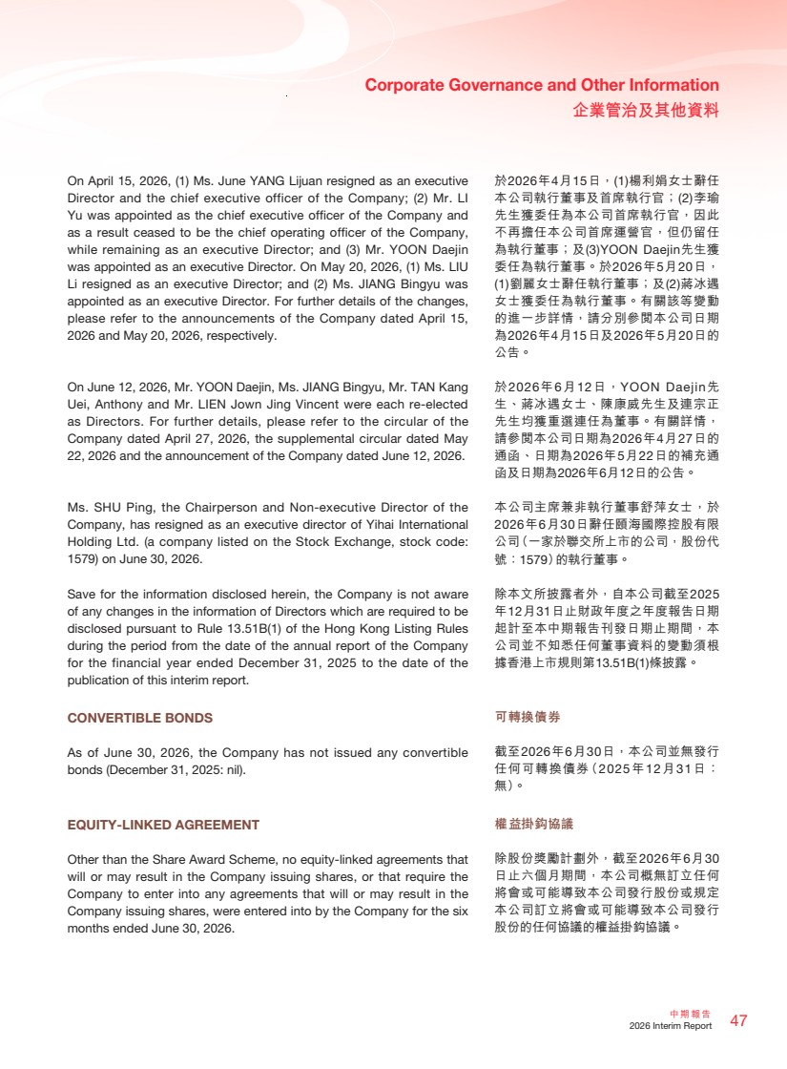 | 47 中期報告 2026 Interim Report Corporate Governance and Other Information 企業管治及其他資料 於2026年4月15日，(1)楊利娟女士辭任 本公司執行董事及首席執行官；(2)李瑜 先生獲委任為本公司首席執行官，因此 不再擔任本公司首席運營官，但仍留任 為執行董事；及(3)YOON Daejin先生獲 委任為執行董事。於2026年5月20日， (1)劉麗女士辭任執行董事；及(2)蔣冰遇 女士獲委任為執行董事。有關該等變動 的進一步詳情，請分別參閱本公司日期 為2026年4月15日及2026年5月20日的 公告。 於2026年6月12日，YOON Daejin先 生、蔣冰遇女士、陳康威先生及連宗正 先生均獲重選連任為董事。有關詳情， 請參閱本公司日期為2026年4月27日的 通函、日期為2026年5月22日的補充通 函及日期為2026年6月12日的公告。 本公司主席兼非執行董事舒萍女士，於 2026年6月30日辭任頤海國際控股有限 公司（一家於聯交所上市的公司，股份代 號：1579）的執行董事。 除本文所披露者外，自本公司截至2025 年12月31日止財政年度之年度報告日期 起計至本中期報告刊發日期止期間，本 公司並不知悉任何董事資料的變動須根 據香港上市規則第13.51B(1)條披露。 可轉換債券 截至2026年6月30日，本公司並無發行 任何可轉換債券（2025年12月31日： 無）。 權益掛鈎協議 除股份獎勵計劃外，截至2026年6月30 日止六個月期間，本公司概無訂立任何 將會或可能導致本公司發行股份或規定 本公司訂立將會或可能導致本公司發行 股份的任何協議的權益掛鈎協議。 On April 15, 2026, (1) Ms. June YANG Lijuan resigned as an executive Director and the chief executive officer of the Company; (2) Mr. LI Yu was appointed as the chief executive officer of the Company and as a result ceased to be the chief operating officer of the Company, while remaining as an executive Director; and (3) Mr. YOON Daejin was appointed as an executive Director. On May 20, 2026, (1) Ms. LIU Li resigned as an executive Director; and (2) Ms. JIANG Bingyu was appointed as an executive Director. For further details of the changes, please refer to the announcements of the Company dated April 15, 2026 and May 20, 2026, respectively. On June 12, 2026, Mr. YOON Daejin, Ms. JIANG Bingyu, Mr. TAN Kang Uei, Anthony and Mr. LIEN Jown Jing Vincent were each re-elected as Directors. For further details, please refer to the circular of the Company dated April 27, 2026, the supplemental circular dated May 22, 2026 and the announcement of the Company dated June 12, 2026. Ms. SHU Ping, the Chairperson and Non-executive Director of the Company, has resigned as an executive director of Yihai International Holding Ltd. (a company listed on the Stock Exchange, stock code: 1579) on June 30, 2026. Save for the information disclosed herein, the Company is not aware of any changes in the information of Directors which are required to be disclosed pursuant to Rule 13.51B(1) of the Hong Kong Listing Rules during the period from the date of the annual report of the Company for the financial year ended December 31, 2025 to the date of the publication of this interim report. CONVERTIBLE BONDS As of June 30, 2026, the Company has not issued any convertible bonds (December 31, 2025: nil). EQUITY-LINKED AGREEMENT Other than the Share Award Scheme, no equity-linked agreements that will or may result in the Company issuing shares, or that require the Company to enter into any agreements that will or may result in the Company issuing shares, were entered into by the Company for the six months ended June 30, 2026.
 | 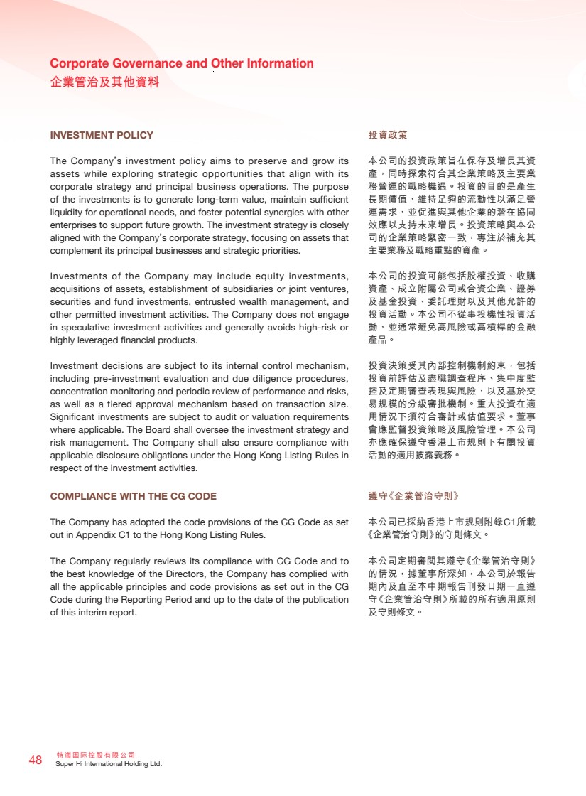 | 特海國際控股有限公司 48 Super Hi International Holding Ltd. Corporate Governance and Other Information 企業管治及其他資料 投資政策 本公司的投資政策旨在保存及增長其資 產，同時探索符合其企業策略及主要業 務營運的戰略機遇。投資的目的是產生 長期價值，維持足夠的流動性以滿足營 運需求，並促進與其他企業的潛在協同 效應以支持未來增長。投資策略與本公 司的企業策略緊密一致，專注於補充其 主要業務及戰略重點的資產。 本公司的投資可能包括股權投資、收購 資產、成立附屬公司或合資企業、證券 及基金投資、委託理財以及其他允許的 投資活動。本公司不從事投機性投資活 動，並通常避免高風險或高槓桿的金融 產品。 投資決策受其內部控制機制約束，包括 投資前評估及盡職調查程序、集中度監 控及定期審查表現與風險，以及基於交 易規模的分級審批機制。重大投資在適 用情況下須符合審計或估值要求。董事 會應監督投資策略及風險管理。本公司 亦應確保遵守香港上市規則下有關投資 活動的適用披露義務。 遵守《企業管治守則》 本公司已採納香港上市規則附錄C1所載 《企業管治守則》的守則條文。 本公司定期審閱其遵守《企業管治守則》 的情況，據董事所深知，本公司於報告 期內及直至本中期報告刊發日期一直遵 守《企業管治守則》所載的所有適用原則 及守則條文。 INVESTMENT POLICY The Company’s investment policy aims to preserve and grow its assets while exploring strategic opportunities that align with its corporate strategy and principal business operations. The purpose of the investments is to generate long-term value, maintain sufficient liquidity for operational needs, and foster potential synergies with other enterprises to support future growth. The investment strategy is closely aligned with the Company’s corporate strategy, focusing on assets that complement its principal businesses and strategic priorities. Investments of the Company may include equity investments, acquisitions of assets, establishment of subsidiaries or joint ventures, securities and fund investments, entrusted wealth management, and other permitted investment activities. The Company does not engage in speculative investment activities and generally avoids high-risk or highly leveraged financial products. Investment decisions are subject to its internal control mechanism, including pre-investment evaluation and due diligence procedures, concentration monitoring and periodic review of performance and risks, as well as a tiered approval mechanism based on transaction size. Significant investments are subject to audit or valuation requirements where applicable. The Board shall oversee the investment strategy and risk management. The Company shall also ensure compliance with applicable disclosure obligations under the Hong Kong Listing Rules in respect of the investment activities. COMPLIANCE WITH THE CG CODE The Company has adopted the code provisions of the CG Code as set out in Appendix C1 to the Hong Kong Listing Rules. The Company regularly reviews its compliance with CG Code and to the best knowledge of the Directors, the Company has complied with all the applicable principles and code provisions as set out in the CG Code during the Reporting Period and up to the date of the publication of this interim report.
 | 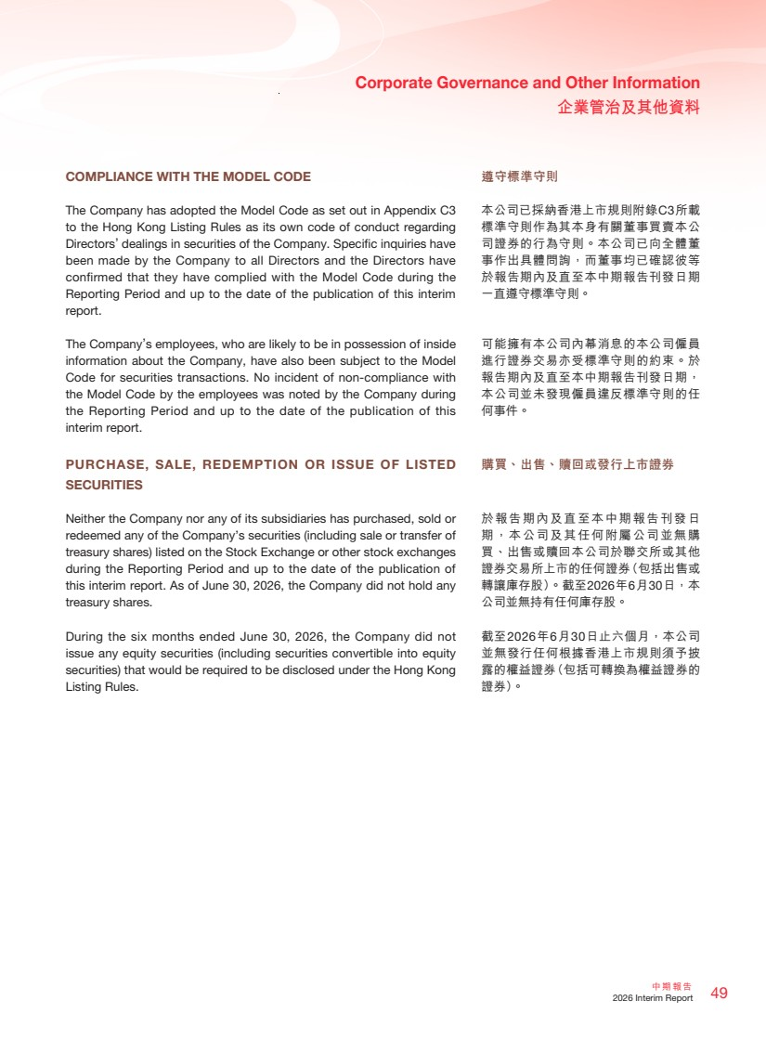 | 49 中期報告 2026 Interim Report Corporate Governance and Other Information 企業管治及其他資料 遵守標準守則 本公司已採納香港上市規則附錄C3所載 標準守則作為其本身有關董事買賣本公 司證券的行為守則。本公司已向全體董 事作出具體問詢，而董事均已確認彼等 於報告期內及直至本中期報告刊發日期 一直遵守標準守則。 可能擁有本公司內幕消息的本公司僱員 進行證券交易亦受標準守則的約束。於 報告期內及直至本中期報告刊發日期， 本公司並未發現僱員違反標準守則的任 何事件。 購買、出售、贖回或發行上市證券 於報告期內及直至本中期報告刊發日 期，本公司及其任何附屬公司並無購 買、出售或贖回本公司於聯交所或其他 證券交易所上市的任何證券（包括出售或 轉讓庫存股）。截至2026年6月30日，本 公司並無持有任何庫存股。 截至2026年6月30日止六個月，本公司 並無發行任何根據香港上市規則須予披 露的權益證券（包括可轉換為權益證券的 證券）。 COMPLIANCE WITH THE MODEL CODE The Company has adopted the Model Code as set out in Appendix C3 to the Hong Kong Listing Rules as its own code of conduct regarding Directors’ dealings in securities of the Company. Specific inquiries have been made by the Company to all Directors and the Directors have confirmed that they have complied with the Model Code during the Reporting Period and up to the date of the publication of this interim report. The Company’s employees, who are likely to be in possession of inside information about the Company, have also been subject to the Model Code for securities transactions. No incident of non-compliance with the Model Code by the employees was noted by the Company during the Reporting Period and up to the date of the publication of this interim report. PURCHASE, SALE, REDEMPTION OR ISSUE OF LISTED SECURITIES Neither the Company nor any of its subsidiaries has purchased, sold or redeemed any of the Company’s securities (including sale or transfer of treasury shares) listed on the Stock Exchange or other stock exchanges during the Reporting Period and up to the date of the publication of this interim report. As of June 30, 2026, the Company did not hold any treasury shares. During the six months ended June 30, 2026, the Company did not issue any equity securities (including securities convertible into equity securities) that would be required to be disclosed under the Hong Kong Listing Rules.
 | 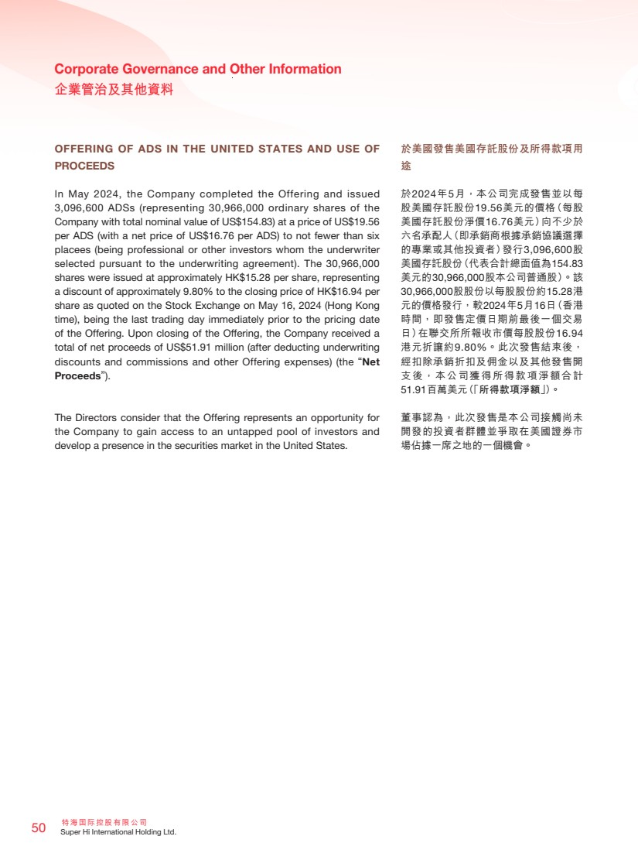 | 特海國際控股有限公司 50 Super Hi International Holding Ltd. Corporate Governance and Other Information 企業管治及其他資料 OFFERING OF ADS IN THE UNITED STATES AND USE OF PROCEEDS In May 2024, the Company completed the Offering and issued 3,096,600 ADSs (representing 30,966,000 ordinary shares of the Company with total nominal value of US$154.83) at a price of US$19.56 per ADS (with a net price of US$16.76 per ADS) to not fewer than six placees (being professional or other investors whom the underwriter selected pursuant to the underwriting agreement). The 30,966,000 shares were issued at approximately HK$15.28 per share, representing a discount of approximately 9.80% to the closing price of HK$16.94 per share as quoted on the Stock Exchange on May 16, 2024 (Hong Kong time), being the last trading day immediately prior to the pricing date of the Offering. Upon closing of the Offering, the Company received a total of net proceeds of US$51.91 million (after deducting underwriting discounts and commissions and other Offering expenses) (the “Net Proceeds”). The Directors consider that the Offering represents an opportunity for the Company to gain access to an untapped pool of investors and develop a presence in the securities market in the United States. 於美國發售美國存託股份及所得款項用 途 於2024年5月，本公司完成發售並以每 股美國存託股份19.56美元的價格（每股 美國存託股份淨價16.76美元）向不少於 六名承配人（即承銷商根據承銷協議選擇 的專業或其他投資者）發行3,096,600股 美國存託股份（代表合計總面值為154.83 美元的30,966,000股本公司普通股）。該 30,966,000股股份以每股股份約15.28港 元的價格發行，較2024年5月16日（香港 時間，即發售定價日期前最後一個交易 日）在聯交所所報收市價每股股份16.94 港元折讓約9.80%。此次發售結束後， 經扣除承銷折扣及佣金以及其他發售開 支後，本公司獲得所得款項淨額合計 51.91百萬美元（「所得款項淨額」）。 董事認為，此次發售是本公司接觸尚未 開發的投資者群體並爭取在美國證券市 場佔據一席之地的一個機會。
 | 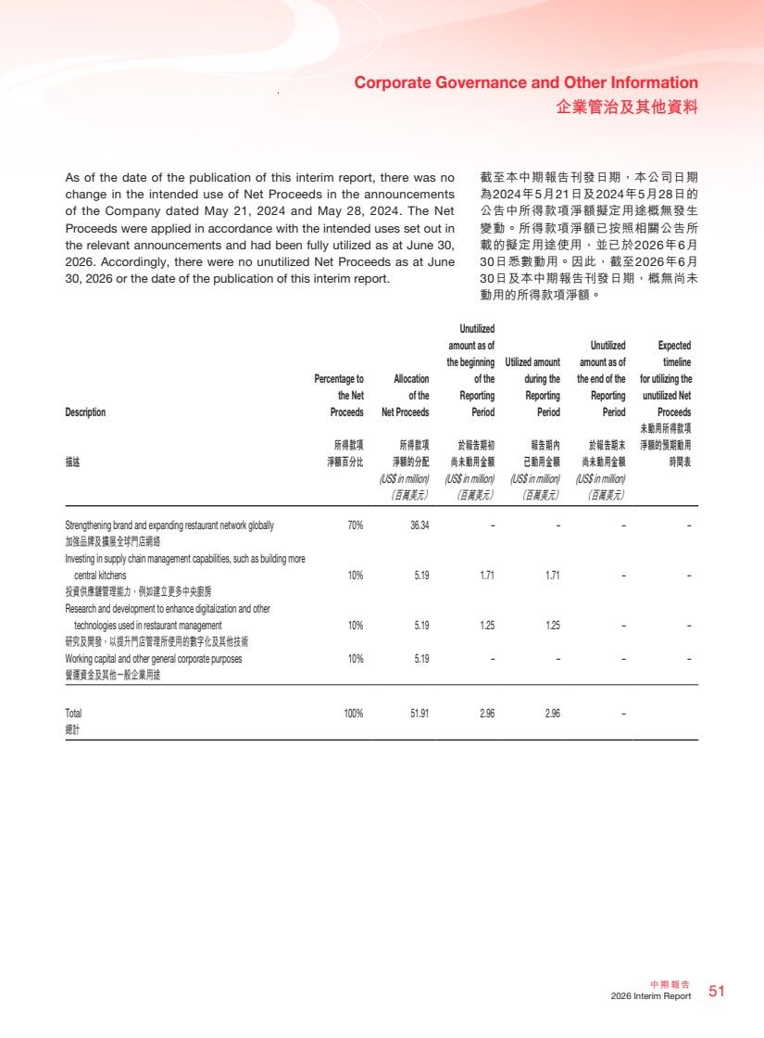 | 51 中期報告 2026 Interim Report Corporate Governance and Other Information 企業管治及其他資料 As of the date of the publication of this interim report, there was no change in the intended use of Net Proceeds in the announcements of the Company dated May 21, 2024 and May 28, 2024. The Net Proceeds were applied in accordance with the intended uses set out in the relevant announcements and had been fully utilized as at June 30, 2026. Accordingly, there were no unutilized Net Proceeds as at June 30, 2026 or the date of the publication of this interim report. Description Percentage to the Net Proceeds Allocation of the Net Proceeds Unutilized amount as of the beginning of the Reporting Period Utilized amount during the Reporting Period Unutilized amount as of the end of the Reporting Period Expected timeline for utilizing the unutilized Net Proceeds 描述 所得款項 淨額百分比 所得款項 淨額的分配 於報告期初 尚未動用金額 報告期內 已動用金額 於報告期末 尚未動用金額 未動用所得款項 淨額的預期動用 時間表 (US$ in million) (US$ in million) (US$ in million) (US$ in million) （百萬美元） （百萬美元） （百萬美元） （百萬美元） Strengthening brand and expanding restaurant network globally 70% 36.34 – – – – 加強品牌及擴展全球門店網絡 Investing in supply chain management capabilities, such as building more central kitchens 10% 5.19 1.71 1.71 – – 投資供應鏈管理能力，例如建立更多中央廚房 Research and development to enhance digitalization and other technologies used in restaurant management 10% 5.19 1.25 1.25 – – 研究及開發，以提升門店管理所使用的數字化及其他技術 Working capital and other general corporate purposes 10% 5.19 – – – – 營運資金及其他一般企業用途 Total 100% 51.91 2.96 2.96 – 總計 截至本中期報告刊發日期，本公司日期 為2024年5月21日及2024年5月28日的 公告中所得款項淨額擬定用途概無發生 變動。所得款項淨額已按照相關公告所 載的擬定用途使用，並已於2026年6月 30日悉數動用。因此，截至2026年6月 30日及本中期報告刊發日期，概無尚未 動用的所得款項淨額。
 | 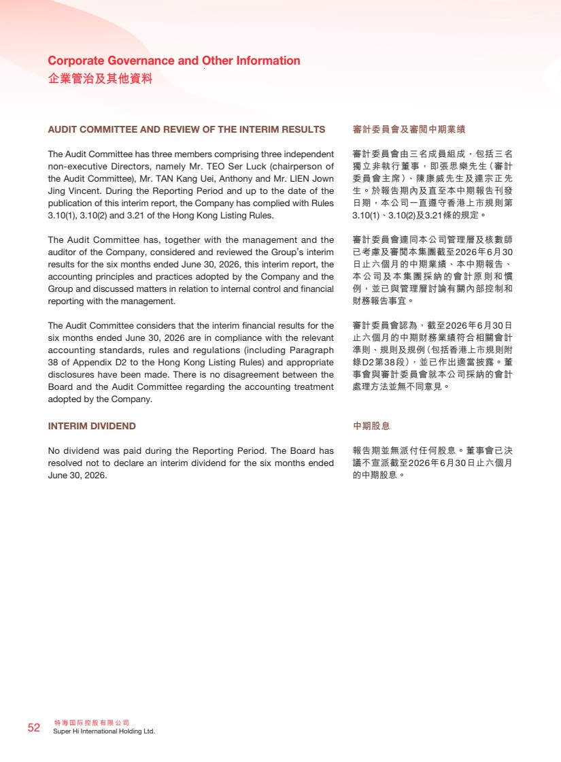 | 特海國際控股有限公司 52 Super Hi International Holding Ltd. Corporate Governance and Other Information 企業管治及其他資料 AUDIT COMMITTEE AND REVIEW OF THE INTERIM RESULTS The Audit Committee has three members comprising three independent non-executive Directors, namely Mr. TEO Ser Luck (chairperson of the Audit Committee), Mr. TAN Kang Uei, Anthony and Mr. LIEN Jown Jing Vincent. During the Reporting Period and up to the date of the publication of this interim report, the Company has complied with Rules 3.10(1), 3.10(2) and 3.21 of the Hong Kong Listing Rules. The Audit Committee has, together with the management and the auditor of the Company, considered and reviewed the Group’s interim results for the six months ended June 30, 2026, this interim report, the accounting principles and practices adopted by the Company and the Group and discussed matters in relation to internal control and financial reporting with the management. The Audit Committee considers that the interim financial results for the six months ended June 30, 2026 are in compliance with the relevant accounting standards, rules and regulations (including Paragraph 38 of Appendix D2 to the Hong Kong Listing Rules) and appropriate disclosures have been made. There is no disagreement between the Board and the Audit Committee regarding the accounting treatment adopted by the Company. INTERIM DIVIDEND No dividend was paid during the Reporting Period. The Board has resolved not to declare an interim dividend for the six months ended June 30, 2026. 審計委員會及審閱中期業績 審計委員會由三名成員組成，包括三名 獨立非執行董事，即張思樂先生（審計 委員會主席）、陳康威先生及連宗正先 生。於報告期內及直至本中期報告刊發 日期，本公司一直遵守香港上市規則第 3.10(1)、3.10(2)及3.21條的規定。 審計委員會連同本公司管理層及核數師 已考慮及審閱本集團截至2026年6月30 日止六個月的中期業績、本中期報告、 本公司及本集團採納的會計原則和慣 例，並已與管理層討論有關內部控制和 財務報告事宜。 審計委員會認為，截至2026年6月30日 止六個月的中期財務業績符合相關會計 準則、規則及規例（包括香港上市規則附 錄D2第38段），並已作出適當披露。董 事會與審計委員會就本公司採納的會計 處理方法並無不同意見。 中期股息 報告期並無派付任何股息。董事會已決 議不宣派截至2026年6月30日止六個月 的中期股息。
 | 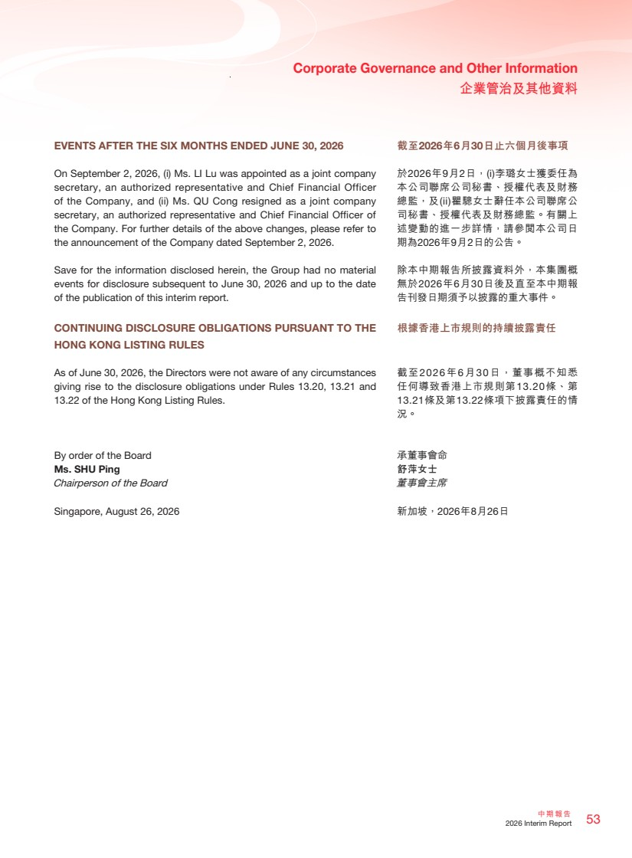 | 53 中期報告 2026 Interim Report Corporate Governance and Other Information 企業管治及其他資料 EVENTS AFTER THE SIX MONTHS ENDED JUNE 30, 2026 On September 2, 2026, (i) Ms. LI Lu was appointed as a joint company secretary, an authorized representative and Chief Financial Officer of the Company, and (ii) Ms. QU Cong resigned as a joint company secretary, an authorized representative and Chief Financial Officer of the Company. For further details of the above changes, please refer to the announcement of the Company dated September 2, 2026. Save for the information disclosed herein, the Group had no material events for disclosure subsequent to June 30, 2026 and up to the date of the publication of this interim report. CONTINUING DISCLOSURE OBLIGATIONS PURSUANT TO THE HONG KONG LISTING RULES As of June 30, 2026, the Directors were not aware of any circumstances giving rise to the disclosure obligations under Rules 13.20, 13.21 and 13.22 of the Hong Kong Listing Rules. By order of the Board Ms. SHU Ping Chairperson of the Board Singapore, August 26, 2026 截至2026年6月30日止六個月後事項 於2026年9月2日，(i)李璐女士獲委任為 本公司聯席公司秘書、授權代表及財務 總監，及(ii)瞿驄女士辭任本公司聯席公 司秘書、授權代表及財務總監。有關上 述變動的進一步詳情，請參閱本公司日 期為2026年9月2日的公告。 除本中期報告所披露資料外，本集團概 無於2026年6月30日後及直至本中期報 告刊發日期須予以披露的重大事件。 根據香港上市規則的持續披露責任 截至2026年6月30日，董事概不知悉 任何導致香港上市規則第13.20條、第 13.21條及第13.22條項下披露責任的情 況。 承董事會命 舒萍女士 董事會主席 新加坡，2026年8月26日
 | 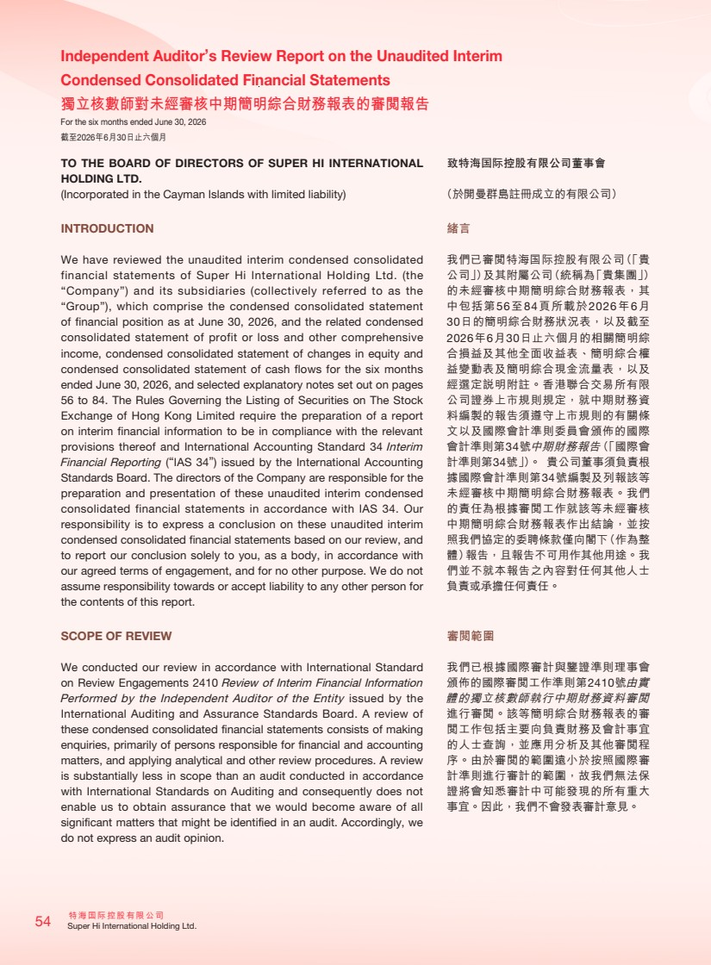 | 特海國際控股有限公司 54 Super Hi International Holding Ltd. Independent Auditor’s Review Report on the Unaudited Interim Condensed Consolidated Financial Statements 獨立核數師對未經審核中期簡明綜合財務報表的審閱報告 For the six months ended June 30, 2026 截至2026年6月30日止六個月 TO THE BOARD OF DIRECTORS OF SUPER HI INTERNATIONAL HOLDING LTD. (Incorporated in the Cayman Islands with limited liability) INTRODUCTION We have reviewed the unaudited interim condensed consolidated financial statements of Super Hi International Holding Ltd. (the “Company”) and its subsidiaries (collectively referred to as the “Group”), which comprise the condensed consolidated statement of financial position as at June 30, 2026, and the related condensed consolidated statement of profit or loss and other comprehensive income, condensed consolidated statement of changes in equity and condensed consolidated statement of cash flows for the six months ended June 30, 2026, and selected explanatory notes set out on pages 56 to 84. The Rules Governing the Listing of Securities on The Stock Exchange of Hong Kong Limited require the preparation of a report on interim financial information to be in compliance with the relevant provisions thereof and International Accounting Standard 34 Interim Financial Reporting (“IAS 34”) issued by the International Accounting Standards Board. The directors of the Company are responsible for the preparation and presentation of these unaudited interim condensed consolidated financial statements in accordance with IAS 34. Our responsibility is to express a conclusion on these unaudited interim condensed consolidated financial statements based on our review, and to report our conclusion solely to you, as a body, in accordance with our agreed terms of engagement, and for no other purpose. We do not assume responsibility towards or accept liability to any other person for the contents of this report. SCOPE OF REVIEW We conducted our review in accordance with International Standard on Review Engagements 2410 Review of Interim Financial Information Performed by the Independent Auditor of the Entity issued by the International Auditing and Assurance Standards Board. A review of these condensed consolidated financial statements consists of making enquiries, primarily of persons responsible for financial and accounting matters, and applying analytical and other review procedures. A review is substantially less in scope than an audit conducted in accordance with International Standards on Auditing and consequently does not enable us to obtain assurance that we would become aware of all significant matters that might be identified in an audit. Accordingly, we do not express an audit opinion. 致特海国際控股有限公司董事會 （於開曼群島註冊成立的有限公司） 緒言 我們已審閱特海国際控股有限公司（「貴 公司」）及其附屬公司（統稱為「貴集團」） 的未經審核中期簡明綜合財務報表，其 中包括第56至84頁所載於2026年6月 30日的簡明綜合財務狀況表，以及截至 2026年6月30日止六個月的相關簡明綜 合損益及其他全面收益表、簡明綜合權 益變動表及簡明綜合現金流量表，以及 經選定說明附註。香港聯合交易所有限 公司證券上市規則規定，就中期財務資 料編製的報告須遵守上市規則的有關條 文以及國際會計準則委員會頒佈的國際 會計準則第34號中期財務報告（「國際會 計準則第34號」）。 貴公司董事須負責根 據國際會計準則第34號編製及列報該等 未經審核中期簡明綜合財務報表。我們 的責任為根據審閱工作就該等未經審核 中期簡明綜合財務報表作出結論，並按 照我們協定的委聘條款僅向閣下（作為整 體）報告，且報告不可用作其他用途。我 們並不就本報告之內容對任何其他人士 負責或承擔任何責任。 審閱範圍 我們已根據國際審計與鑒證準則理事會 頒佈的國際審閱工作準則第2410號由實 體的獨立核數師執行中期財務資料審閱 進行審閱。該等簡明綜合財務報表的審 閱工作包括主要向負責財務及會計事宜 的人士查詢，並應用分析及其他審閱程 序。由於審閱的範圍遠小於按照國際審 計準則進行審計的範圍，故我們無法保 證將會知悉審計中可能發現的所有重大 事宜。因此，我們不會發表審計意見。
 | 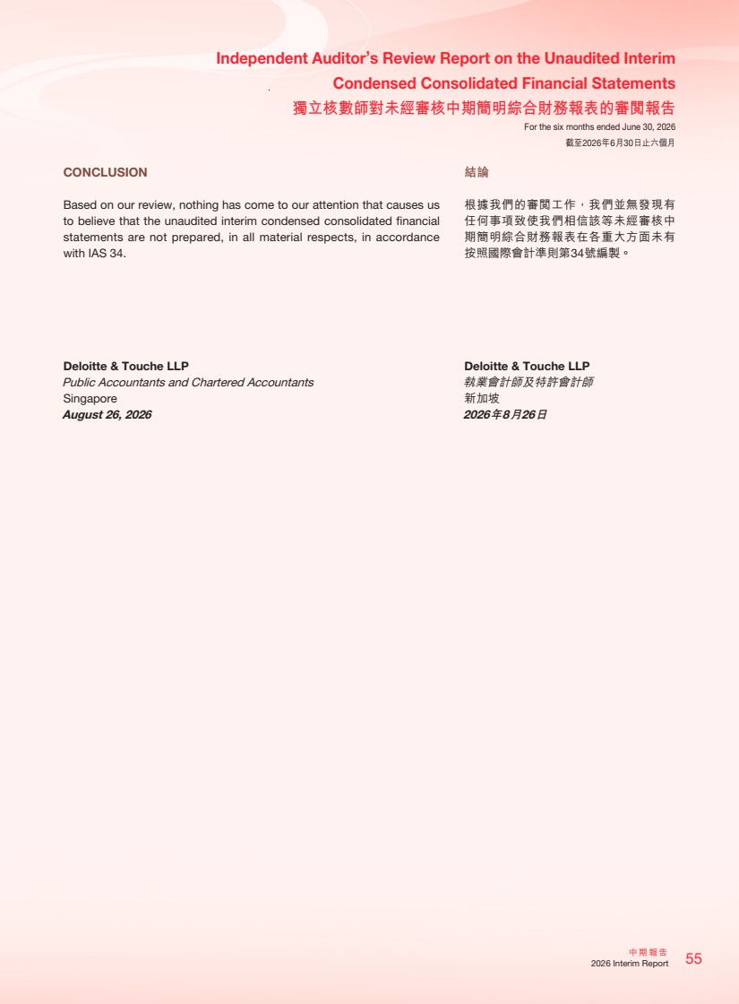 | 55 中期報告 2026 Interim Report Independent Auditor’s Review Report on the Unaudited Interim Condensed Consolidated Financial Statements 獨立核數師對未經審核中期簡明綜合財務報表的審閱報告 For the six months ended June 30, 2026 截至2026年6月30日止六個月 CONCLUSION Based on our review, nothing has come to our attention that causes us to believe that the unaudited interim condensed consolidated financial statements are not prepared, in all material respects, in accordance with IAS 34. Deloitte & Touche LLP Public Accountants and Chartered Accountants Singapore August 26, 2026 結論 根據我們的審閱工作，我們並無發現有 任何事項致使我們相信該等未經審核中 期簡明綜合財務報表在各重大方面未有 按照國際會計準則第34號編製。 Deloitte & Touche LLP 執業會計師及特許會計師 新加坡 2026年8月26日
 | 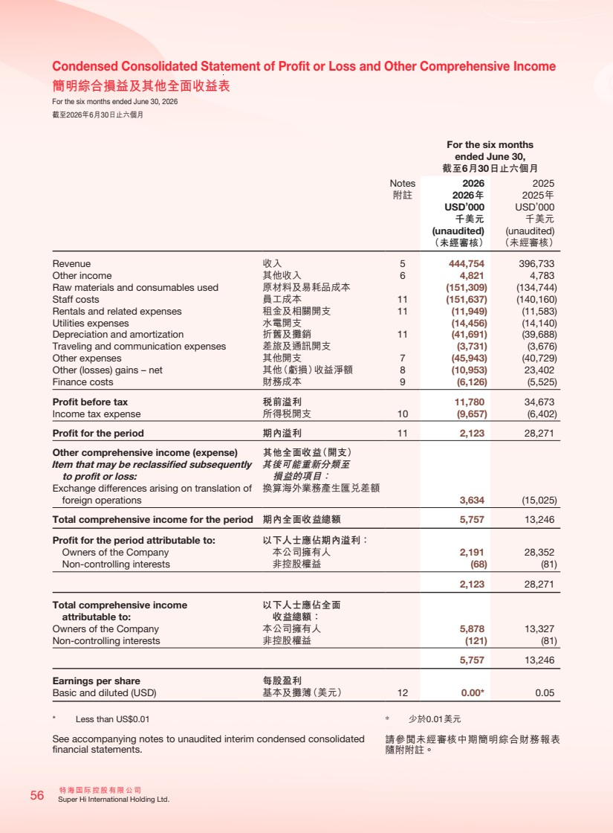 | 特海國際控股有限公司 56 Super Hi International Holding Ltd. Condensed Consolidated Statement of Profit or Loss and Other Comprehensive Income 簡明綜合損益及其他全面收益表 For the six months ended June 30, 2026 截至2026年6月30日止六個月 For the six months ended June 30, 截至6月30日止六個月 Notes 2026 2025 附註 2026年 2025年 USD’000 USD’000 千美元 千美元 (unaudited) (unaudited) （未經審核） （未經審核） Revenue 收入 5 444,754 396,733 Other income 其他收入 6 4,821 4,783 Raw materials and consumables used 原材料及易耗品成本 (151,309) (134,744) Staff costs 員工成本 11 (151,637) (140,160) Rentals and related expenses 租金及相關開支 11 (11,949) (11,583) Utilities expenses 水電開支 (14,456) (14,140) Depreciation and amortization 折舊及攤銷 11 (41,691) (39,688) Traveling and communication expenses 差旅及通訊開支 (3,731) (3,676) Other expenses 其他開支 7 (45,943) (40,729) Other (losses) gains – net 其他（虧損）收益淨額 8 (10,953) 23,402 Finance costs 財務成本 9 (6,126) (5,525) Profit before tax 稅前溢利 11,780 34,673 Income tax expense 所得稅開支 10 (9,657) (6,402) Profit for the period 期內溢利 11 2,123 28,271 Other comprehensive income (expense) 其他全面收益（開支） Item that may be reclassified subsequently to profit or loss: 其後可能重新分類至 損益的項目： Exchange differences arising on translation of foreign operations 換算海外業務產生匯兌差額 3,634 (15,025) Total comprehensive income for the period 期內全面收益總額 5,757 13,246 Profit for the period attributable to: 以下人士應佔期內溢利： Owners of the Company 本公司擁有人 2,191 28,352 Non-controlling interests 非控股權益 (68) (81) 2,123 28,271 Total comprehensive income attributable to: 以下人士應佔全面 收益總額： Owners of the Company 本公司擁有人 5,878 13,327 Non-controlling interests 非控股權益 (121) (81) 5,757 13,246 Earnings per share 每股盈利 Basic and diluted (USD) 基本及攤薄（美元） 12 0.00* 0.05 * Less than US$0.01 See accompanying notes to unaudited interim condensed consolidated financial statements. * 少於0.01美元 請參閱未經審核中期簡明綜合財務報表 隨附附註。
 | 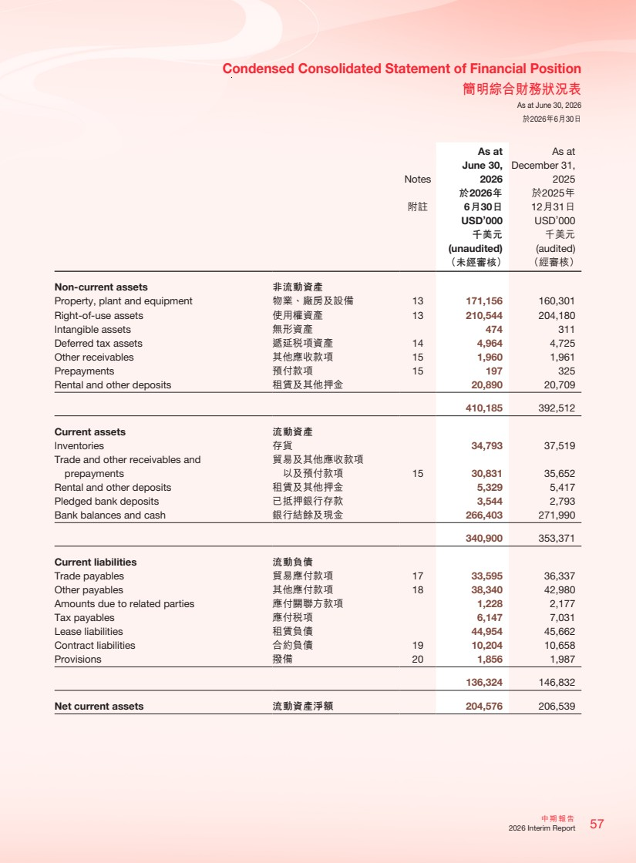 | 57 中期報告 2026 Interim Report Condensed Consolidated Statement of Financial Position 簡明綜合財務狀況表 As at June 30, 2026 於2026年6月30日 Notes As at June 30, 2026 As at December 31, 2025 附註 於2026年 6月30日 於2025年 12月31日 USD’000 USD’000 千美元 千美元 (unaudited) (audited) （未經審核） （經審核） Non-current assets 非流動資產 Property, plant and equipment 物業、廠房及設備 13 171,156 160,301 Right-of-use assets 使用權資產 13 210,544 204,180 Intangible assets 無形資產 474 311 Deferred tax assets 遞延稅項資產 14 4,964 4,725 Other receivables 其他應收款項 15 1,960 1,961 Prepayments 預付款項 15 197 325 Rental and other deposits 租賃及其他押金 20,890 20,709 410,185 392,512 Current assets 流動資產 Inventories 存貨 34,793 37,519 Trade and other receivables and prepayments 貿易及其他應收款項 以及預付款項 15 30,831 35,652 Rental and other deposits 租賃及其他押金 5,329 5,417 Pledged bank deposits 已抵押銀行存款 3,544 2,793 Bank balances and cash 銀行結餘及現金 266,403 271,990 340,900 353,371 Current liabilities 流動負債 Trade payables 貿易應付款項 17 33,595 36,337 Other payables 其他應付款項 18 38,340 42,980 Amounts due to related parties 應付關聯方款項 1,228 2,177 Tax payables 應付稅項 6,147 7,031 Lease liabilities 租賃負債 44,954 45,662 Contract liabilities 合約負債 19 10,204 10,658 Provisions 撥備 20 1,856 1,987 136,324 146,832 Net current assets 流動資產淨額 204,576 206,539
 | 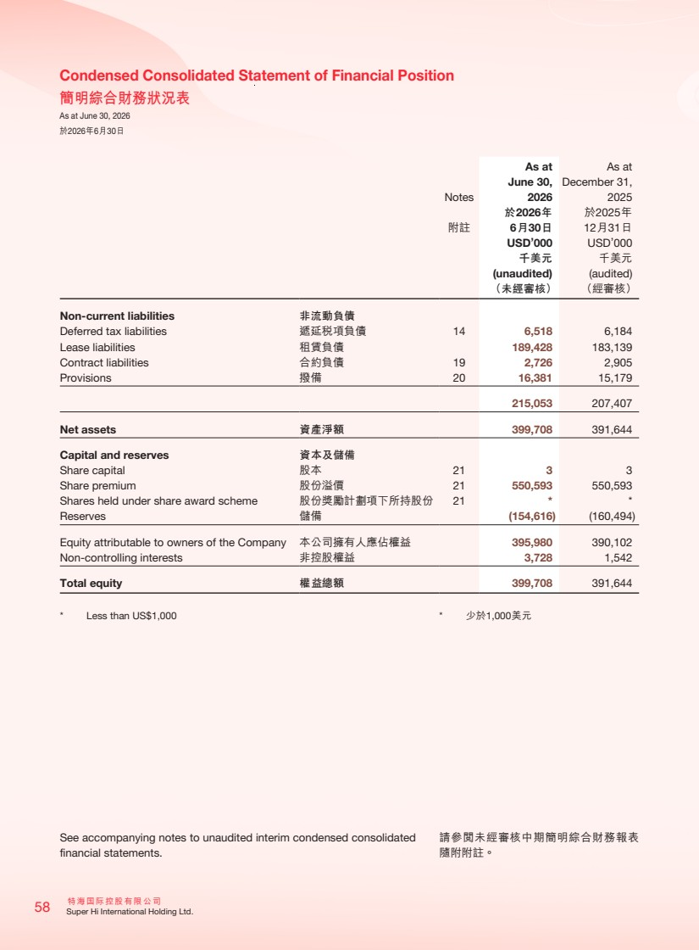 | 特海國際控股有限公司 58 Super Hi International Holding Ltd. Condensed Consolidated Statement of Financial Position 簡明綜合財務狀況表 As at June 30, 2026 於2026年6月30日 Notes As at June 30, 2026 As at December 31, 2025 附註 於2026年 6月30日 於2025年 12月31日 USD’000 USD’000 千美元 千美元 (unaudited) (audited) （未經審核） （經審核） Non-current liabilities 非流動負債 Deferred tax liabilities 遞延稅項負債 14 6,518 6,184 Lease liabilities 租賃負債 189,428 183,139 Contract liabilities 合約負債 19 2,726 2,905 Provisions 撥備 20 16,381 15,179 215,053 207,407 Net assets 資產淨額 399,708 391,644 Capital and reserves 資本及儲備 Share capital 股本 21 3 3 Share premium 股份溢價 21 550,593 550,593 Shares held under share award scheme 股份獎勵計劃項下所持股份 21 * * Reserves 儲備 (154,616) (160,494) Equity attributable to owners of the Company 本公司擁有人應佔權益 395,980 390,102 Non-controlling interests 非控股權益 3,728 1,542 Total equity 權益總額 399,708 391,644 * Less than US$1,000 See accompanying notes to unaudited interim condensed consolidated financial statements. * 少於1,000美元 請參閱未經審核中期簡明綜合財務報表 隨附附註。
 | 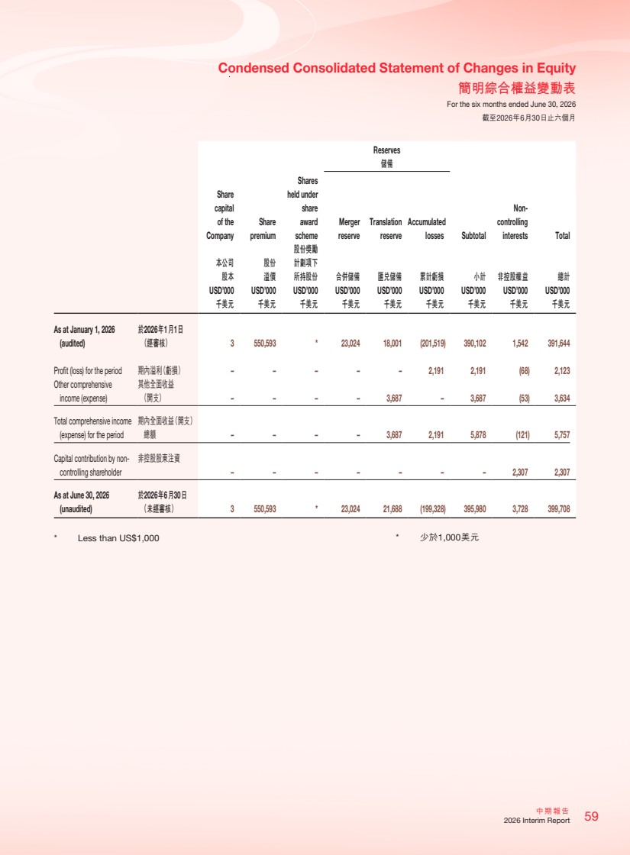 | 59 中期報告 2026 Interim Report Condensed Consolidated Statement of Changes in Equity 簡明綜合權益變動表 For the six months ended June 30, 2026 截至2026年6月30日止六個月 Reserves 儲備 Share capital of the Company Share premium Shares held under share award scheme Merger reserve Translation reserve Accumulated losses Subtotal Non-controlling interests Total 本公司 股本 股份 溢價 股份獎勵 計劃項下 所持股份 合併儲備 匯兌儲備 累計虧損 小計 非控股權益 總計 USD’000 USD’000 USD’000 USD’000 USD’000 USD’000 USD’000 USD’000 USD’000 千美元 千美元 千美元 千美元 千美元 千美元 千美元 千美元 千美元 As at January 1, 2026 (audited) 於2026年1月1日 （經審核） 3 550,593 * 23,024 18,001 (201,519) 390,102 1,542 391,644 Profit (loss) for the period 期內溢利（虧損） – – – – – 2,191 2,191 (68) 2,123 Other comprehensive income (expense) 其他全面收益 （開支） – – – – 3,687 – 3,687 (53) 3,634 Total comprehensive income (expense) for the period 期內全面收益（開支） 總額 – – – – 3,687 2,191 5,878 (121) 5,757 Capital contribution by non-controlling shareholder 非控股股東注資 – – – – – – – 2,307 2,307 As at June 30, 2026 (unaudited) 於2026年6月30日 （未經審核） 3 550,593 * 23,024 21,688 (199,328) 395,980 3,728 399,708 * Less than US$1,000 * 少於1,000美元
 | 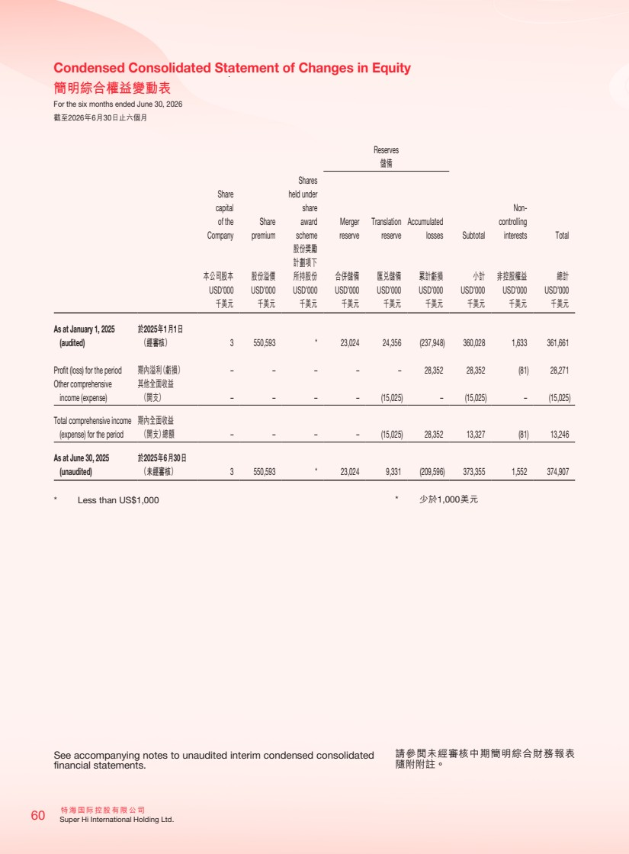 | 特海國際控股有限公司 60 Super Hi International Holding Ltd. Condensed Consolidated Statement of Changes in Equity 簡明綜合權益變動表 For the six months ended June 30, 2026 截至2026年6月30日止六個月 Reserves 儲備 Share capital of the Company Share premium Shares held under share award scheme Merger reserve Translation reserve Accumulated losses Subtotal Non-controlling interests Total 本公司股本 股份溢價 股份獎勵 計劃項下 所持股份 合併儲備 匯兌儲備 累計虧損 小計 非控股權益 總計 USD’000 USD’000 USD’000 USD’000 USD’000 USD’000 USD’000 USD’000 USD’000 千美元 千美元 千美元 千美元 千美元 千美元 千美元 千美元 千美元 As at January 1, 2025 (audited) 於2025年1月1日 （經審核） 3 550,593 * 23,024 24,356 (237,948) 360,028 1,633 361,661 Profit (loss) for the period 期內溢利（虧損） – – – – – 28,352 28,352 (81) 28,271 Other comprehensive income (expense) 其他全面收益 （開支） – – – – (15,025) – (15,025) – (15,025) Total comprehensive income (expense) for the period 期內全面收益 （開支）總額 – – – – (15,025) 28,352 13,327 (81) 13,246 As at June 30, 2025 (unaudited) 於2025年6月30日 （未經審核） 3 550,593 * 23,024 9,331 (209,596) 373,355 1,552 374,907 * Less than US$1,000 See accompanying notes to unaudited interim condensed consolidated financial statements. * 少於1,000美元 請參閱未經審核中期簡明綜合財務報表 隨附附註。
 | 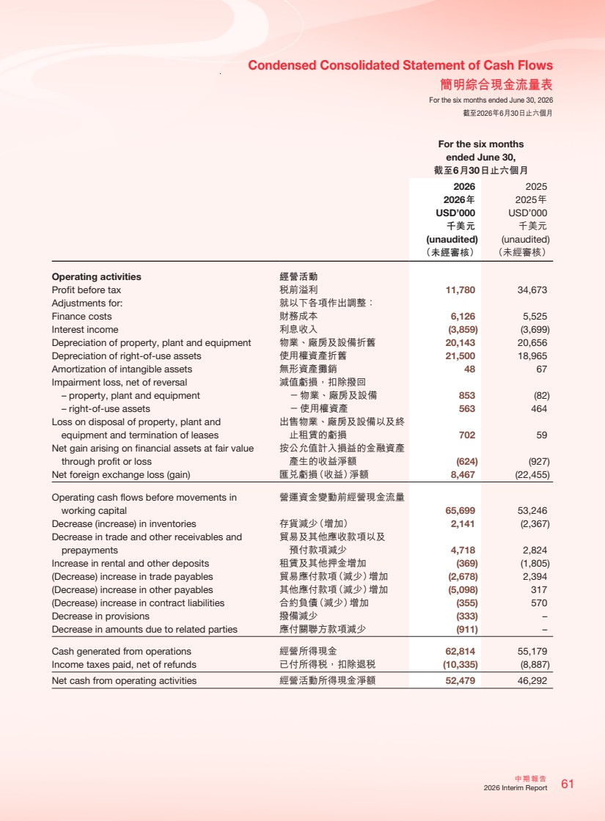 | 61 中期報告 2026 Interim Report Condensed Consolidated Statement of Cash Flows 簡明綜合現金流量表 For the six months ended June 30, 2026 截至2026年6月30日止六個月 For the six months ended June 30, 截至6月30日止六個月 2026 2025 2026年 2025年 USD’000 USD’000 千美元 千美元 (unaudited) (unaudited) （未經審核） （未經審核） Operating activities 經營活動 Profit before tax 稅前溢利 11,780 34,673 Adjustments for: 就以下各項作出調整： Finance costs 財務成本 6,126 5,525 Interest income 利息收入 (3,859) (3,699) Depreciation of property, plant and equipment 物業、廠房及設備折舊 20,143 20,656 Depreciation of right-of-use assets 使用權資產折舊 21,500 18,965 Amortization of intangible assets 無形資產攤銷 48 67 Impairment loss, net of reversal 減值虧損，扣除撥回 – property, plant and equipment －物業、廠房及設備 853 (82) – right-of-use assets －使用權資產 563 464 Loss on disposal of property, plant and equipment and termination of leases 出售物業、廠房及設備以及終 止租賃的虧損 702 59 Net gain arising on financial assets at fair value through profit or loss 按公允值計入損益的金融資產 產生的收益淨額 (624) (927) Net foreign exchange loss (gain) 匯兌虧損（收益）淨額 8,467 (22,455) Operating cash flows before movements in working capital 營運資金變動前經營現金流量 65,699 53,246 Decrease (increase) in inventories 存貨減少（增加） 2,141 (2,367) Decrease in trade and other receivables and prepayments 貿易及其他應收款項以及 預付款項減少 4,718 2,824 Increase in rental and other deposits 租賃及其他押金增加 (369) (1,805) (Decrease) increase in trade payables 貿易應付款項（減少）增加 (2,678) 2,394 (Decrease) increase in other payables 其他應付款項（減少）增加 (5,098) 317 (Decrease) increase in contract liabilities 合約負債（減少）增加 (355) 570 Decrease in provisions 撥備減少 (333) – Decrease in amounts due to related parties 應付關聯方款項減少 (911) – Cash generated from operations 經營所得現金 62,814 55,179 Income taxes paid, net of refunds 已付所得稅，扣除退稅 (10,335) (8,887) Net cash from operating activities 經營活動所得現金淨額 52,479 46,292
 | 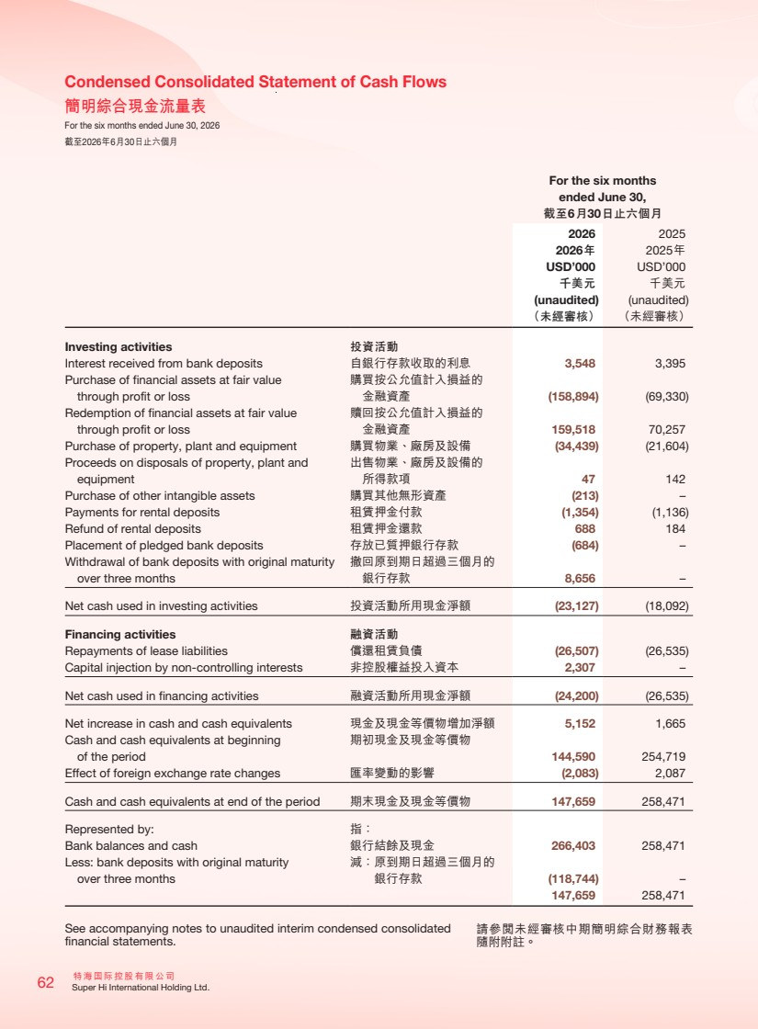 | 特海國際控股有限公司 62 Super Hi International Holding Ltd. Condensed Consolidated Statement of Cash Flows 簡明綜合現金流量表 For the six months ended June 30, 2026 截至2026年6月30日止六個月 For the six months ended June 30, 截至6月30日止六個月 2026 2025 2026年 2025年 USD’000 USD’000 千美元 千美元 (unaudited) (unaudited) （未經審核） （未經審核） Investing activities 投資活動 Interest received from bank deposits 自銀行存款收取的利息 3,548 3,395 Purchase of financial assets at fair value through profit or loss 購買按公允值計入損益的 金融資產 (158,894) (69,330) Redemption of financial assets at fair value through profit or loss 贖回按公允值計入損益的 金融資產 159,518 70,257 Purchase of property, plant and equipment 購買物業、廠房及設備 (34,439) (21,604) Proceeds on disposals of property, plant and equipment 出售物業、廠房及設備的 所得款項 47 142 Purchase of other intangible assets 購買其他無形資產 (213) – Payments for rental deposits 租賃押金付款 (1,354) (1,136) Refund of rental deposits 租賃押金還款 688 184 Placement of pledged bank deposits 存放已質押銀行存款 (684) – Withdrawal of bank deposits with original maturity over three months 撤回原到期日超過三個月的 銀行存款 8,656 – Net cash used in investing activities 投資活動所用現金淨額 (23,127) (18,092) Financing activities 融資活動 Repayments of lease liabilities 償還租賃負債 (26,507) (26,535) Capital injection by non-controlling interests 非控股權益投入資本 2,307 – Net cash used in financing activities 融資活動所用現金淨額 (24,200) (26,535) Net increase in cash and cash equivalents 現金及現金等價物增加淨額 5,152 1,665 Cash and cash equivalents at beginning of the period 期初現金及現金等價物 144,590 254,719 Effect of foreign exchange rate changes 匯率變動的影響 (2,083) 2,087 Cash and cash equivalents at end of the period 期末現金及現金等價物 147,659 258,471 Represented by: 指： Bank balances and cash 銀行結餘及現金 266,403 258,471 Less: bank deposits with original maturity over three months 減：原到期日超過三個月的 銀行存款 (118,744) – 147,659 258,471 See accompanying notes to unaudited interim condensed consolidated financial statements. 請參閱未經審核中期簡明綜合財務報表 隨附附註。
 | 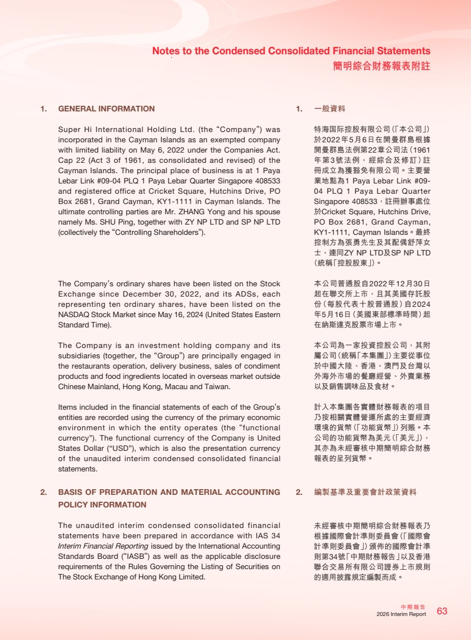 | 63 中期報告 2026 Interim Report Notes to the Condensed Consolidated Financial Statements 簡明綜合財務報表附註 1. GENERAL INFORMATION Super Hi International Holding Ltd. (the “Company”) was incorporated in the Cayman Islands as an exempted company with limited liability on May 6, 2022 under the Companies Act. Cap 22 (Act 3 of 1961, as consolidated and revised) of the Cayman Islands. The principal place of business is at 1 Paya Lebar Link #09-04 PLQ 1 Paya Lebar Quarter Singapore 408533 and registered office at Cricket Square, Hutchins Drive, PO Box 2681, Grand Cayman, KY1-1111 in Cayman Islands. The ultimate controlling parties are Mr. ZHANG Yong and his spouse namely Ms. SHU Ping, together with ZY NP LTD and SP NP LTD (collectively the “Controlling Shareholders”). The Company’s ordinary shares have been listed on the Stock Exchange since December 30, 2022, and its ADSs, each representing ten ordinary shares, have been listed on the NASDAQ Stock Market since May 16, 2024 (United States Eastern Standard Time). The Company is an investment holding company and its subsidiaries (together, the “Group”) are principally engaged in the restaurants operation, delivery business, sales of condiment products and food ingredients located in overseas market outside Chinese Mainland, Hong Kong, Macau and Taiwan. Items included in the financial statements of each of the Group’s entities are recorded using the currency of the primary economic environment in which the entity operates (the “functional currency”). The functional currency of the Company is United States Dollar (“USD”), which is also the presentation currency of the unaudited interim condensed consolidated financial statements. 2. BASIS OF PREPARATION AND MATERIAL ACCOUNTING POLICY INFORMATION The unaudited interim condensed consolidated financial statements have been prepared in accordance with IAS 34 Interim Financial Reporting issued by the International Accounting Standards Board (“IASB”) as well as the applicable disclosure requirements of the Rules Governing the Listing of Securities on The Stock Exchange of Hong Kong Limited. 1. 一般資料 特海国際控股有限公司（「本公司」） 於2022年5月6日在開曼群島根據 開曼群島法例第22章公司法（1961 年第3號法例，經綜合及修訂）註 冊成立為獲豁免有限公司。主要營 業地點為1 Paya Lebar Link #09- 04 PLQ 1 Paya Lebar Quarter Singapore 408533，註冊辦事處位 於Cricket Square, Hutchins Drive, PO Box 2681, Grand Cayman, KY1-1111, Cayman Islands。最終 控制方為張勇先生及其配偶舒萍女 士，連同ZY NP LTD及SP NP LTD （統稱「控股股東」）。 本公司普通股自2022年12月30日 起在聯交所上市，且其美國存託股 份（每股代表十股普通股）自2024 年5月16日（美國東部標準時間）起 在納斯達克股票市場上市。 本公司為一家投資控股公司，其附 屬公司（統稱「本集團」）主要從事位 於中國大陸、香港、澳門及台灣以 外海外市場的餐廳經營、外賣業務 以及銷售調味品及食材。 計入本集團各實體財務報表的項目 乃按相關實體營運所處的主要經濟 環境的貨幣（「功能貨幣」）列賬。本 公司的功能貨幣為美元（「美元」）， 其亦為未經審核中期簡明綜合財務 報表的呈列貨幣。 2. 編製基準及重要會計政策資料 未經審核中期簡明綜合財務報表乃 根據國際會計準則委員會（「國際會 計準則委員會」）頒佈的國際會計準 則第34號「中期財務報告」以及香港 聯合交易所有限公司證券上市規則 的適用披露規定編製而成。
 | 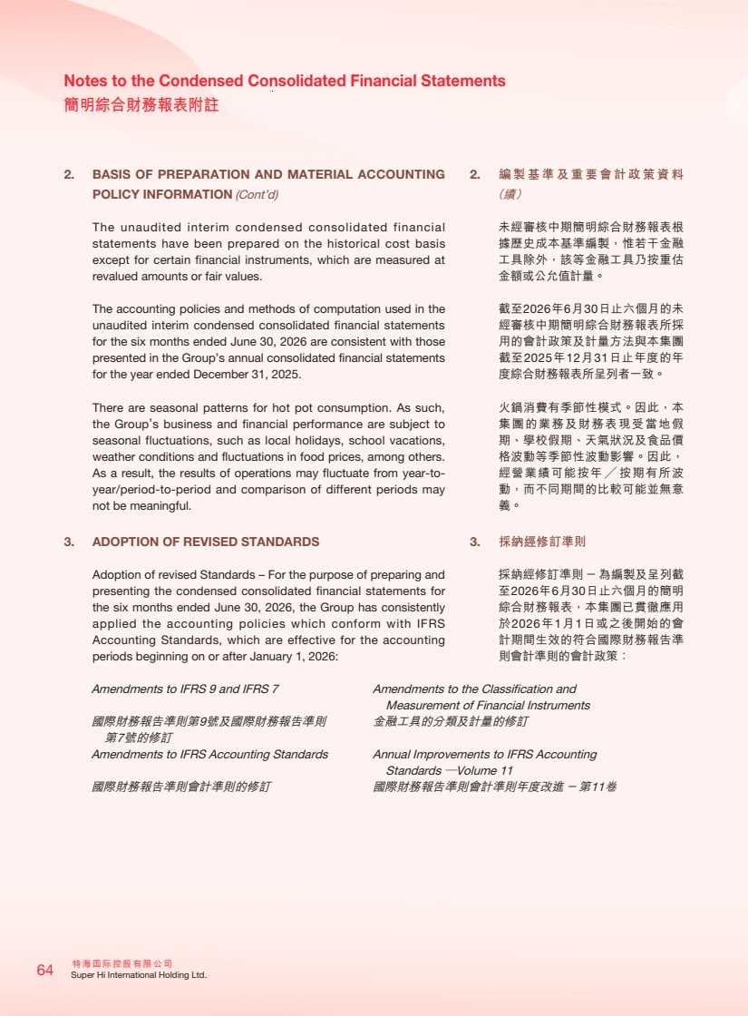 | 特海國際控股有限公司 64 Super Hi International Holding Ltd. Notes to the Condensed Consolidated Financial Statements 簡明綜合財務報表附註 2. BASIS OF PREPARATION AND MATERIAL ACCOUNTING POLICY INFORMATION (Cont’d) The unaudited interim condensed consolidated financial statements have been prepared on the historical cost basis except for certain financial instruments, which are measured at revalued amounts or fair values. The accounting policies and methods of computation used in the unaudited interim condensed consolidated financial statements for the six months ended June 30, 2026 are consistent with those presented in the Group’s annual consolidated financial statements for the year ended December 31, 2025. There are seasonal patterns for hot pot consumption. As such, the Group’s business and financial performance are subject to seasonal fluctuations, such as local holidays, school vacations, weather conditions and fluctuations in food prices, among others. As a result, the results of operations may fluctuate from year-to-year/period-to-period and comparison of different periods may not be meaningful. 3. ADOPTION OF REVISED STANDARDS Adoption of revised Standards – For the purpose of preparing and presenting the condensed consolidated financial statements for the six months ended June 30, 2026, the Group has consistently applied the accounting policies which conform with IFRS Accounting Standards, which are effective for the accounting periods beginning on or after January 1, 2026: Amendments to IFRS 9 and IFRS 7 Amendments to the Classification and Measurement of Financial Instruments 國際財務報告準則第9號及國際財務報告準則 第7號的修訂 金融工具的分類及計量的修訂 Amendments to IFRS Accounting Standards Annual Improvements to IFRS Accounting Standards —Volume 11 國際財務報告準則會計準則的修訂 國際財務報告準則會計準則年度改進－第11卷 2. 編製基準及重要會計政策資料 （續） 未經審核中期簡明綜合財務報表根 據歷史成本基準編製，惟若干金融 工具除外，該等金融工具乃按重估 金額或公允值計量。 截至2026年6月30日止六個月的未 經審核中期簡明綜合財務報表所採 用的會計政策及計量方法與本集團 截至2025年12月31日止年度的年 度綜合財務報表所呈列者一致。 火鍋消費有季節性模式。因此，本 集團的業務及財務表現受當地假 期、學校假期、天氣狀況及食品價 格波動等季節性波動影響。因此， 經營業績可能按年╱按期有所波 動，而不同期間的比較可能並無意 義。 3. 採納經修訂準則 採納經修訂準則－為編製及呈列截 至2026年6月30日止六個月的簡明 綜合財務報表，本集團已貫徹應用 於2026年1月1日或之後開始的會 計期間生效的符合國際財務報告準 則會計準則的會計政策：
 | 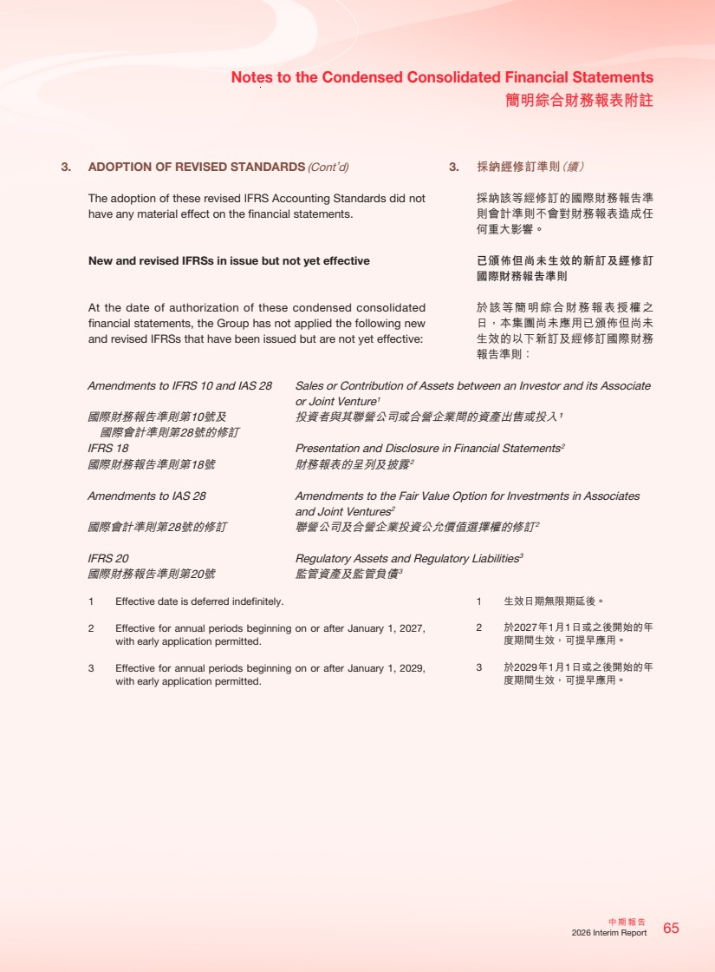 | 65 中期報告 2026 Interim Report Notes to the Condensed Consolidated Financial Statements 簡明綜合財務報表附註 3. ADOPTION OF REVISED STANDARDS (Cont’d) The adoption of these revised IFRS Accounting Standards did not have any material effect on the financial statements. New and revised IFRSs in issue but not yet effective At the date of authorization of these condensed consolidated financial statements, the Group has not applied the following new and revised IFRSs that have been issued but are not yet effective: Amendments to IFRS 10 and IAS 28 Sales or Contribution of Assets between an Investor and its Associate or Joint Venture1 國際財務報告準則第10號及 國際會計準則第28號的修訂 投資者與其聯營公司或合營企業間的資產出售或投入¹ IFRS 18 Presentation and Disclosure in Financial Statements2 國際財務報告準則第18號 財務報表的呈列及披露2 Amendments to IAS 28 Amendments to the Fair Value Option for Investments in Associates and Joint Ventures2 國際會計準則第28號的修訂 聯營公司及合營企業投資公允價值選擇權的修訂2 IFRS 20 Regulatory Assets and Regulatory Liabilities3 國際財務報告準則第20號 監管資產及監管負債3 1 Effective date is deferred indefinitely. 2 Effective for annual periods beginning on or after January 1, 2027, with early application permitted. 3 Effective for annual periods beginning on or after January 1, 2029, with early application permitted. 3. 採納經修訂準則（續） 採納該等經修訂的國際財務報告準 則會計準則不會對財務報表造成任 何重大影響。 已頒佈但尚未生效的新訂及經修訂 國際財務報告準則 於該等簡明綜合財務報表授權之 日，本集團尚未應用已頒佈但尚未 生效的以下新訂及經修訂國際財務 報告準則： 1 生效日期無限期延後。 2 於2027年1月1日或之後開始的年 度期間生效，可提早應用。 3 於2029年1月1日或之後開始的年 度期間生效，可提早應用。
 | 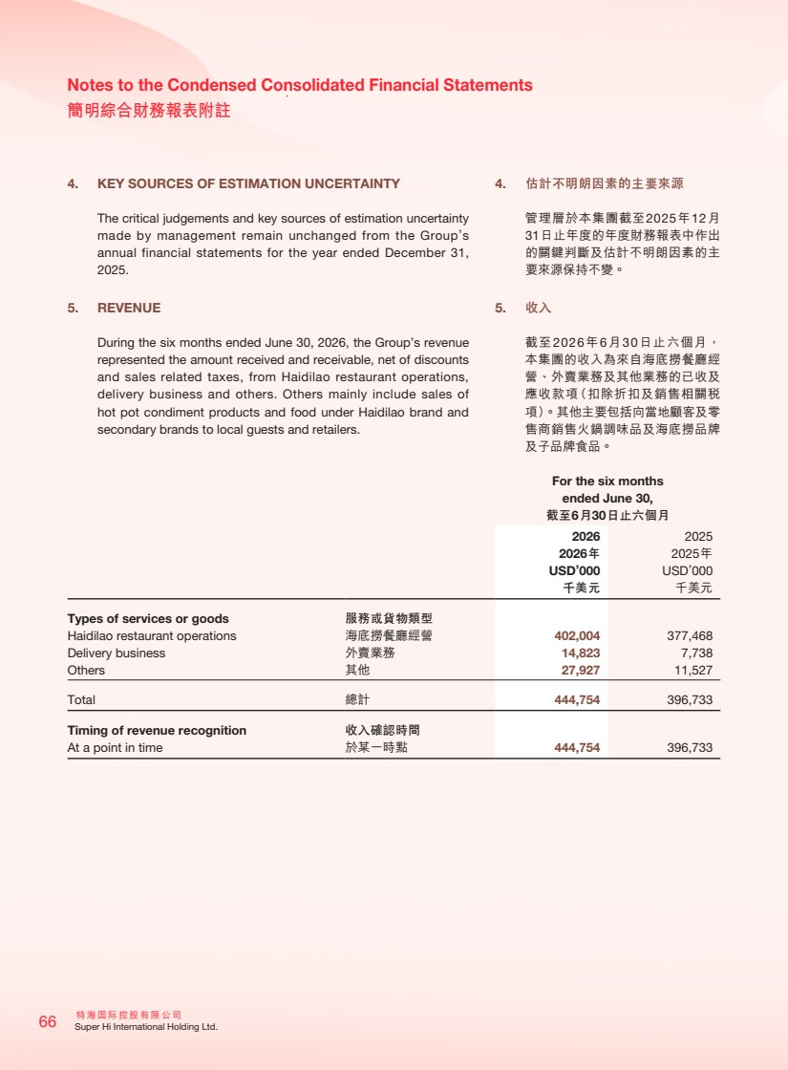 | 特海國際控股有限公司 66 Super Hi International Holding Ltd. Notes to the Condensed Consolidated Financial Statements 簡明綜合財務報表附註 4. KEY SOURCES OF ESTIMATION UNCERTAINTY The critical judgements and key sources of estimation uncertainty made by management remain unchanged from the Group’s annual financial statements for the year ended December 31, 2025. 5. REVENUE During the six months ended June 30, 2026, the Group’s revenue represented the amount received and receivable, net of discounts and sales related taxes, from Haidilao restaurant operations, delivery business and others. Others mainly include sales of hot pot condiment products and food under Haidilao brand and secondary brands to local guests and retailers. For the six months ended June 30, 截至6月30日止六個月 2026 2025 2026年 2025年 USD’000 USD’000 千美元 千美元 Types of services or goods 服務或貨物類型 Haidilao restaurant operations 海底撈餐廳經營 402,004 377,468 Delivery business 外賣業務 14,823 7,738 Others 其他 27,927 11,527 Total 總計 444,754 396,733 Timing of revenue recognition 收入確認時間 At a point in time 於某一時點 444,754 396,733 4. 估計不明朗因素的主要來源 管理層於本集團截至2025年12月 31日止年度的年度財務報表中作出 的關鍵判斷及估計不明朗因素的主 要來源保持不變。 5. 收入 截至2026年6月30日止六個月， 本集團的收入為來自海底撈餐廳經 營、外賣業務及其他業務的已收及 應收款項（扣除折扣及銷售相關稅 項）。其他主要包括向當地顧客及零 售商銷售火鍋調味品及海底撈品牌 及子品牌食品。
 | 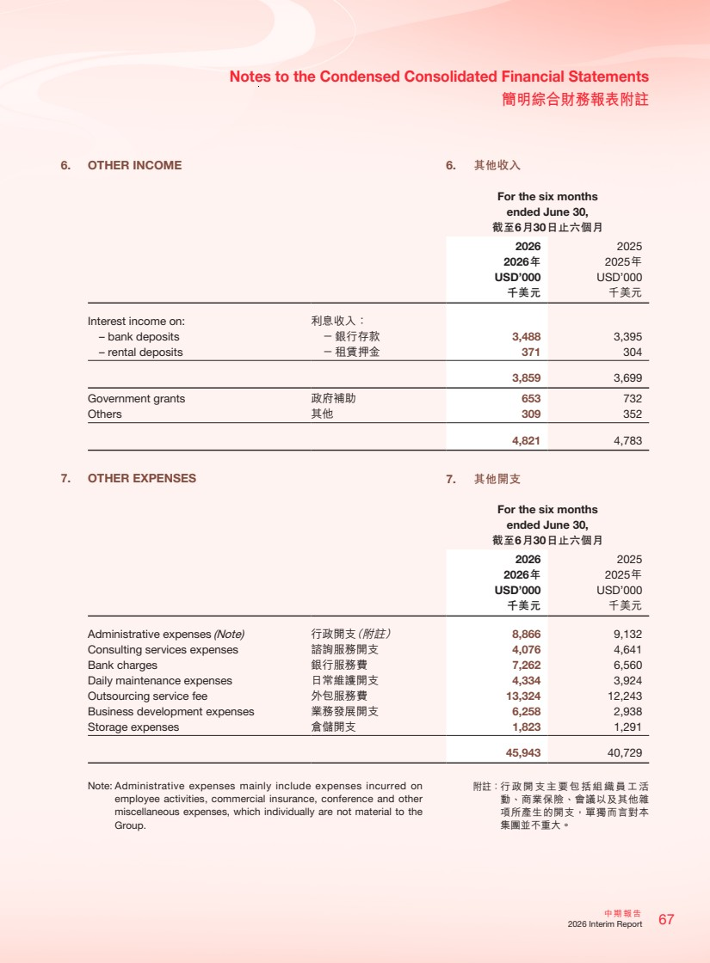 | 67 中期報告 2026 Interim Report Notes to the Condensed Consolidated Financial Statements 簡明綜合財務報表附註 6. OTHER INCOME For the six months ended June 30, 截至6月30日止六個月 2026 2025 2026年 2025年 USD’000 USD’000 千美元 千美元 Interest income on: 利息收入： – bank deposits －銀行存款 3,488 3,395 – rental deposits －租賃押金 371 304 3,859 3,699 Government grants 政府補助 653 732 Others 其他 309 352 4,821 4,783 7. OTHER EXPENSES For the six months ended June 30, 截至6月30日止六個月 2026 2025 2026年 2025年 USD’000 USD’000 千美元 千美元 Administrative expenses (Note) 行政開支（附註） 8,866 9,132 Consulting services expenses 諮詢服務開支 4,076 4,641 Bank charges 銀行服務費 7,262 6,560 Daily maintenance expenses 日常維護開支 4,334 3,924 Outsourcing service fee 外包服務費 13,324 12,243 Business development expenses 業務發展開支 6,258 2,938 Storage expenses 倉儲開支 1,823 1,291 45,943 40,729 Note: Administrative expenses mainly include expenses incurred on employee activities, commercial insurance, conference and other miscellaneous expenses, which individually are not material to the Group. 6. 其他收入 7. 其他開支 附註：行政開支主要包括組織員工活 動、商業保險、會議以及其他雜 項所產生的開支，單獨而言對本 集團並不重大。
 | 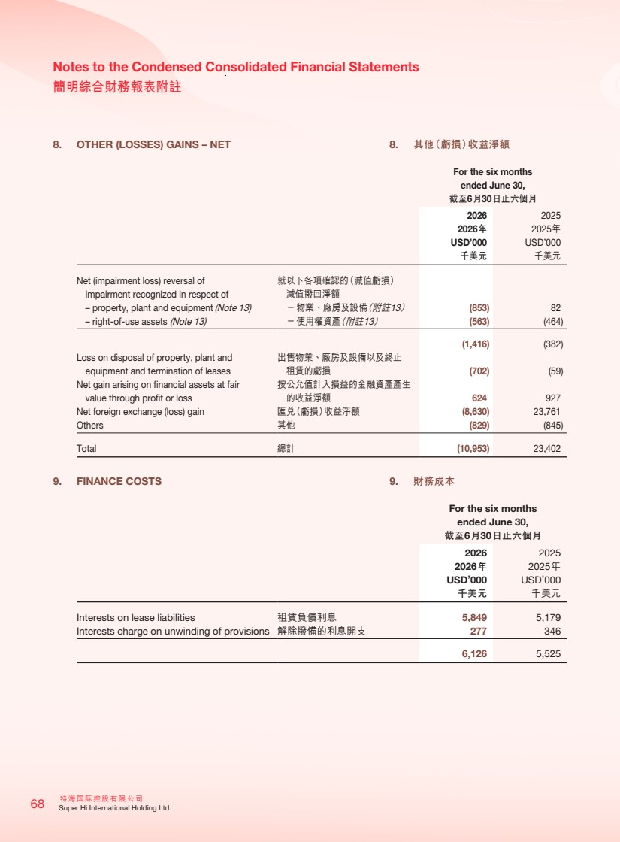 | 特海國際控股有限公司 68 Super Hi International Holding Ltd. Notes to the Condensed Consolidated Financial Statements 簡明綜合財務報表附註 8. OTHER (LOSSES) GAINS – NET For the six months ended June 30, 截至6月30日止六個月 2026 2025 2026年 2025年 USD’000 USD’000 千美元 千美元 Net (impairment loss) reversal of impairment recognized in respect of 就以下各項確認的（減值虧損） 減值撥回淨額 – property, plant and equipment (Note 13) －物業、廠房及設備（附註13） (853) 82 – right-of-use assets (Note 13) －使用權資產（附註13） (563) (464) (1,416) (382) Loss on disposal of property, plant and equipment and termination of leases 出售物業、廠房及設備以及終止 租賃的虧損 (702) (59) Net gain arising on financial assets at fair value through profit or loss 按公允值計入損益的金融資產產生 的收益淨額 624 927 Net foreign exchange (loss) gain 匯兌（虧損）收益淨額 (8,630) 23,761 Others 其他 (829) (845) Total 總計 (10,953) 23,402 9. FINANCE COSTS For the six months ended June 30, 截至6月30日止六個月 2026 2025 2026年 2025年 USD’000 USD’000 千美元 千美元 Interests on lease liabilities 租賃負債利息 5,849 5,179 Interests charge on unwinding of provisions 解除撥備的利息開支 277 346 6,126 5,525 8. 其他（虧損）收益淨額 9. 財務成本
 | 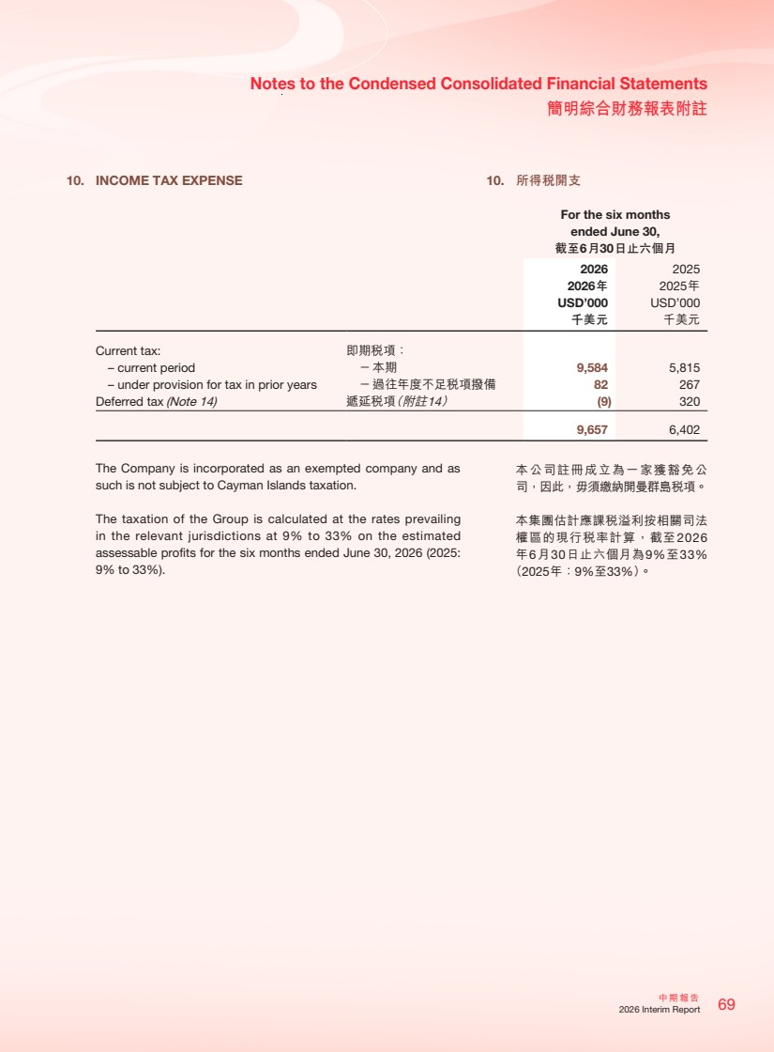 | 69 中期報告 2026 Interim Report Notes to the Condensed Consolidated Financial Statements 簡明綜合財務報表附註 10. INCOME TAX EXPENSE For the six months ended June 30, 截至6月30日止六個月 2026 2025 2026年 2025年 USD’000 USD’000 千美元 千美元 Current tax: 即期稅項： – current period －本期 9,584 5,815 – under provision for tax in prior years －過往年度不足稅項撥備 82 267 Deferred tax (Note 14) 遞延稅項（附註14） (9) 320 9,657 6,402 The Company is incorporated as an exempted company and as such is not subject to Cayman Islands taxation. The taxation of the Group is calculated at the rates prevailing in the relevant jurisdictions at 9% to 33% on the estimated assessable profits for the six months ended June 30, 2026 (2025: 9% to 33%). 10. 所得稅開支 本公司註冊成立為一家獲豁免公 司，因此，毋須繳納開曼群島稅項。 本集團估計應課稅溢利按相關司法 權區的現行稅率計算，截至2026 年6月30日止六個月為9%至33% （2025年：9%至33%）。
 | 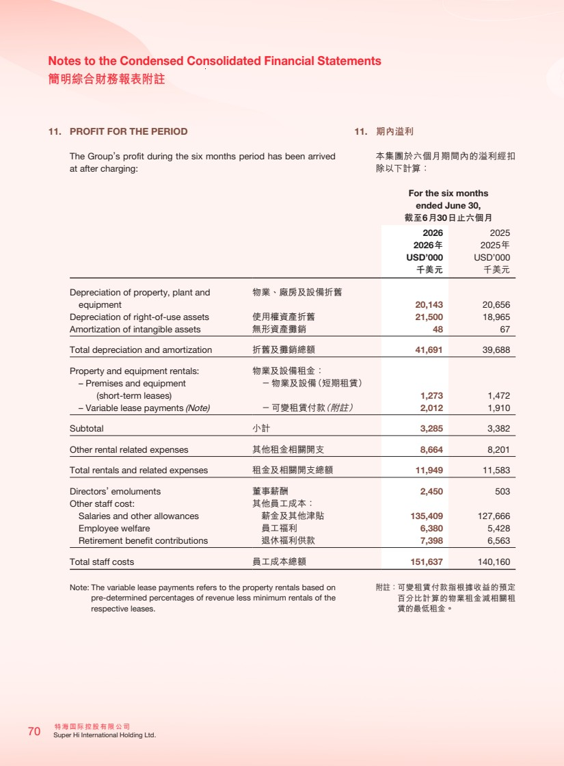 | 特海國際控股有限公司 70 Super Hi International Holding Ltd. Notes to the Condensed Consolidated Financial Statements 簡明綜合財務報表附註 11. PROFIT FOR THE PERIOD The Group’s profit during the six months period has been arrived at after charging: For the six months ended June 30, 截至6月30日止六個月 2026 2025 2026年 2025年 USD’000 USD’000 千美元 千美元 Depreciation of property, plant and equipment 物業、廠房及設備折舊 20,143 20,656 Depreciation of right-of-use assets 使用權資產折舊 21,500 18,965 Amortization of intangible assets 無形資產攤銷 48 67 Total depreciation and amortization 折舊及攤銷總額 41,691 39,688 Property and equipment rentals: 物業及設備租金： – Premises and equipment (short-term leases) －物業及設備（短期租賃） 1,273 1,472 – Variable lease payments (Note) －可變租賃付款（附註） 2,012 1,910 Subtotal 小計 3,285 3,382 Other rental related expenses 其他租金相關開支 8,664 8,201 Total rentals and related expenses 租金及相關開支總額 11,949 11,583 Directors’ emoluments 董事薪酬 2,450 503 Other staff cost: 其他員工成本： Salaries and other allowances 薪金及其他津貼 135,409 127,666 Employee welfare 員工福利 6,380 5,428 Retirement benefit contributions 退休福利供款 7,398 6,563 Total staff costs 員工成本總額 151,637 140,160 Note: The variable lease payments refers to the property rentals based on pre-determined percentages of revenue less minimum rentals of the respective leases. 11. 期內溢利 本集團於六個月期間內的溢利經扣 除以下計算： 附註：可變租賃付款指根據收益的預定 百分比計算的物業租金減相關租 賃的最低租金。
 | 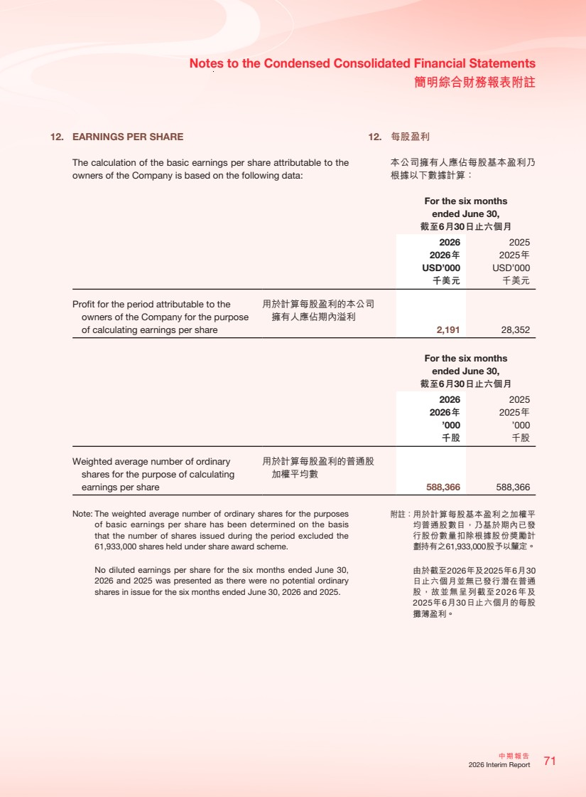 | 71 中期報告 2026 Interim Report Notes to the Condensed Consolidated Financial Statements 簡明綜合財務報表附註 12. EARNINGS PER SHARE The calculation of the basic earnings per share attributable to the owners of the Company is based on the following data: For the six months ended June 30, 截至6月30日止六個月 2026 2025 2026年 2025年 USD’000 USD’000 千美元 千美元 Profit for the period attributable to the owners of the Company for the purpose of calculating earnings per share 用於計算每股盈利的本公司 擁有人應佔期內溢利 2,191 28,352 For the six months ended June 30, 截至6月30日止六個月 2026 2025 2026年 2025年 ’000 ’000 千股 千股 Weighted average number of ordinary shares for the purpose of calculating earnings per share 用於計算每股盈利的普通股 加權平均數 588,366 588,366 Note: The weighted average number of ordinary shares for the purposes of basic earnings per share has been determined on the basis that the number of shares issued during the period excluded the 61,933,000 shares held under share award scheme. No diluted earnings per share for the six months ended June 30, 2026 and 2025 was presented as there were no potential ordinary shares in issue for the six months ended June 30, 2026 and 2025. 12. 每股盈利 本公司擁有人應佔每股基本盈利乃 根據以下數據計算： 附註：用於計算每股基本盈利之加權平 均普通股數目，乃基於期內已發 行股份數量扣除根據股份獎勵計 劃持有之61,933,000股予以釐定。 由於截至2026年及2025年6月30 日止六個月並無已發行潛在普通 股，故並無呈列截至2026年及 2025年6月30日止六個月的每股 攤薄盈利。
 | 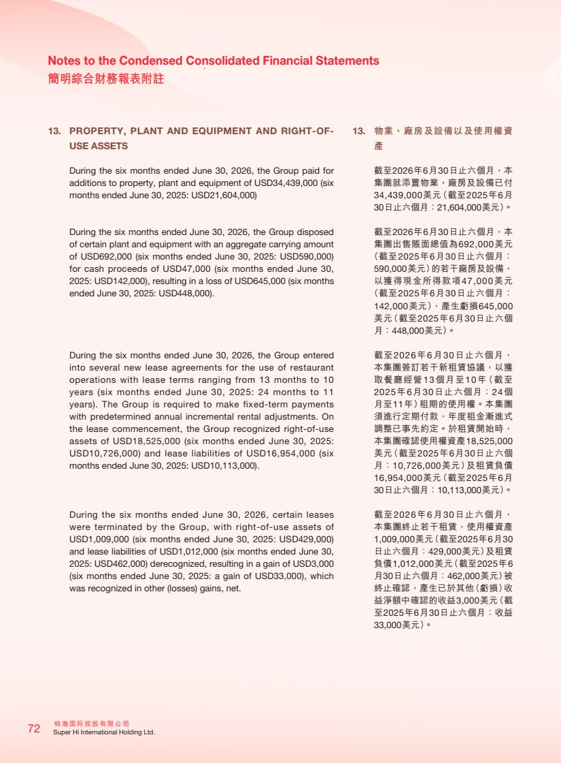 | 特海國際控股有限公司 72 Super Hi International Holding Ltd. Notes to the Condensed Consolidated Financial Statements 簡明綜合財務報表附註 13. PROPERTY, PLANT AND EQUIPMENT AND RIGHT-OF-USE ASSETS During the six months ended June 30, 2026, the Group paid for additions to property, plant and equipment of USD34,439,000 (six months ended June 30, 2025: USD21,604,000) During the six months ended June 30, 2026, the Group disposed of certain plant and equipment with an aggregate carrying amount of USD692,000 (six months ended June 30, 2025: USD590,000) for cash proceeds of USD47,000 (six months ended June 30, 2025: USD142,000), resulting in a loss of USD645,000 (six months ended June 30, 2025: USD448,000). During the six months ended June 30, 2026, the Group entered into several new lease agreements for the use of restaurant operations with lease terms ranging from 13 months to 10 years (six months ended June 30, 2025: 24 months to 11 years). The Group is required to make fixed-term payments with predetermined annual incremental rental adjustments. On the lease commencement, the Group recognized right-of-use assets of USD18,525,000 (six months ended June 30, 2025: USD10,726,000) and lease liabilities of USD16,954,000 (six months ended June 30, 2025: USD10,113,000). During the six months ended June 30, 2026, certain leases were terminated by the Group, with right-of-use assets of USD1,009,000 (six months ended June 30, 2025: USD429,000) and lease liabilities of USD1,012,000 (six months ended June 30, 2025: USD462,000) derecognized, resulting in a gain of USD3,000 (six months ended June 30, 2025: a gain of USD33,000), which was recognized in other (losses) gains, net. 13. 物業、廠房及設備以及使用權資 產 截至2026年6月30日止六個月，本 集團就添置物業、廠房及設備已付 34,439,000美元（截至2025年6月 30日止六個月：21,604,000美元）。 截至2026年6月30日止六個月，本 集團出售賬面總值為692,000美元 （截至2025年6月30日止六個月： 590,000美元）的若干廠房及設備， 以獲得現金所得款項47,000美元 （截至2025年6月30日止六個月： 142,000美元），產生虧損645,000 美元（截至2025年6月30日止六個 月：448,000美元）。 截至2026年6月30日止六個月， 本集團簽訂若干新租賃協議，以獲 取餐廳經營13個月至10年（截至 2025年6月30日止六個月：24個 月至11年）租期的使用權。本集團 須進行定期付款，年度租金漸進式 調整已事先約定。於租賃開始時， 本集團確認使用權資產18,525,000 美元（截至2025年6月30日止六個 月：10,726,000美元）及租賃負債 16,954,000美元（截至2025年6月 30日止六個月：10,113,000美元）。 截至2026年6月30日止六個月， 本集團終止若干租賃，使用權資產 1,009,000美元（截至2025年6月30 日止六個月：429,000美元）及租賃 負債1,012,000美元（截至2025年6 月30日止六個月：462,000美元）被 終止確認，產生已於其他（虧損）收 益淨額中確認的收益3,000美元（截 至2025年6月30日止六個月：收益 33,000美元）。
 | 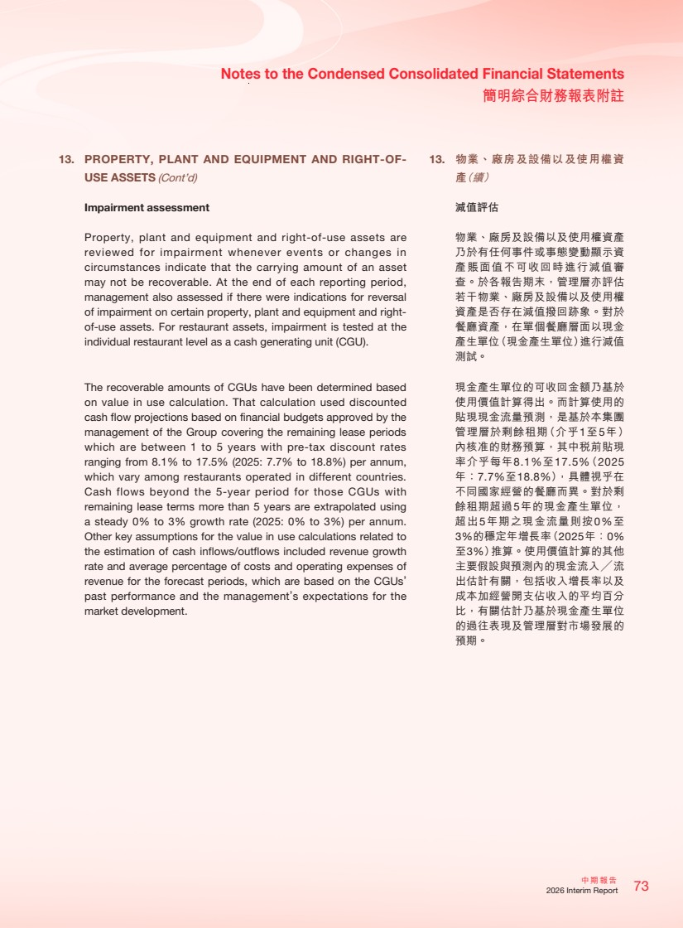 | 73 中期報告 2026 Interim Report Notes to the Condensed Consolidated Financial Statements 簡明綜合財務報表附註 13. PROPERTY, PLANT AND EQUIPMENT AND RIGHT-OF-USE ASSETS (Cont’d) Impairment assessment Property, plant and equipment and right-of-use assets are reviewed for impairment whenever events or changes in circumstances indicate that the carrying amount of an asset may not be recoverable. At the end of each reporting period, management also assessed if there were indications for reversal of impairment on certain property, plant and equipment and right-of-use assets. For restaurant assets, impairment is tested at the individual restaurant level as a cash generating unit (CGU). The recoverable amounts of CGUs have been determined based on value in use calculation. That calculation used discounted cash flow projections based on financial budgets approved by the management of the Group covering the remaining lease periods which are between 1 to 5 years with pre-tax discount rates ranging from 8.1% to 17.5% (2025: 7.7% to 18.8%) per annum, which vary among restaurants operated in different countries. Cash flows beyond the 5-year period for those CGUs with remaining lease terms more than 5 years are extrapolated using a steady 0% to 3% growth rate (2025: 0% to 3%) per annum. Other key assumptions for the value in use calculations related to the estimation of cash inflows/outflows included revenue growth rate and average percentage of costs and operating expenses of revenue for the forecast periods, which are based on the CGUs’ past performance and the management’s expectations for the market development. 13. 物業、廠房及設備以及使用權資 產（續） 減值評估 物業、廠房及設備以及使用權資產 乃於有任何事件或事態變動顯示資 產賬面值不可收回時進行減值審 查。於各報告期末，管理層亦評估 若干物業、廠房及設備以及使用權 資產是否存在減值撥回跡象。對於 餐廳資產，在單個餐廳層面以現金 產生單位（現金產生單位）進行減值 測試。 現金產生單位的可收回金額乃基於 使用價值計算得出。而計算使用的 貼現現金流量預測，是基於本集團 管理層於剩餘租期（介乎1至5年） 內核准的財務預算，其中稅前貼現 率介乎每年8.1%至17.5%（2025 年：7.7%至18.8%），具體視乎在 不同國家經營的餐廳而異。對於剩 餘租期超過5年的現金產生單位， 超出5年期之現金流量則按0%至 3%的穩定年增長率（2025年：0% 至3%）推算。使用價值計算的其他 主要假設與預測內的現金流入╱流 出估計有關，包括收入增長率以及 成本加經營開支佔收入的平均百分 比，有關估計乃基於現金產生單位 的過往表現及管理層對市場發展的 預期。
 | 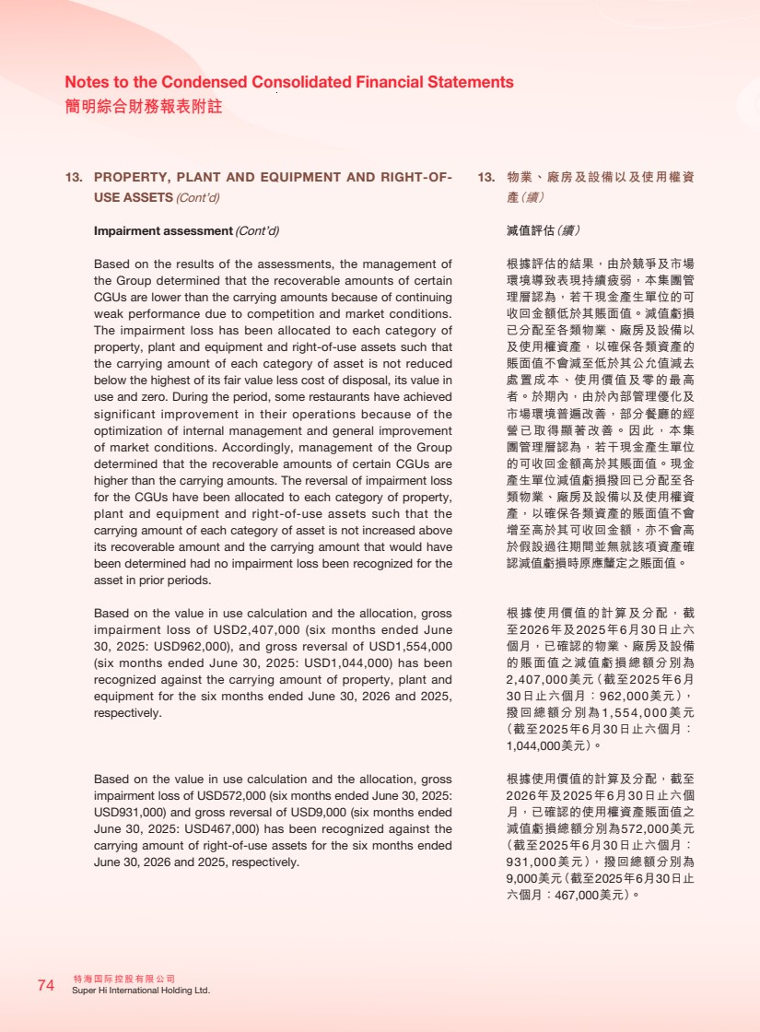 | 特海國際控股有限公司 74 Super Hi International Holding Ltd. Notes to the Condensed Consolidated Financial Statements 簡明綜合財務報表附註 13. PROPERTY, PLANT AND EQUIPMENT AND RIGHT-OF-USE ASSETS (Cont’d) Impairment assessment (Cont’d) Based on the results of the assessments, the management of the Group determined that the recoverable amounts of certain CGUs are lower than the carrying amounts because of continuing weak performance due to competition and market conditions. The impairment loss has been allocated to each category of property, plant and equipment and right-of-use assets such that the carrying amount of each category of asset is not reduced below the highest of its fair value less cost of disposal, its value in use and zero. During the period, some restaurants have achieved significant improvement in their operations because of the optimization of internal management and general improvement of market conditions. Accordingly, management of the Group determined that the recoverable amounts of certain CGUs are higher than the carrying amounts. The reversal of impairment loss for the CGUs have been allocated to each category of property, plant and equipment and right-of-use assets such that the carrying amount of each category of asset is not increased above its recoverable amount and the carrying amount that would have been determined had no impairment loss been recognized for the asset in prior periods. Based on the value in use calculation and the allocation, gross impairment loss of USD2,407,000 (six months ended June 30, 2025: USD962,000), and gross reversal of USD1,554,000 (six months ended June 30, 2025: USD1,044,000) has been recognized against the carrying amount of property, plant and equipment for the six months ended June 30, 2026 and 2025, respectively. Based on the value in use calculation and the allocation, gross impairment loss of USD572,000 (six months ended June 30, 2025: USD931,000) and gross reversal of USD9,000 (six months ended June 30, 2025: USD467,000) has been recognized against the carrying amount of right-of-use assets for the six months ended June 30, 2026 and 2025, respectively. 13. 物業、廠房及設備以及使用權資 產（續） 減值評估（續） 根據評估的結果，由於競爭及市場 環境導致表現持續疲弱，本集團管 理層認為，若干現金產生單位的可 收回金額低於其賬面值。減值虧損 已分配至各類物業、廠房及設備以 及使用權資產，以確保各類資產的 賬面值不會減至低於其公允值減去 處置成本、使用價值及零的最高 者。於期內，由於內部管理優化及 市場環境普遍改善，部分餐廳的經 營已取得顯著改善。因此，本集 團管理層認為，若干現金產生單位 的可收回金額高於其賬面值。現金 產生單位減值虧損撥回已分配至各 類物業、廠房及設備以及使用權資 產，以確保各類資產的賬面值不會 增至高於其可收回金額，亦不會高 於假設過往期間並無就該項資產確 認減值虧損時原應釐定之賬面值。 根據使用價值的計算及分配，截 至2026年及2025年6月30日止六 個月，已確認的物業、廠房及設備 的賬面值之減值虧損總額分別為 2,407,000美元（截至2025年6月 30日止六個月：962,000美元）， 撥回總額分別為1,554,000美元 （截至2025年6月30日止六個月： 1,044,000美元）。 根據使用價值的計算及分配，截至 2026年及2025年6月30日止六個 月，已確認的使用權資產賬面值之 減值虧損總額分別為572,000美元 （截至2025年6月30日止六個月： 931,000美元），撥回總額分別為 9,000美元（截至2025年6月30日止 六個月：467,000美元）。
 | 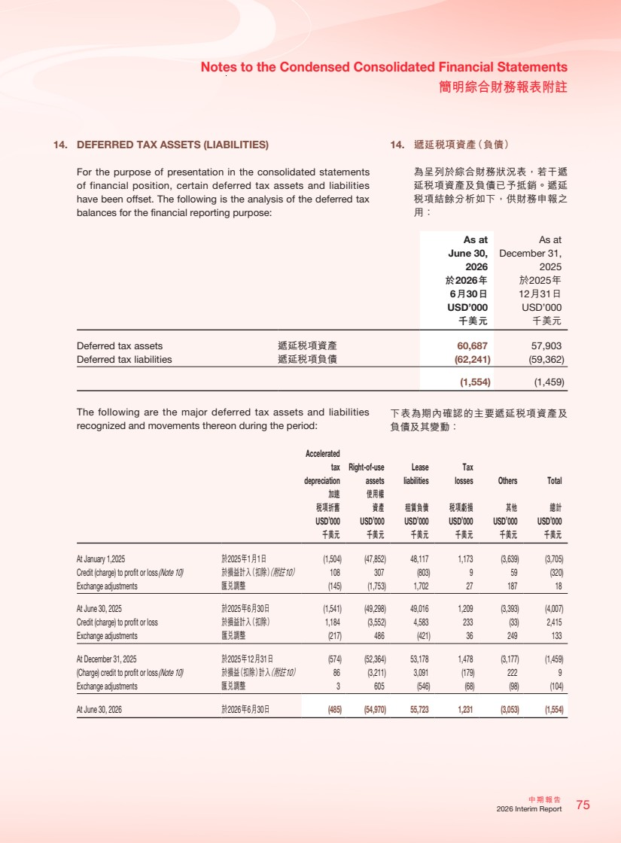 | 75 中期報告 2026 Interim Report Notes to the Condensed Consolidated Financial Statements 簡明綜合財務報表附註 14. DEFERRED TAX ASSETS (LIABILITIES) For the purpose of presentation in the consolidated statements of financial position, certain deferred tax assets and liabilities have been offset. The following is the analysis of the deferred tax balances for the financial reporting purpose: As at June 30, 2026 As at December 31, 2025 於2026年 6月30日 於2025年 12月31日 USD’000 USD’000 千美元 千美元 Deferred tax assets 遞延稅項資產 60,687 57,903 Deferred tax liabilities 遞延稅項負債 (62,241) (59,362) (1,554) (1,459) The following are the major deferred tax assets and liabilities recognized and movements thereon during the period: Accelerated tax depreciation Right-of-use assets Lease liabilities Tax losses Others Total 加速 稅項折舊 使用權 資產 租賃負債 稅項虧損 其他 總計 USD’000 USD’000 USD’000 USD’000 USD’000 USD’000 千美元 千美元 千美元 千美元 千美元 千美元 At January 1,2025 於2025年1月1日 (1,504) (47,852) 48,117 1,173 (3,639) (3,705) Credit (charge) to profit or loss (Note 10) 於損益計入（扣除）（附註10） 108 307 (803) 9 59 (320) Exchange adjustments 匯兌調整 (145) (1,753) 1,702 27 187 18 At June 30, 2025 於2025年6月30日 (1,541) (49,298) 49,016 1,209 (3,393) (4,007) Credit (charge) to profit or loss 於損益計入（扣除） 1,184 (3,552) 4,583 233 (33) 2,415 Exchange adjustments 匯兌調整 (217) 486 (421) 36 249 133 At December 31, 2025 於2025年12月31日 (574) (52,364) 53,178 1,478 (3,177) (1,459) (Charge) credit to profit or loss (Note 10) 於損益（扣除）計入（附註10） 86 (3,211) 3,091 (179) 222 9 Exchange adjustments 匯兌調整 3 605 (546) (68) (98) (104) At June 30, 2026 於2026年6月30日 (485) (54,970) 55,723 1,231 (3,053) (1,554) 14. 遞延稅項資產（負債） 為呈列於綜合財務狀況表，若干遞 延稅項資產及負債已予抵銷。遞延 稅項結餘分析如下，供財務申報之 用： 下表為期內確認的主要遞延稅項資產及 負債及其變動：
 | 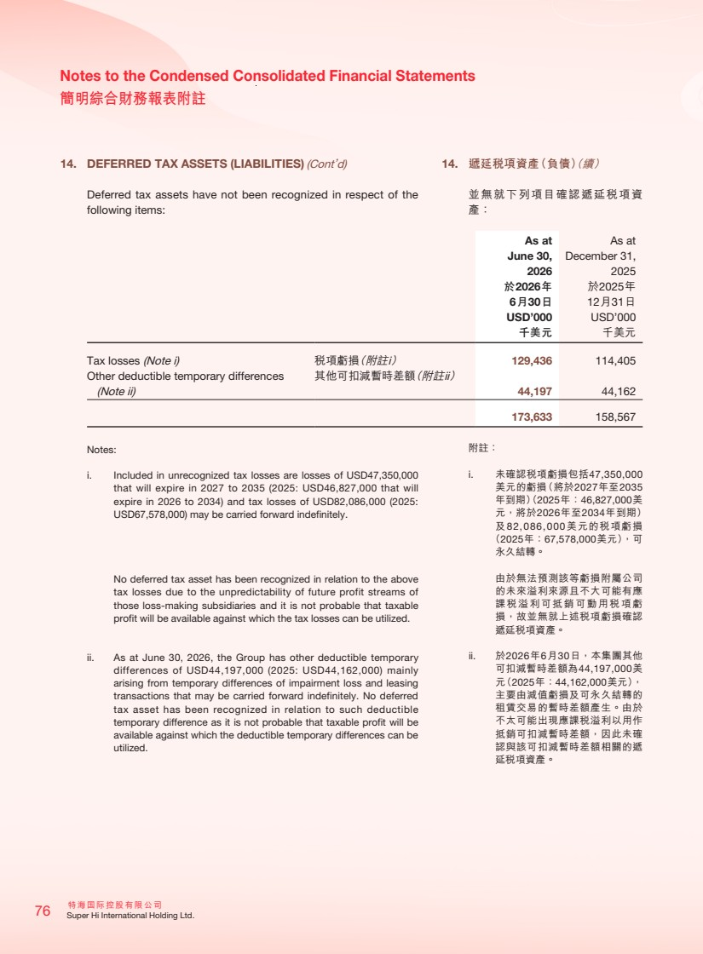 | 特海國際控股有限公司 76 Super Hi International Holding Ltd. Notes to the Condensed Consolidated Financial Statements 簡明綜合財務報表附註 14. DEFERRED TAX ASSETS (LIABILITIES) (Cont’d) Deferred tax assets have not been recognized in respect of the following items: As at June 30, 2026 As at December 31, 2025 於2026年 6月30日 於2025年 12月31日 USD’000 USD’000 千美元 千美元 Tax losses (Note i) 稅項虧損（附註i） 129,436 114,405 Other deductible temporary differences (Note ii) 其他可扣減暫時差額（附註ii） 44,197 44,162 173,633 158,567 Notes: i. Included in unrecognized tax losses are losses of USD47,350,000 that will expire in 2027 to 2035 (2025: USD46,827,000 that will expire in 2026 to 2034) and tax losses of USD82,086,000 (2025: USD67,578,000) may be carried forward indefinitely. No deferred tax asset has been recognized in relation to the above tax losses due to the unpredictability of future profit streams of those loss-making subsidiaries and it is not probable that taxable profit will be available against which the tax losses can be utilized. ii. As at June 30, 2026, the Group has other deductible temporary differences of USD44,197,000 (2025: USD44,162,000) mainly arising from temporary differences of impairment loss and leasing transactions that may be carried forward indefinitely. No deferred tax asset has been recognized in relation to such deductible temporary difference as it is not probable that taxable profit will be available against which the deductible temporary differences can be utilized. 14. 遞延稅項資產（負債）（續） 並無就下列項目確認遞延稅項資 產： 附註： i. 未確認稅項虧損包括47,350,000 美元的虧損（將於2027年至2035 年到期）（2025年：46,827,000美 元，將於2026年至2034年到期） 及82,086,000美元的稅項虧損 （2025年：67,578,000美元），可 永久結轉。 由於無法預測該等虧損附屬公司 的未來溢利來源且不大可能有應 課稅溢利可抵銷可動用稅項虧 損，故並無就上述稅項虧損確認 遞延稅項資產。 ii. 於2026年6月30日，本集團其他 可扣減暫時差額為44,197,000美 元（2025年：44,162,000美元）， 主要由減值虧損及可永久結轉的 租賃交易的暫時差額產生。由於 不太可能出現應課稅溢利以用作 抵銷可扣減暫時差額，因此未確 認與該可扣減暫時差額相關的遞 延稅項資產。
 | 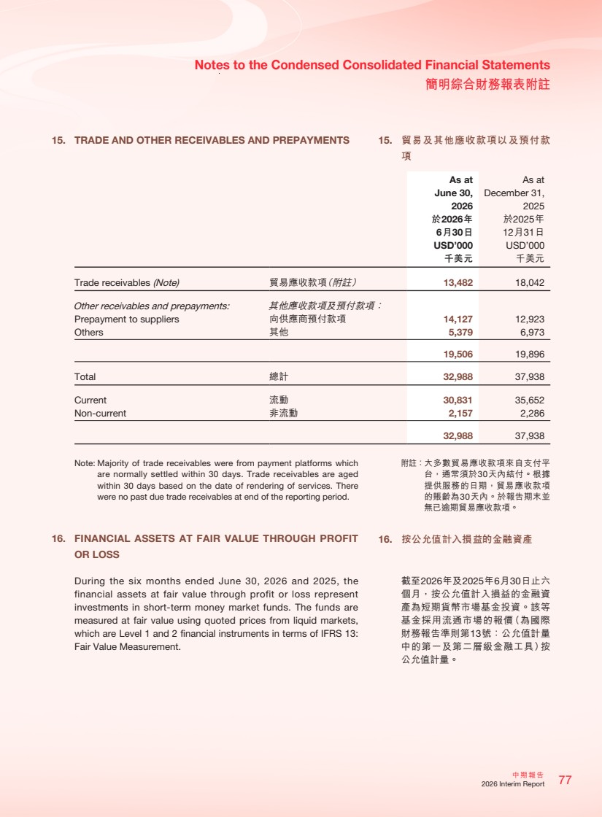 | 77 中期報告 2026 Interim Report Notes to the Condensed Consolidated Financial Statements 簡明綜合財務報表附註 15. TRADE AND OTHER RECEIVABLES AND PREPAYMENTS As at June 30, 2026 As at December 31, 2025 於2026年 6月30日 於2025年 12月31日 USD’000 USD’000 千美元 千美元 Trade receivables (Note) 貿易應收款項（附註） 13,482 18,042 Other receivables and prepayments: 其他應收款項及預付款項： Prepayment to suppliers 向供應商預付款項 14,127 12,923 Others 其他 5,379 6,973 19,506 19,896 Total 總計 32,988 37,938 Current 流動 30,831 35,652 Non-current 非流動 2,157 2,286 32,988 37,938 Note: Majority of trade receivables were from payment platforms which are normally settled within 30 days. Trade receivables are aged within 30 days based on the date of rendering of services. There were no past due trade receivables at end of the reporting period. 16. FINANCIAL ASSETS AT FAIR VALUE THROUGH PROFIT OR LOSS During the six months ended June 30, 2026 and 2025, the financial assets at fair value through profit or loss represent investments in short-term money market funds. The funds are measured at fair value using quoted prices from liquid markets, which are Level 1 and 2 financial instruments in terms of IFRS 13: Fair Value Measurement. 15. 貿易及其他應收款項以及預付款 項 附註：大多數貿易應收款項來自支付平 台，通常須於30天內結付。根據 提供服務的日期，貿易應收款項 的賬齡為30天內。於報告期末並 無已逾期貿易應收款項。 16. 按公允值計入損益的金融資產 截至2026年及2025年6月30日止六 個月，按公允值計入損益的金融資 產為短期貨幣市場基金投資。該等 基金採用流通市場的報價（為國際 財務報告準則第13號：公允值計量 中的第一及第二層級金融工具）按 公允值計量。
 | 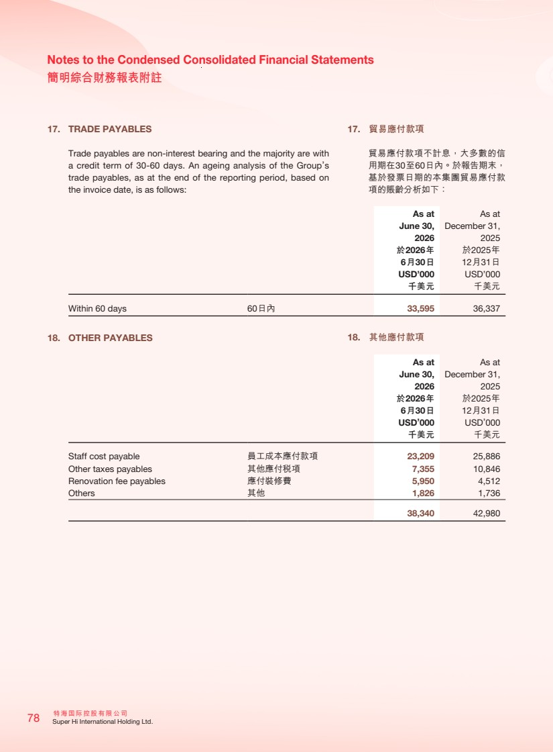 | 特海國際控股有限公司 78 Super Hi International Holding Ltd. Notes to the Condensed Consolidated Financial Statements 簡明綜合財務報表附註 17. TRADE PAYABLES Trade payables are non-interest bearing and the majority are with a credit term of 30-60 days. An ageing analysis of the Group’s trade payables, as at the end of the reporting period, based on the invoice date, is as follows: As at June 30, 2026 As at December 31, 2025 於2026年 6月30日 於2025年 12月31日 USD’000 USD’000 千美元 千美元 Within 60 days 60日內 33,595 36,337 18. OTHER PAYABLES As at June 30, 2026 As at December 31, 2025 於2026年 6月30日 於2025年 12月31日 USD’000 USD’000 千美元 千美元 Staff cost payable 員工成本應付款項 23,209 25,886 Other taxes payables 其他應付稅項 7,355 10,846 Renovation fee payables 應付裝修費 5,950 4,512 Others 其他 1,826 1,736 38,340 42,980 17. 貿易應付款項 貿易應付款項不計息，大多數的信 用期在30至60日內。於報告期末， 基於發票日期的本集團貿易應付款 項的賬齡分析如下： 18. 其他應付款項
 | 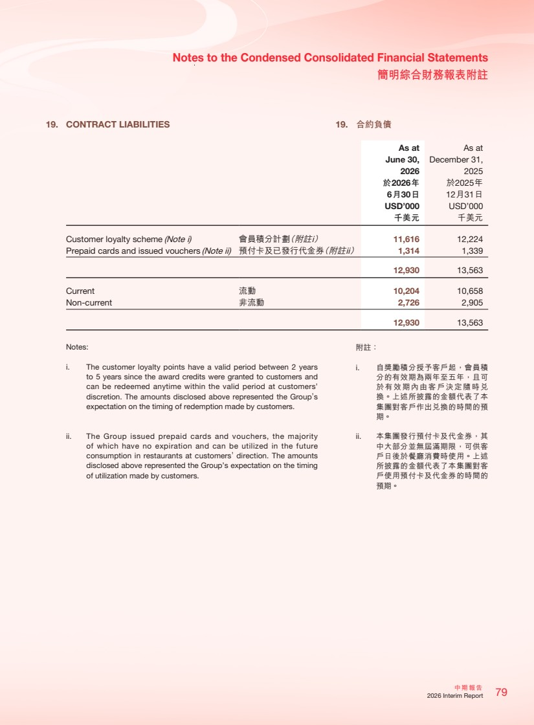 | 79 中期報告 2026 Interim Report Notes to the Condensed Consolidated Financial Statements 簡明綜合財務報表附註 19. CONTRACT LIABILITIES As at June 30, 2026 As at December 31, 2025 於2026年 6月30日 於2025年 12月31日 USD’000 USD’000 千美元 千美元 Customer loyalty scheme (Note i) 會員積分計劃（附註i） 11,616 12,224 Prepaid cards and issued vouchers (Note ii) 預付卡及已發行代金券（附註ii） 1,314 1,339 12,930 13,563 Current 流動 10,204 10,658 Non-current 非流動 2,726 2,905 12,930 13,563 Notes: i. The customer loyalty points have a valid period between 2 years to 5 years since the award credits were granted to customers and can be redeemed anytime within the valid period at customers’ discretion. The amounts disclosed above represented the Group’s expectation on the timing of redemption made by customers. ii. The Group issued prepaid cards and vouchers, the majority of which have no expiration and can be utilized in the future consumption in restaurants at customers’ direction. The amounts disclosed above represented the Group’s expectation on the timing of utilization made by customers. 19. 合約負債 附註： i. 自獎勵積分授予客戶起，會員積 分的有效期為兩年至五年，且可 於有效期內由客戶決定隨時兌 換。上述所披露的金額代表了本 集團對客戶作出兌換的時間的預 期。 ii. 本集團發行預付卡及代金券，其 中大部分並無屆滿期限，可供客 戶日後於餐廳消費時使用。上述 所披露的金額代表了本集團對客 戶使用預付卡及代金券的時間的 預期。
 | 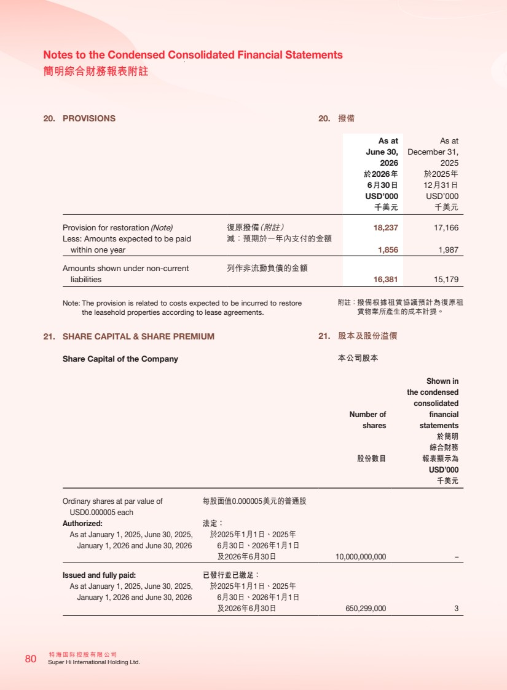 | 特海國際控股有限公司 80 Super Hi International Holding Ltd. Notes to the Condensed Consolidated Financial Statements 簡明綜合財務報表附註 20. PROVISIONS As at June 30, 2026 As at December 31, 2025 於2026年 6月30日 於2025年 12月31日 USD’000 USD’000 千美元 千美元 Provision for restoration (Note) 復原撥備（附註） 18,237 17,166 Less: Amounts expected to be paid within one year 減：預期於一年內支付的金額 1,856 1,987 Amounts shown under non-current liabilities 列作非流動負債的金額 16,381 15,179 Note: The provision is related to costs expected to be incurred to restore the leasehold properties according to lease agreements. 21. SHARE CAPITAL & SHARE PREMIUM Share Capital of the Company Number of shares Shown in the condensed consolidated financial statements 股份數目 於簡明 綜合財務 報表顯示為 USD’000 千美元 Ordinary shares at par value of USD0.000005 each 每股面值0.000005美元的普通股 Authorized: 法定： As at January 1, 2025, June 30, 2025, January 1, 2026 and June 30, 2026 於2025年1月1日、2025年 6月30日、2026年1月1日 及2026年6月30日 10,000,000,000 – Issued and fully paid: 已發行並已繳足： As at January 1, 2025, June 30, 2025, January 1, 2026 and June 30, 2026 於2025年1月1日、2025年 6月30日、2026年1月1日 及2026年6月30日 650,299,000 3 20. 撥備 附註：撥備根據租賃協議預計為復原租 賃物業所產生的成本計提。 21. 股本及股份溢價 本公司股本
 | 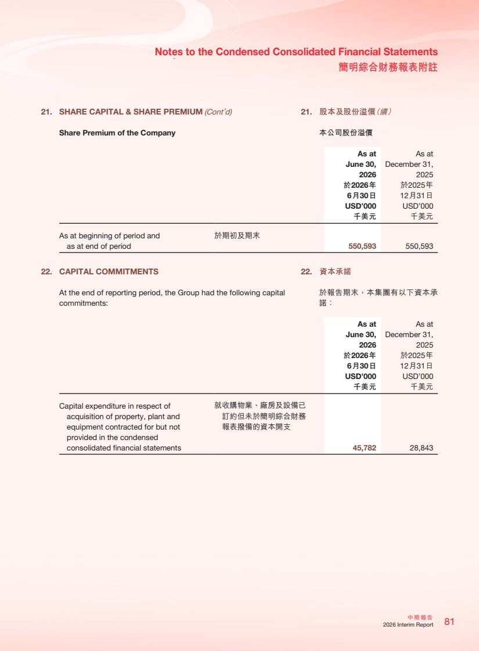 | 81 中期報告 2026 Interim Report Notes to the Condensed Consolidated Financial Statements 簡明綜合財務報表附註 21. SHARE CAPITAL & SHARE PREMIUM (Cont’d) Share Premium of the Company As at June 30, 2026 As at December 31, 2025 於2026年 6月30日 於2025年 12月31日 USD’000 USD’000 千美元 千美元 As at beginning of period and as at end of period 於期初及期末 550,593 550,593 22. CAPITAL COMMITMENTS At the end of reporting period, the Group had the following capital commitments: As at June 30, 2026 As at December 31, 2025 於2026年 6月30日 於2025年 12月31日 USD’000 USD’000 千美元 千美元 Capital expenditure in respect of acquisition of property, plant and equipment contracted for but not provided in the condensed consolidated financial statements 就收購物業、廠房及設備已 訂約但未於簡明綜合財務 報表撥備的資本開支 45,782 28,843 21. 股本及股份溢價（續） 本公司股份溢價 22. 資本承諾 於報告期末，本集團有以下資本承 諾：
 | 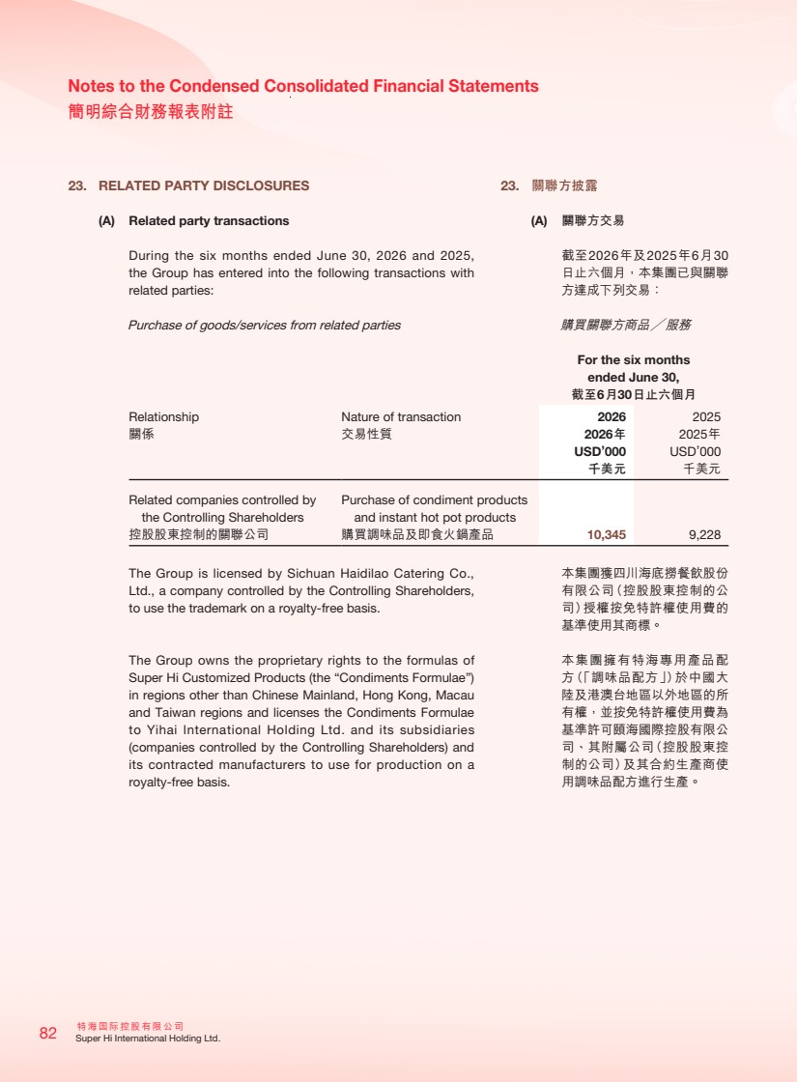 | 特海國際控股有限公司 82 Super Hi International Holding Ltd. Notes to the Condensed Consolidated Financial Statements 簡明綜合財務報表附註 23. RELATED PARTY DISCLOSURES (A) Related party transactions During the six months ended June 30, 2026 and 2025, the Group has entered into the following transactions with related parties: Purchase of goods/services from related parties For the six months ended June 30, 截至6月30日止六個月 Relationship 關係 Nature of transaction 交易性質 2026 2026年 2025 2025年 USD’000 千美元 USD’000 千美元 Related companies controlled by the Controlling Shareholders 控股股東控制的關聯公司 Purchase of condiment products and instant hot pot products 購買調味品及即食火鍋產品 10,345 9,228 The Group is licensed by Sichuan Haidilao Catering Co., Ltd., a company controlled by the Controlling Shareholders, to use the trademark on a royalty-free basis. The Group owns the proprietary rights to the formulas of Super Hi Customized Products (the “Condiments Formulae”) in regions other than Chinese Mainland, Hong Kong, Macau and Taiwan regions and licenses the Condiments Formulae to Yihai International Holding Ltd. and its subsidiaries (companies controlled by the Controlling Shareholders) and its contracted manufacturers to use for production on a royalty-free basis. 23. 關聯方披露 (A) 關聯方交易 截至2026年及2025年6月30 日止六個月，本集團已與關聯 方達成下列交易： 購買關聯方商品╱服務 本集團獲四川海底撈餐飲股份 有限公司（控股股東控制的公 司）授權按免特許權使用費的 基準使用其商標。 本集團擁有特海專用產品配 方（「調味品配方」）於中國大 陸及港澳台地區以外地區的所 有權，並按免特許權使用費為 基準許可頤海國際控股有限公 司、其附屬公司（控股股東控 制的公司）及其合約生產商使 用調味品配方進行生產。
 | 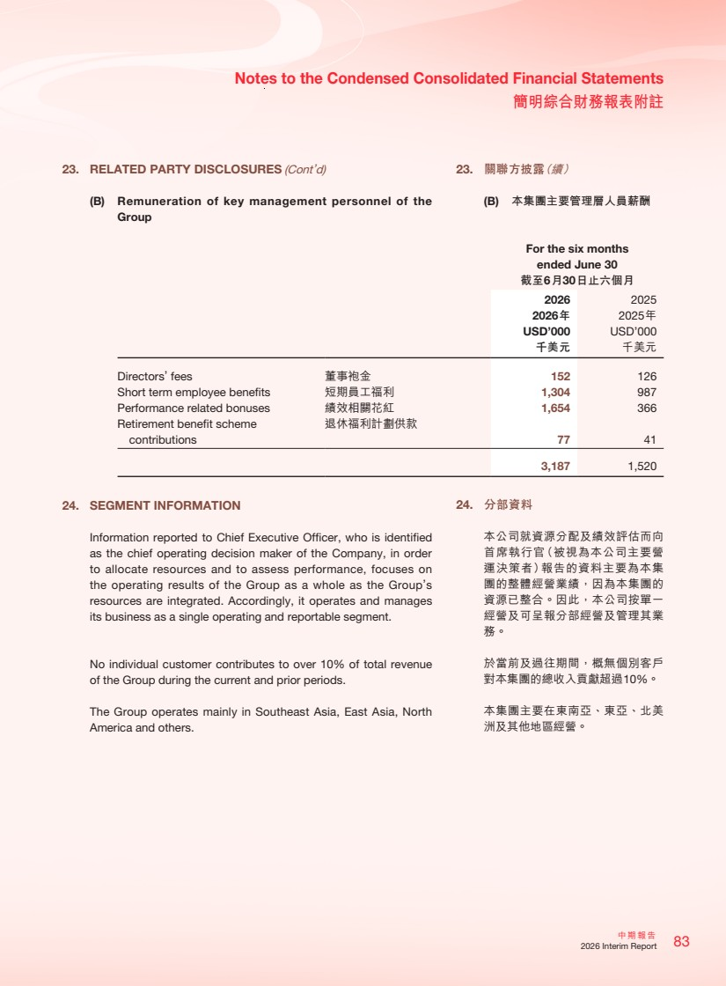 | 83 中期報告 2026 Interim Report Notes to the Condensed Consolidated Financial Statements 簡明綜合財務報表附註 23. RELATED PARTY DISCLOSURES (Cont’d) (B) Remuneration of key management personnel of the Group For the six months ended June 30 截至6月30日止六個月 2026 2025 2026年 2025年 USD’000 USD’000 千美元 千美元 Directors’ fees 董事袍金 152 126 Short term employee benefits 短期員工福利 1,304 987 Performance related bonuses 績效相關花紅 1,654 366 Retirement benefit scheme contributions 退休福利計劃供款 77 41 3,187 1,520 24. SEGMENT INFORMATION Information reported to Chief Executive Officer, who is identified as the chief operating decision maker of the Company, in order to allocate resources and to assess performance, focuses on the operating results of the Group as a whole as the Group’s resources are integrated. Accordingly, it operates and manages its business as a single operating and reportable segment. No individual customer contributes to over 10% of total revenue of the Group during the current and prior periods. The Group operates mainly in Southeast Asia, East Asia, North America and others. 23. 關聯方披露（續） (B) 本集團主要管理層人員薪酬 24. 分部資料 本公司就資源分配及績效評估而向 首席執行官（被視為本公司主要營 運決策者）報告的資料主要為本集 團的整體經營業績，因為本集團的 資源已整合。因此，本公司按單一 經營及可呈報分部經營及管理其業 務。 於當前及過往期間，概無個別客戶 對本集團的總收入貢獻超過10%。 本集團主要在東南亞、東亞、北美 洲及其他地區經營。
 | 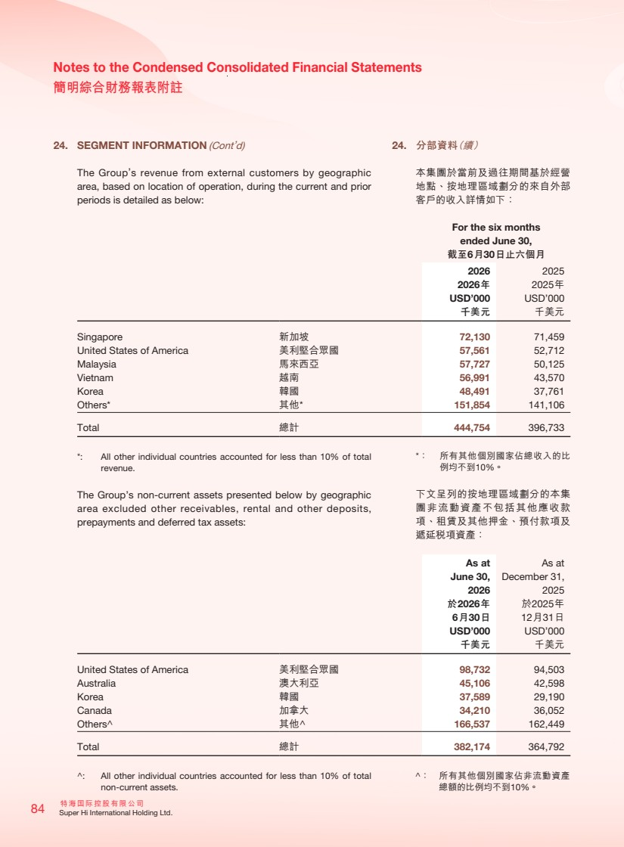 | 特海國際控股有限公司 84 Super Hi International Holding Ltd. Notes to the Condensed Consolidated Financial Statements 簡明綜合財務報表附註 24. SEGMENT INFORMATION (Cont’d) The Group’s revenue from external customers by geographic area, based on location of operation, during the current and prior periods is detailed as below: For the six months ended June 30, 截至6月30日止六個月 2026 2025 2026年 2025年 USD’000 USD’000 千美元 千美元 Singapore 新加坡 72,130 71,459 United States of America 美利堅合眾國 57,561 52,712 Malaysia 馬來西亞 57,727 50,125 Vietnam 越南 56,991 43,570 Korea 韓國 48,491 37,761 Others* 其他* 151,854 141,106 Total 總計 444,754 396,733 *: All other individual countries accounted for less than 10% of total revenue. The Group’s non-current assets presented below by geographic area excluded other receivables, rental and other deposits, prepayments and deferred tax assets: As at June 30, As at December 31, 2026 2025 於2026年 6月30日 於2025年 12月31日 USD’000 USD’000 千美元 千美元 United States of America 美利堅合眾國 98,732 94,503 Australia 澳大利亞 45,106 42,598 Korea 韓國 37,589 29,190 Canada 加拿大 34,210 36,052 Others 其他 166,537 162,449 Total 總計 382,174 364,792 : All other individual countries accounted for less than 10% of total non-current assets. 24. 分部資料（續） 本集團於當前及過往期間基於經營 地點、按地理區域劃分的來自外部 客戶的收入詳情如下： *： 所有其他個別國家佔總收入的比 例均不到10%。 下文呈列的按地理區域劃分的本集 團非流動資產不包括其他應收款 項、租賃及其他押金、預付款項及 遞延稅項資產： ： 所有其他個別國家佔非流動資產 總額的比例均不到10%。
 |  | 特海国际控股有限公司 SUPER HI INTERNATIONAL HOLDING LTD. 特海国际控股有限公司 SUPER HI INTERNATIONAL HOLDING LTD.

