UNITED STATES
SECURITIES AND EXCHANGE COMMISSION
Washington, D.C. 20549

FORM 6-K

REPORT OF FOREIGN PRIVATE ISSUER
PURSUANT TO RULE 13a-16 OR 15d-16 UNDER
THE SECURITIES EXCHANGE ACT OF 1934

For the month of August 2026

Commission File Number: 001-42101

SUPER HI INTERNATIONAL HOLDING LTD.

1 Paya Lebar Link, #09-04
PLQ 1 Paya Lebar Quarter
Singapore 408533
+65 6378 1921
(Address of principal executive offices)

Indicate by check mark whether the registrant files or will file annual reports under cover of Form 20-F or Form 40-F.

Form 20-F ☒ Form 40-F ☐

Exhibit Index

Exhibit No. |  | Description
Exhibit 99.1 |  | Monthly Return for Equity Issuer and Hong Kong Depositary Receipts listed under Chapter 19B of the Exchange Listing Rules on Movements in Securities

SIGNATURE

Pursuant to the requirements of the Securities Exchange Act of 1934, the registrant has duly caused this report to be signed on its behalf by the undersigned, thereunto duly authorized.

 | SUPER HI INTERNATIONAL HOLDING LTD.
 | By: | /s/ Ping Shu
 | Name: | Ping Shu
 | Title: | Director and Chairperson

Date: August 5, 2026

Exhibit 99.1
 | 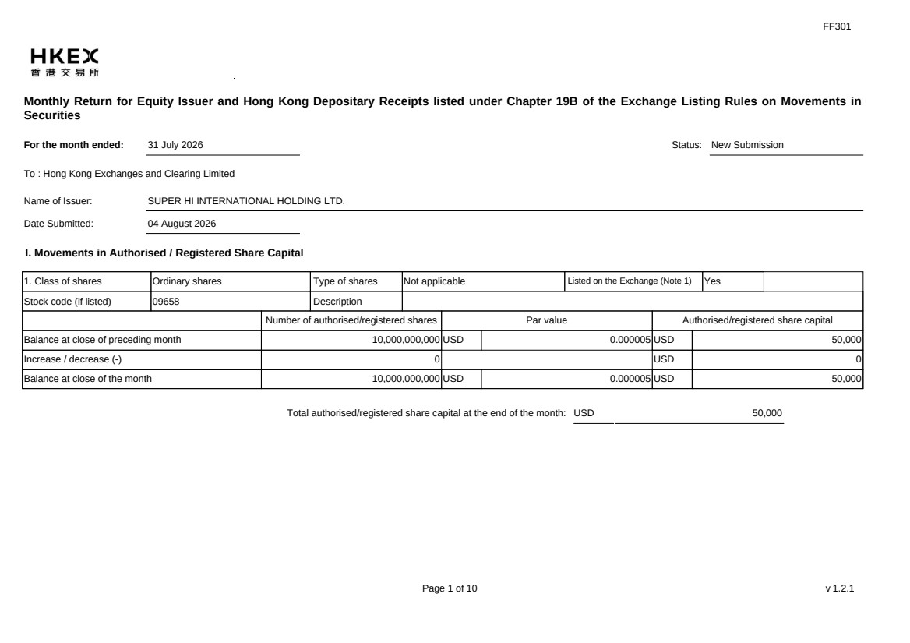 | FF301 Page 1 of 10 v 1.2.1 Monthly Return for Equity Issuer and Hong Kong Depositary Receipts listed under Chapter 19B of the Exchange Listing Rules on Movements in Securities For the month ended: 31 July 2026 Status: New Submission To : Hong Kong Exchanges and Clearing Limited Name of Issuer: SUPER HI INTERNATIONAL HOLDING LTD. Date Submitted: 04 August 2026 I. Movements in Authorised / Registered Share Capital 1. Class of shares Ordinary shares Type of shares Not applicable Listed on the Exchange (Note 1) Yes Stock code (if listed) 09658 Description Number of authorised/registered shares Par value Authorised/registered share capital Balance at close of preceding month 10,000,000,000 USD 0.000005 USD 50,000 Increase / decrease (-) 0 USD 0 Balance at close of the month 10,000,000,000 USD 0.000005 USD 50,000 Total authorised/registered share capital at the end of the month: USD 50,000
 | 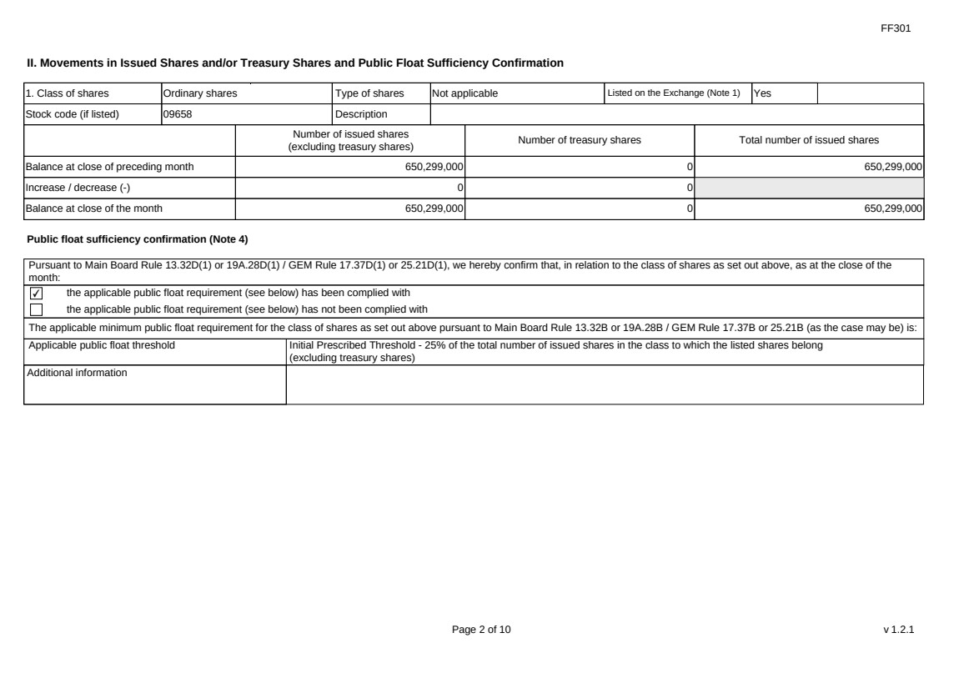 | FF301 Page 2 of 10 v 1.2.1 II. Movements in Issued Shares and/or Treasury Shares and Public Float Sufficiency Confirmation 1. Class of shares Ordinary shares Type of shares Not applicable Listed on the Exchange (Note 1) Yes Stock code (if listed) 09658 Description Number of issued shares (excluding treasury shares) Number of treasury shares Total number of issued shares Balance at close of preceding month 650,299,000 0 650,299,000 Increase / decrease (-) 0 0 Balance at close of the month 650,299,000 0 650,299,000 Public float sufficiency confirmation (Note 4) Pursuant to Main Board Rule 13.32D(1) or 19A.28D(1) / GEM Rule 17.37D(1) or 25.21D(1), we hereby confirm that, in relation to the class of shares as set out above, as at the close of the month: ✔ the applicable public float requirement (see below) has been complied with the applicable public float requirement (see below) has not been complied with The applicable minimum public float requirement for the class of shares as set out above pursuant to Main Board Rule 13.32B or 19A.28B / GEM Rule 17.37B or 25.21B (as the case may be) is: Applicable public float threshold Initial Prescribed Threshold - 25% of the total number of issued shares in the class to which the listed shares belong (excluding treasury shares) Additional information
 | 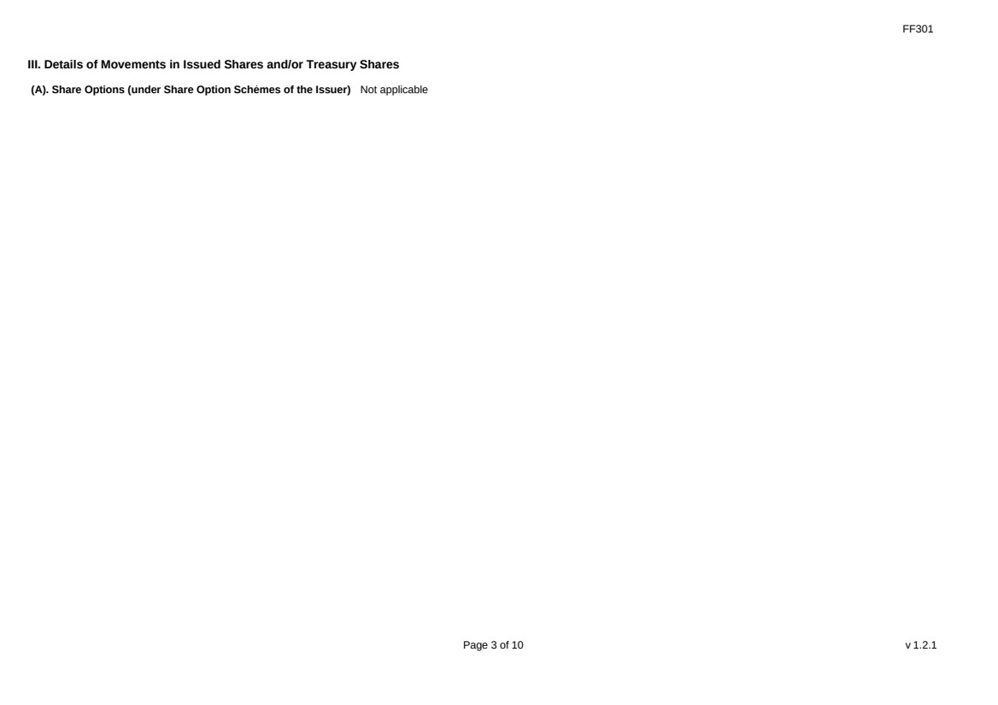 | FF301 Page 3 of 10 v 1.2.1 III. Details of Movements in Issued Shares and/or Treasury Shares (A). Share Options (under Share Option Schemes of the Issuer) Not applicable
 |  | FF301 Page 4 of 10 v 1.2.1 (B). Warrants to Issue Shares of the Issuer Not applicable
 | 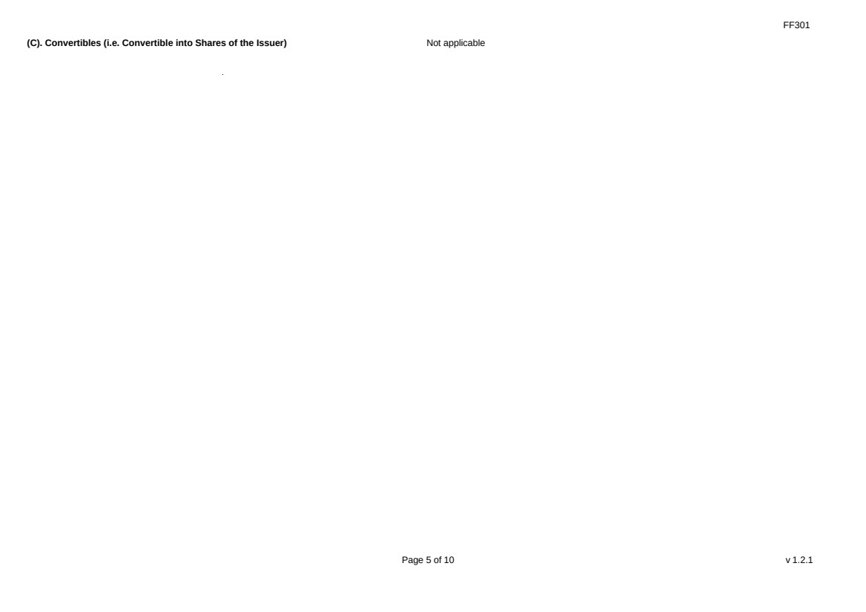 | FF301 Page 5 of 10 v 1.2.1 (C). Convertibles (i.e. Convertible into Shares of the Issuer) Not applicable
 | 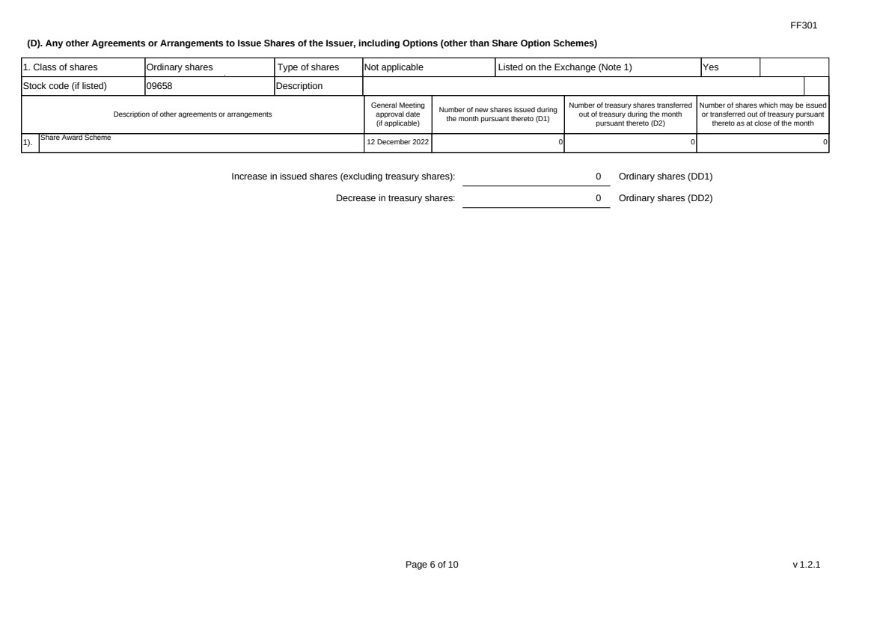 | FF301 Page 6 of 10 v 1.2.1 (D). Any other Agreements or Arrangements to Issue Shares of the Issuer, including Options (other than Share Option Schemes) 1. Class of shares Ordinary shares Type of shares Not applicable Listed on the Exchange (Note 1) Yes Stock code (if listed) 09658 Description Description of other agreements or arrangements General Meeting approval date (if applicable) Number of new shares issued during the month pursuant thereto (D1) Number of treasury shares transferred out of treasury during the month pursuant thereto (D2) Number of shares which may be issued or transferred out of treasury pursuant thereto as at close of the month 1). Share Award Scheme 12 December 2022 0 0 0 Increase in issued shares (excluding treasury shares): 0 Ordinary shares (DD1) Decrease in treasury shares: 0 Ordinary shares (DD2)
 | 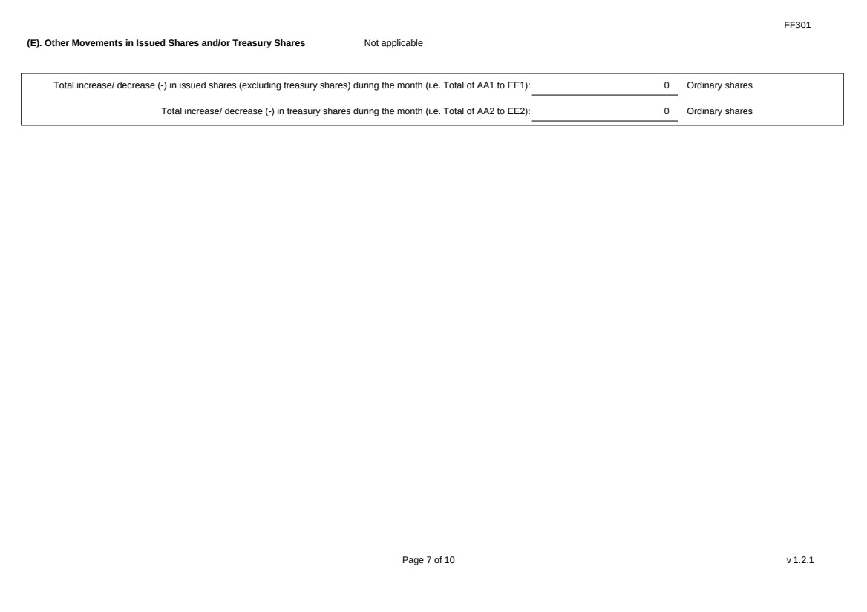 | FF301 Page 7 of 10 v 1.2.1 (E). Other Movements in Issued Shares and/or Treasury Shares Not applicable Total increase/ decrease (-) in issued shares (excluding treasury shares) during the month (i.e. Total of AA1 to EE1): 0 Ordinary shares Total increase/ decrease (-) in treasury shares during the month (i.e. Total of AA2 to EE2): 0 Ordinary shares
 | 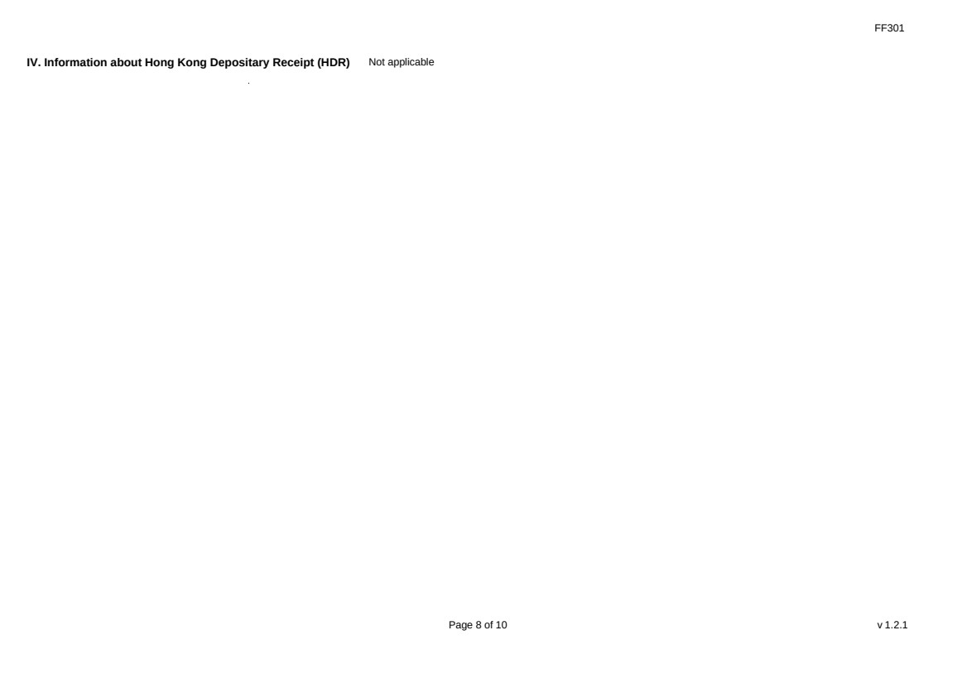 | FF301 Page 8 of 10 v 1.2.1 IV. Information about Hong Kong Depositary Receipt (HDR) Not applicable
 | 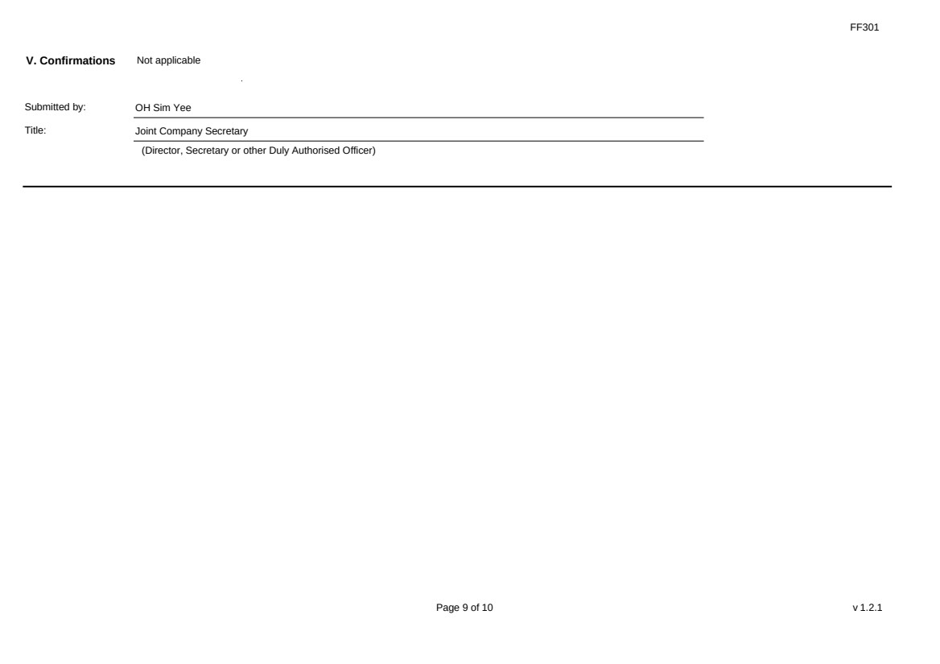 | FF301 Page 9 of 10 v 1.2.1 V. Confirmations Not applicable Submitted by: OH Sim Yee Title: Joint Company Secretary (Director, Secretary or other Duly Authorised Officer)
 | 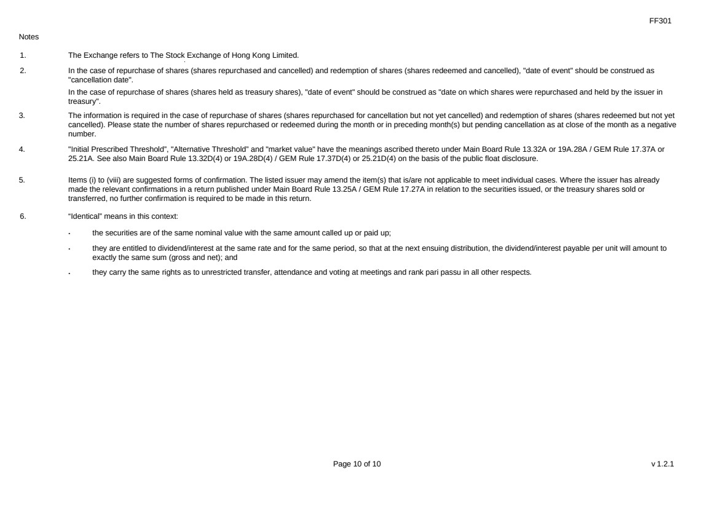 | FF301 Page 10 of 10 v 1.2.1 Notes 1. The Exchange refers to The Stock Exchange of Hong Kong Limited. 2. In the case of repurchase of shares (shares repurchased and cancelled) and redemption of shares (shares redeemed and cancelled), "date of event" should be construed as "cancellation date". In the case of repurchase of shares (shares held as treasury shares), "date of event" should be construed as "date on which shares were repurchased and held by the issuer in treasury". 3. The information is required in the case of repurchase of shares (shares repurchased for cancellation but not yet cancelled) and redemption of shares (shares redeemed but not yet cancelled). Please state the number of shares repurchased or redeemed during the month or in preceding month(s) but pending cancellation as at close of the month as a negative number. 4. "Initial Prescribed Threshold”, "Alternative Threshold” and "market value" have the meanings ascribed thereto under Main Board Rule 13.32A or 19A.28A / GEM Rule 17.37A or 25.21A. See also Main Board Rule 13.32D(4) or 19A.28D(4) / GEM Rule 17.37D(4) or 25.21D(4) on the basis of the public float disclosure. 5. Items (i) to (viii) are suggested forms of confirmation. The listed issuer may amend the item(s) that is/are not applicable to meet individual cases. Where the issuer has already made the relevant confirmations in a return published under Main Board Rule 13.25A / GEM Rule 17.27A in relation to the securities issued, or the treasury shares sold or transferred, no further confirmation is required to be made in this return. 6. “Identical” means in this context: ． the securities are of the same nominal value with the same amount called up or paid up; ． they are entitled to dividend/interest at the same rate and for the same period, so that at the next ensuing distribution, the dividend/interest payable per unit will amount to exactly the same sum (gross and net); and ． they carry the same rights as to unrestricted transfer, attendance and voting at meetings and rank pari passu in all other respects.

